# **Case Study - Centrica/British Gas**

## Profile

|  |  |
| --- | --- |
| Company Name: | British Gas |
| Business Sector: | Energy provider |
| Postal Address: | Lakeside House  30 The Causeway Staines  Middlesex |
| Postcode: | TW18 3BY |
| Fleet Size Overall: | 14,054 vehicles in United Kingdom |
| HGV: | 24 |
| LGV: | 10,200 |
| Company Cars: | 1,880 |
| Private vehicles used for business purposes: | 1,950 |

## Company Overview

**British Gas** is Britain's favorite domestic energy supplier.  As well as providing gas and electricity, it is the largest domestic central heating and gas appliance installation company.  Customers can also choose trained engineers to look after Central Heating, Plumbing and Drains, Home Electrics and Kitchen Appliances.

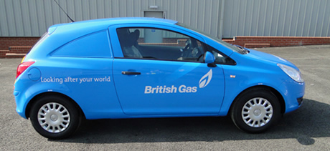

**British Gas** are the biggest supplier of green power to homes in Great Britain and the electricity supplied has the lowest CO2 emissions of any major United Kingdom energy supplier.  As a responsible energy provider, **British Gas** is planning for the future in two ways, firstly by investing in renewable energy and secondly by focusing on improving efficiency, thus helping customers reduce their own carbon footprint.

Operating in England under the **British Gas** brand name and as **Scottish Gas** in Scotland, the employee base consists of more than 12,000 staff in the United Kingdom based call centres and over 8,000 highly trained, Gas Safe registered engineers.  **British Gas** invests heavily in training to help ensure that the service offered is always of the highest quality possible, being Britain’s largest single employer and trainer of gas engineers, investing over £26 million each year.

During 2010 the “Great Places to Work Institute” formally praised **British Gas** as a providing an outstanding workplace in comparison with other United Kingdom employers.  This echoes an earlier achievement during 2010 when **British Gas** was listed in the Sunday Timesroll of the top “25 Best Big Companies” to work for.

**British Gas** has one of the largest fleets in the United Kingdom and it is important for employees and customers that it demonstrates a pro-active approach to managing foreseeable risks.

## Nature of operation and driving activities

Compliance with the joint Health and Safety Executive/ Department for Transport guidance on “Driving at Work – Managing work-related road safety” (HSE INDG 382 09/03) issued in September 2003, is particularly important and is the basis for the **British Gas** road risk policy.

**British Gas** operates approximately 14,000 vehicles in the United Kingdom and is therefore very serious about the safety performance of its fleet and its impact on the wider society in which they operate. The road safety programmes described below are based on the belief that promoting sound driving practices at work also extends to private driving, which should reduce the chances of employees, family members and people in the local community being injured in vehicle collisions.

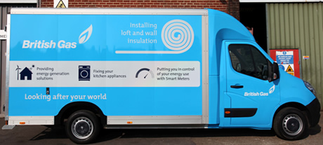

* Very detailed fuel monitoring and incident analysis.
* Vehicle safety features.
* Young driver safety initiative.
* Electronic driver licence checks.
* Pre employment driver risk assessment.
* Permit to Drive within fleet induction driver profiling booklet.
* Continuous road safety business plan.
* New initiatives to manage Grey fleet drivers.

## Organisational structure

**Centrica**Group Health, Safety and Environment (HS&E) provide road safety statistics for discussion at all board level meetings to analyse the current status plus any current and future initiatives that will positively impact on road safety.  Group HS&E and Fleet cascade any outcomes and work together to raise awareness within all areas of the business, plus implement the road safety initiatives discussed within the case study.

## Work related road safety policy and procedures

During 2010, the **Centrica** Group HS&E staff has reviewed and comprehensively updated the arrangements and expectations for driving on company business.  The new strategy is designed to deliver a leading road safety incident performance which protects people, third parties and the environment.  This is to be achieved through the co-operation and engagement of employees and by applying the same standards and practices for driving within the commercial fleet to company car and grey fleet drivers.

In conjunction with the Fleet team (and in consultation with the business), **Centrica**has updated its “Driving on Company Business” Group standards and guidelines.  These introduce a higher minimum expectation on all the group businesses globally, for example including:

* Expanded definitions of line manager and driver responsibilities.
* Mandatory risk-prioritised training for drivers.
* Preventing high risk drivers from driving on company business until their risk is adequately reduced.
* Restrictions on the use of hands-free mobile phones.
* More frequent checks on licence, insurance and vehicle roadworthiness (i.e. MOT or equivalent) for grey fleet drivers.

## Work related road safety guidance for drivers

Two factors shape **British Gas** guidance for drivers.  These are described below:

* **Electronic Licence Entitlement Check**s. British Gas ensures all employees have the appropriate licence, which are visually checked by a driver trainer and then verified electronically with DVLA through the electronic driver licence entitlement check.  This ensures no employee can drive unlicensed.
* **Multi-media Driver Risk Assessment.**British Gas also uses driver risk assessments which are carried out either ‘in-vehicle’ with an advanced driving instructor, through a booklet completed in a classroom or web based, to target both engineers and company car drivers, in addition to young drivers.

## Specific examples of procedures

**British Gas** has introduced the following work-related road safety initiatives:

### Fuel Monitoring

**British Gas** has implemented what is probably the United Kingdom’s most detailed and comprehensive fuel monitoring program.  Vehicles are subject to fuel data analysis with feedback through driver league tables.  These, in turn, trigger practical driver development based on improving efficiency using safe and fuel efficient driving techniques.  **British Gas** is in a unique position within the Fleet industry in the United Kingdom as they know the fuel efficiency of all types of vehicles currently operating and only procure the best performers.  As a result of this policy, they therefore challenge manufacturers to produce more fuel-efficient engines if they wish to supply vehicles to **British Gas**.  For example, **British Gas** has negotiated a contract with **Seat** to supply 500 new Leon Ecomotives.  These cars were delivered during the 1st. Quarter 2010.  The new eco Leon has a 1.6-litre diesel engine emitting 99g/km of CO2.  **British Gas** is combining its vehicle collision data with fuel efficiency data to verify the relationship between excessive fuel use and poor road safety.

### Vehicle Safety Features

Vehicle Safety Features are important to **British Gas** for sound business reasons.  **British Gas** decided in 2006 to restrict all new **British Gas** vans to a maximum speed of 70 mph.  By mid 2010 the entire fleet of commercial vehicles will have been fitted with speed restriction devices.  This initiative has positively influenced both road safety and fuel consumption, reducing the potential for drivers to be involved in high-speed incidents.  All vans also display a 70 mph maximum speed sticker on the rear doors to advise other road users.

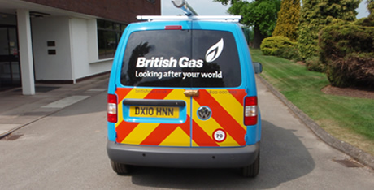

### E-learning Programme

**British Gas** has implemented a web-based driver development programme, named 'Be Smart' which incorporates safe and fuel efficient driving techniques through text, video and voice.  Be Smart assists in reducing the risks associated with driving. The intention is that driver development will increase safety when driving by developing knowledge and driving skills. Be Smart is an e-learning Safe and Fuel Efficient Driver Development product, which is seen as an industry leading environmental initiative.

### Van Best Practice Programme

**British Gas** is among the United Kingdom’s biggest fleets which are backing the Van Best Practice programme.  The **British Gas** fleet has already adopted many of the safe and fuel efficient practices advised in the guides.  **British Gas** is now in the process of fitting all vans with a telematics system with the aim of reducing fuel costs across the business through the production of league tables linked to practical driver development. At present **British Gas** spends £14 million on fuel every year.

### New Recruits

Each year a large number of new recruits, including young drivers, attend a one day fleet induction which consists of:

* In-vehicle driver assessment.
* Familiarisation with a driver profile booklet.
* Class room sessions on road safety, fuel efficiency, vehicle management and other fleet issues.
* Eyesight and licence check.
* **‘Think’** campaign videos’ to supplement road safety issues.

As the complexity of the fleet has increased, the fleet induction is now specific to the type of vehicle driven.  As a result of this focus, the timings of the driver assessment for large panel vans have been increased to concentrate more on manoeuvring techniques.

Over the past 3 years a total of 2,000 drivers were ‘touched’ by what has become one of the largest ever safety improvement initiatives undertaken in the United Kingdom.  An additional 1,500 drivers will be inducted during 2010 as the business begins to deliver insulation and smart meter products.  The fleet induction program is also important in the context of the wider concerns for young driver road safety.

**British Gas** developed a young driver programme which took in to consideration the fact that, in the United Kingdom, although drivers under 25 years old make up only 10% of all drivers, they are involved in 25% of the road traffic fatalities.  The fleet induction process was partly inspired the young driver themes from the Road Safety charity Brake.  Young apprentices driving a van not long after passing their test in a small vehicle were particularly vulnerable – and have been successfully identified and targeted as such by the **British Gas** initiative.

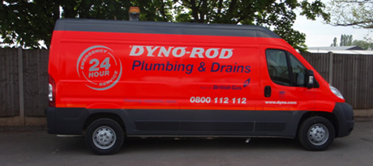

### Driver Risk Management System

The continuous Driver Risk Management Scheme (DRMS) is designed to contribute to the company objective of reducing Lost Time Injuries (LTI) by 25% and actual driving incidents by 10% during 2009.  Both these targets were achieved during 2009.  Since 2005, the number of vehicle related incidents has reduced by 30%.  **British Gas** realised that a totally new method of identifying and managing the risks associated with driving was required, if the company was to continue this improved safety trend.

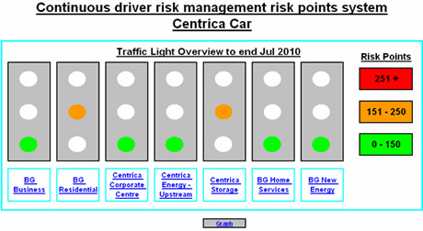

DRMS allocates risk points to a combination of driver related incidents.  The output is a system for “management” traffic lights for individual drivers who then receive specific interventions, training or otherwise, appropriate to their perceived risk.  DRMS enhances the visibility and management focus on Lost Time Injuries and associated driving incidents.  It creates a process with the ability to remove the right to drive from drivers whose personal attitude to safety is an unacceptably high risk for the business. For those drivers with a zero risk rating, there are incentives and rewards for being safe drivers.

### Fleet Safety Reviews

A **British Gas** employee who is a high risk driver may be formally invited to a Fleet Safety Review.  The review takes place with the General Manager; the Regional Service Manager; the Customer Operations Manager; the Service Manager; the Health, Safety and Environment (HS&E) Adviser, the Fleet Account manager and their local Safety representative.  At this meeting a number of factors are considered:

* Technical safety defects.
* Attitude to safety scores.
* Personal Accident history (last 12 months).
* Data from Driver Risk Management System (driver license plus vehicle claims).
* Assessments of tyre usage; fuel efficiency (MPG); wing mirror damage; and correct fuel card usage.
* Van checks on the day include tyre pressures; tyre condition; and outside/inside van condition.
* Driver development; driver monitoring; and any other actions.

The Fleet Safety Review board then reaches a decision on the overall risk of the driver to the business and determines an outcome that may include further training requirements for this individual. If further training is recommended, the **British Gas**employee is required to return to the Fleet Safety Review board after specific driver development activities have been completed to discuss their impact on the individual.

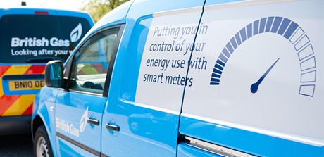

## Accident reduction and financial and other benefits

In 2006, the **British Gas** authorised a five-year business case for their occupational road risk policy to cover all employees who travel in the course of their employment. The programme is holistic, innovative, data-led, proactive and a genuine attempt to contribute to the improvement of road safety in the United Kingdom.  There are obviously wider benefits associated with this programme for the communities in which **British Gas** operates.  The programme covers the following:

* Risk assessments.
* Licence checking.
* Training and development of:
  + Engineers.
  + Company car drivers.
  + Cash alternative drivers.
  + Casual users.
  + Recruits
  + Any driver involved in two or more collisions each year.

British Gas currently spends approximately £6.7 million per year on vehicle collisions which includes all own damage and third party costs within their fleet of 10,200 vans and 1,880 company cars, as well as £14 million on fuel.

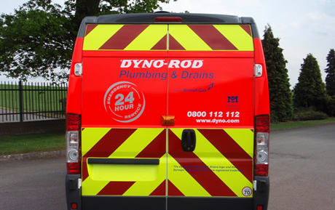

During 2009 a phased implementation of the DRMS was introduced along with the road risk interventions shown below:

* Two hour sessions completed for staff with multiple incidents or poor fuel efficiency.
* 297 participants in safe and fuel efficient driving (Be Smart) e-learning.
* 37 new induction courses.
* 415 x 1 hr driving assessments.
* 8,981 Driving licence entitlement checks.

The combination of all the above resulted in a further in reduction road traffic incidents of 10%.

The table below shows a significant reduction in vehicle collisions and associated costs over the past 2 years.

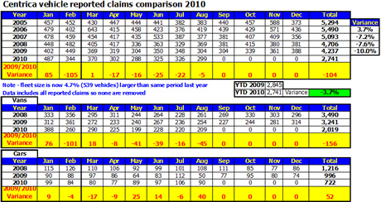

## Current and future developments

**British Gas** has introduced their own BTEC Level 3 advanced driving course named **ASK**(**A**ttitude, **S**kill and **K**nowledge) which is accredited by Edexcel.  Successful completion earns a BTEC level 3 award in advanced driving.  The objective is to improve driving skills in order to cope with everyday driving as well as meeting the standards expected of an advanced driver.  **British Gas** believes that it will further reduce vehicle collisions and protect the **British Gas** brands.

Prior to attending this course, candidates must complete the e-learning ‘Be-Smart’ programme.  The **ASK** syllabus includes three presentations and two practical driving sessions which are split down as follows:

**Attitude:**

* Driving Hazards and Risk Reduction Strategy.
* Hazard Perception.
* The Seven Driving Situations.
* Patience.

**Skill:**

* See the Big Picture.
* The Three Keys O.A.P.
* Vehicle Technology and Dynamics.

**Knowledge:**

* Prevailing Conditions.
* Risk Reduction Strategies.
* System of Vehicle Control.
* Situational Awareness and Distractions.
* Importance of Concentration.

## ****Additional information****

**British Gas** has received a great deal of external recognition for its road safety initiatives, which have been adopted by many other organisations.  Examples include:

* Early involvement in the Road Haulage Modernisation Fund, and SAFED for trucks program.
* Regular features in the trade press.
* Speaking at key industry events in the United Kingdom and overseas.
* Pioneering involvement in the SAFED for vans program.
* Being asked to benchmark data and processes with a number of other high profile fleets.
* Volunteering to take part in industry initiatives such as the Roadsafe / Department for Transport Driving for Better Business campaign and the FedEx / Brake Road Safety Academy.
* Acknowledgement of programs by Brake, Motor Transport, Chartered Institute of Logistics & Transport and the Prince Michael International Road Safety awards.