Calderdale Metropolitan Borough Council

Profile
Company Name: | Calderdale Metropolitan Borough Council
Business Sector: | Local Government
Postal Address: | Halifax Town Hall
Postcode: | HX1 1UJ
Fleet Size Overall: | 214
HGV: | 12
LGV: | 0
Company Cars: | 4
Private vehicles used for business purposes: | Not less than 1,600 Grey Fleet drivers

OVERVIEW
Calderdale Metropolitan Borough Council was created in 1974, bringing together the towns of Brighouse; Elland; Halifax; Hebden Bridge; Sowerby Bridge and Todmorden, as well as the surrounding villages of the South Pennine uplands. It is the sixth largest of the 36 metropolitan authorities in terms of land area, yet the seventh smallest in terms of population. The population is 201,600.
Calderdale is an area of many contrasts and boasts a tremendous industrial and architectural heritage, including the unique 18th Century Piece Hall and over 4,000 listed buildings. The surrounding Pennine moorland that inspired Emily Bronte’s ‘Wuthering Heights’ provides spectacular walking country.
The Borough’s traditional economic base was founded on textiles, engineering and manufacturing during the industrial revolution. In recent years, service industries have overtaken manufacturing in terms of number of employees.
The social characteristics of the area are also varied. Some rural and semi-rural areas that are close to the transport network are growing as a result of new housing developments, with people commuting typically to Leeds or Manchester for employment. In contrast, some residents of remote rural communities lack ready access to the facilities available in the larger towns of the district. The vehicle fleet and staff are vital to the effective delivery of Calderdale Borough Council services to these communities.
Calderdale Metropolitan Borough Council employs 4011 full time and 4897 part time people in 6178 full time equivalent posts. Further detailed information on the borough is available at www.calderdale.gov.uk/council/statistics/index.html.
Calderdale Metropolitan Borough Council delivers services across a range of directorates and services as shown in the following management structure.

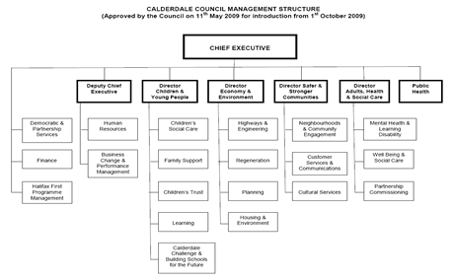

NATURE OF OPERATION AND DRIVING ACTIVITIES
Calderdale Metropolitan Borough Council carries out a wide range of functions utilising a diverse range of vehicles. These functions include:
- Home to School and Day Care transport using specially converted minibuses.
- District wide Access Bus service for older people and people with mobility problems.
- Provision of minibuses to schools and community-based organisations.
- Gritting/snow blowing using dedicated HGVs and Snow Blowers.
- Street cleansing using gulley wagons, large sweepers and mini sweepers.
- Parks and street scene works and grounds maintenance using various tippers; vans; mowers and tractors.
- Mobile libraries of various sizes.
- Highways maintenance using towers, tippers and vans.
- Provision of cars for civic functions.
- Provision of vehicles for services such as Dog Wardens; Pest Control; Building Cleaning; Parking Services and Youth Service.
- Collection and delivery of school meals throughout the district.
- Driver training and assessments for authorisation to drive Council vehicles.

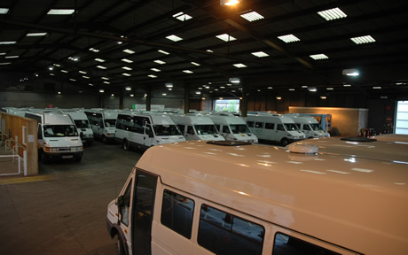

As the result of these widespread activities, Calderdale Metropolitan Borough Council faces and manages a complex series of workplace transport arrangements. Calderdale Metropolitan Borough Council focuses on managing risks associated with workplace transport. Its Health and Safety management system is designed to cover its employees and contractors employed by the Calderdale Metropolitan Borough Council, including customers and visitors to council sites.
Calderdale Metropolitan Borough Council management at all levels is responsible for ensuring that risk assessments are carried out for all aspects of workplace transport across the Council’s areas of activity. Control measures have been introduced to minimise and reduce these risks. Key elements of this process are:
- Making all Calderdale Metropolitan Borough Council employees aware of their responsibilities for ensuring their own safety and the safety of other people.
- Ensuring that employees report to their Line Manager anything that may affect their ability or eligibility to drive. This includes the requirement to report any new endorsements; other penalties; convictions or medical conditions.
- Carrying out risk assessments for each site and implementing actions required by any findings.
- Ensuring that drivers are competent and trained to carry out their tasks in a safe manner. This is a formal process which initiates re-assessments as appropriate.
- Checking drivers’ licences on an annual basis for validity.
- Ensuring that all vehicles are used and maintained in accordance with manufacturer and industry guidelines.
- Ensuring all incidents and near misses are reported using the Calderdale Metropolitan Borough Council reporting procedures.

ORGANISATIONAL STRUCTURE
The management of Occupational Road Risk is embedded in the Health and Safety culture of all Calderdale Metropolitan Borough Council employees. The Council’s statement ‘Everyone Different, Everyone Matters’, embraces this culture. The statement of commitment signed by Leader of the Council and Chief Executive is given below:
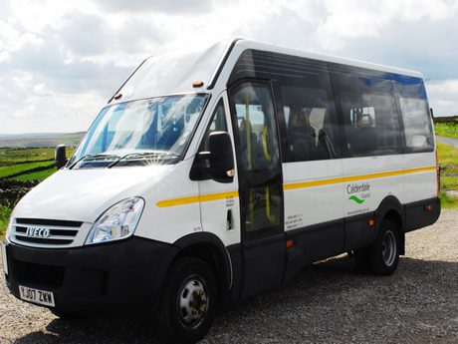
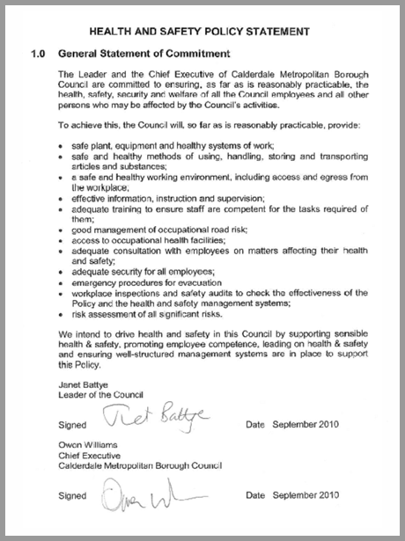
All staff members receive training and guidance on health and safety and the management of occupational road risk. To ensure road risk is managed and monitored in the Calderdale Metropolitan Borough Council the following management systems are in place:

Strategic Level
At a Strategic level Directors and Heads of Service complete their own annual audits. This provides evidence that they are aware of all health and safety management issues, including the Management of Occupational Road Risk within their directorate or department.

Accident Reports
Injuries arising from work related Road Traffic Collisions (RTC) for all employees of the Council are recorded as a category within the Accident/Incident reporting procedures. Where appropriate, the Health and Safety team will investigate and report on individual incidents. All Health and Safety Committee meetings receive briefings on accident statistics and, if applicable, individual incidents. The accident statistics are one element of the criteria used to formulate the Health and Safety team’s annual activity focus.

Annual Audit Database
Calderdale Metropolitan Borough Council’s Health and Szfety Policy requires all managers to complete an on-line health and safety audit which includes a section on the Management of Occupational Road Risk. There is a series of questions in the Calderdale Metropolitan Borough Council annual audit on the Management of Occupational Road Risk. This provides a mechanism by which Line Managers are made aware their responsibilities and proactive in managing the Council’s occupational road risk.
The audits are monitored and checked by the Health and Safety team throughout the year and all the information is stored on-line. Any concerns highlighted by the audit on the Management of Occupational Road Risk will be followed up by the Corporate Health and Safety Advisers.

Annual Report to Cabinet
Any relevant issues regarding the Management of Occupational Road Risk and the Annual Audit statistics are reported in the Annual Health and Safety Report to Cabinet. This identifies any managers not co-operating with the Policy or the Safety Audit process and results in remedial action being taken.
The Calderdale Metropolitan Borough Council Transport Services Manager is responsible for the Council’s Operator Licences. The fleet is procured and maintained in-house by Transport Services where all servicing, MOTs and repairs of vehicles are carried out. Transport Services currently delivers in-house driver training and assessments for passenger carrying vehicles.
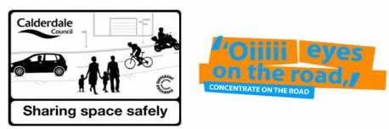
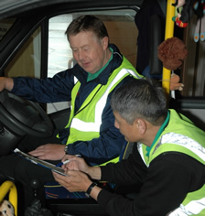Calderdale Metropolitan Borough Council Line Managers are responsible for ensuring that suitable and sufficient risk assessments are in place for driving activities. Service Managers with control of drivers are responsible for ensuring that drivers undergo driver risk assessments and training to include:

- Knowledge of Driving at Work Policy.
- Vehicle/Driver risk assessments.
- Collision Incident Reporting.
- Annual Vehicle Licence checks.
- Drivers Health requirements.
- Licence categories and restrictions.
- Blue Card Permit assessment scheme
Each directorate has a designated Health and Safety Co-ordinator. The Health and Safety Co-ordinator has overall responsibility for co-ordinating health and safety within their directorate and representing the directorate on strategic health and safety issues on the Calderdale Metropolitan Borough Council’s Health and Safety Steering Group.

WORK RELATED ROAD SAFETY POLICY & PROCEDURES
Calderdale Metropolitan Borough Council aims to provide and maintain a safe and healthy working environment for all employees. It believes that all its employees and contractors have a major part in making the organisation a safe and healthy place in which to work. All employees and contractors have an individual responsibility for maintaining the safety of their working environment. They are required to follow safe working practices.
Calderdale Metropolitan Borough Council provides the information, instruction, training and supervision required to deliver these safe working practices.
The work-related road safety policy deals with
- Competency.
- Training and instruction.
- Fitness and health.
Over the past 24 months Calderdale Metropolitan Borough Council has upgraded its policy in respect of Driving at Work. It has introduced and implemented a new Driving at Work Policy.
This policy was produced in conjunction with the Health and Safety section; Health and Safety Co-ordinators; the Road Safety team and Transport Services. It was agreed with the Corporate Management Team (CMT). Its objectives are to identify and minimise risks and actively to encourage safe driving in order to reduce the number of collisions. Advice on the Driving at Work Policy can be obtained from the Calderdale Metropolitan Borough Council’s:
- Intranet.
- Health and Safety advisers.
- Road Safety Officers.
- Transport Services Manager.
The Driving at Work Policy is based on addressing each key element of work-related road safety.
- The driver.
- The vehicle.
- The journey.
- The site.
Calderdale Metropolitan Borough Council policy statements include the following:
- The use of Council minibuses.
- Speeding.
- Licence checks.
- Safe vehicle operation.
- Carrying passengers.
- Alcohol and drugs.
- Driver assessment and training.
- Mobile phones.
- Vehicle safety checks.
- Vehicle risk assessments.
- Job/task risk assessment.
- Break-ins/theft.
- Driving convictions.
- Declaration of health.

Calderdale Metropolitan Borough Council Grey Fleet
The grey fleet consists of Council employees who use their privately owned vehicles on Council business. The Blue Card Permit Scheme is currently being rolled out to include all grey fleet users. In addition, Council employees’ documents are checked on an annual basis by their Line Managers.

The Calderdale Metropolitan Borough Council Driving at Work Policy also covers the use of privately owned vehicles for business use, which includes all casual and essential car users. Owners are expected to ensure that their vehicles meet certain minimum standards. Drivers must have a valid UK driving licence that complies with the Driving at Work Policy. Any privately owned vehicles used on Council business must have fully comprehensive insurance for business use and a current MOT certificate where this is relevant.

Blue Card Permit Assessment Scheme
All Calderdale Metropolitan Borough Council employees who drive a council-owned Minibus and Multi-person Vehicle must successfully complete a Driver Assessment prior to operating the vehicle. The Driver Assessment is carried out by Calderdale Metropolitan Borough Council assessors.
All persons who drive for, or on behalf of Calderdale Metropolitan Borough Council (including grey fleet drivers) must have a valid UK driving licence that complies with the Council’s driving policy and must complete a driver’s declaration of health form and undergo an eyesight test.
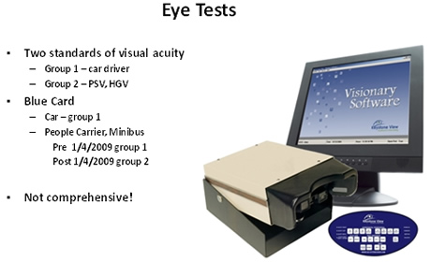
On successful completion they will then be issued with a Blue Card permit which has photo ID and which states the category of vehicle they are permitted to drive. This process is repeated every 3 years. If a person accumulates more than 6 penalty points on their licence, or if a Line Manager is concerned about a driver’s ability, re-assessment and training will be initiated. This will be carried out by one of Calderdale Metropolitan Borough Council’s driving assessors.
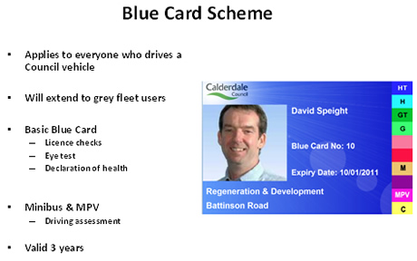
All employees involved in the transportation of vulnerable adults and children are subject to enhanced CRB checks.

WORK RELATED ROAD SAFETY GUIDANCE FOR DRIVERS
Work related road safety guidance is contained in the Driver’s Handbook which is issued to all drivers when they begin employment with Calderdale Metropolitan Borough Council. Other publications or materials may also be issued at this time.
Calderdale Metropolitan Borough Council has an Intranet service over which electronic versions of policies, procedures and other documents are readily available for staff members to view. In addition, there are “Bite size Safety” leaflets on various topics such as Driving at Work, Lone Working and Manual handling and other safety topics. Updates and other important issues are sent out via electronic newsletters.
The Driver’s Handbook includes sections on the following:
- Safety equipment.
- Vehicle condition.
- Driver condition.
- Posture and driving comfort.
- Manual handling.
- Stress and Road Rage.
- Driving when pregnant.
- Journey planning.
- Weather conditions.
- Lone driving.
- Breakdowns including action at night.
- Daily/weekly vehicle inspections which are to be carried out before starting the vehicle.
- Pre-journey checks.
- Action in the event of collisions and other emergencies.
- Vehicle systems (ABS).
- Speed limits/Stopping distances.
- Safe Loading.
- Contact Names.
Line Managers are responsible for ensuring that policies and procedures are reviewed and updated as required. Any changes to existing policy and procedures are to be passed on to all employees.

Vehicle Checks
Line Managers must also ensure that drivers are trained in how to carry out and record basic pre-use safety checks, including:
External checks
- Fuel and oil levels.
- Water level.
- Brake fluid level.
- Power steering fluid level.
- Tyre condition - physical check on pressure, sidewall damage and tread depth.
- Body damage checks.
- Passenger Lift check.
- All wipers working.
- Mirrors set correctly and clean.
- All lights working.
- Tax disc and Section 19 Permit are all in date
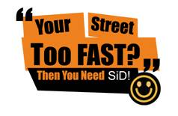
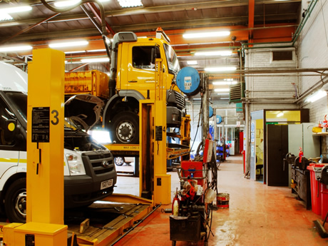
Internal checks
- All controls working.
- Warning triangle present.
- Fire extinguishers front and rear reading Green.
- First Aid box sealed.
- All seats are secure.
- Seat belts in good working order without fraying.
- All equipment stowed away.
- Rear door unlocked and tested for easy opening from inside.
All defects must be reported immediately and rectified before the vehicle is used. Any vehicle with a defect MUST be taken out of service until the defect is resolved. Any damage to the vehicle is to be highlighted on the Vehicle Damage Chart and signed off by a responsible person.

SPECIFIC EXAMPLES OF PROCEDURES
The following are examples of Calderdale Metropolitan Borough Council work-related road safety procedures:
- Driver Licence and Vehicle Documentation Check. The Driver Licence and Vehicle Documentation Check form is used by the Line Manager to keep a record of annual checks for staff that they manage. This is required as part of the Driving at Work policy. It also applies to employees who use their own personal vehicles for business use. It is the responsibility of the Line Manager to keep this record until another form is completed the following year.
- Daily Vehicle Inspections. All drivers carry out daily checks prior to commencing operations. Procedures are demonstrated as part of the staff induction process. Drivers are required to sign the Daily Vehicle Check Sheet.
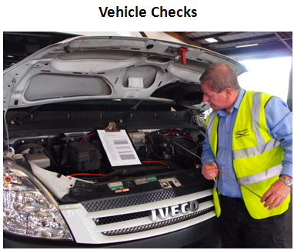

- Daily Vehicle Log Sheet. Log sheets are kept with the vehicle and are completed when a journey commences. They note the mileage and destination where vehicles have been used. The Line Manager is responsible for ensuring these log sheets are filled in.
- Calderdale Metropolitan Borough Council employs a Training Officer who is part of the Transport Services Team. His role covers all aspects of training covering:
  - Driving assessments.
  - Driver training.
  - Vehicle and fire evacuation.
  - Manual handling.
  - Safe transportation of wheelchairs.
  - Passenger assistance techniques.
  - Disability awareness.
  - Green Driving techniques.

AUDITING AND REVIEW
The nature of transport operations and the changes to legislation mean that information and procedures require constant monitoring and review.

Driver Licences
As well as being recorded by the Line Managers on an annual basis, there is also a corporate annual audit system. This is a further check that procedures are being followed.

Operations
Where a Fleet vehicle is owned or leased by Calderdale Metropolitan Borough Council, Transport Services will ensure that the vehicle is properly maintained and intermediate safety inspections are carried out where appropriate. When a vehicle has a defect the employee must complete a defect form and submit this to Transport Services for immediate action. Drivers of fleet vehicles that are owned or leased by Calderdale Metropolitan Borough Council are required to ensure that they maintain accurate records for each vehicle they drive covering its daily use. These include the following documents
- Driver’s Daily Vehicle Check Sheet.
- Daily Vehicle Log Sheet.
- Vehicle Damage Chart.
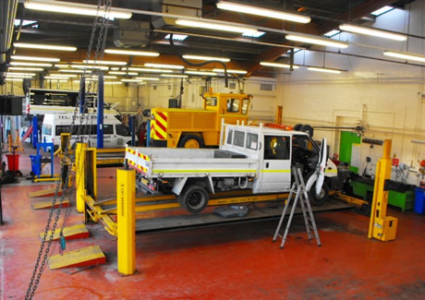

PERFORMANCE MEASURES
The key performance measures identified by Calderdale Metropolitan Borough Council are:
- The number of employees failing the assessment test and having to be re-assessed or trained.
- Total number of accidents per year concentrating specifically on “own fault” accidents.
- Total cost of accident claims per year.
- Average cost of accident claims per year.
- Changes -/+ to insurance premium costs.
- Types of damage, Front/Rear etc.
The pie chart illustrates how management information is used to inform training design. This example shows the distribution of damage to vehicles in 2009. It indicates that damage occurred to the rear of vehicles in 18% of cases. In comparison in 2007 damage to the rear of vehicles had occurred in 43% of cases. The change and improvement came about as the result of remedial training measures being introduced.
All forms used for vehicles checks including Vehicle Damage Charts and Daily Vehicle Log Sheets are monitored. They are analysed to ensure that vehicles are roadworthy and to reduce or eliminate costs for repairs.

ACCIDENT REDUCTION
Calderdale Metropolitan Borough Council monitors its accident rate continually with the aim of reducing the quantity and severity of incidents. Trends are the responsibility of the Transport Services Manager. Calderdale Metropolitan Borough Council operates a “no blame” culture enabling all road safety incidents to be reported without penalty. It encourages its drivers to report incidents via the Collision Incident Report form. In instances where Calderdale Metropolitan Borough Council is not at fault, it actively seeks costs from the Third Party for damage to its vehicles. All drivers are aware that this happens. The Driving at Work Co-ordinator investigates every accident. The findings of this investigation are sent to the driver’s Line Manager. The Driving at Work Co-ordinator makes recommendations in this report to reduce the likelihood of a repeat incident.
Currently, Calderdale Metropolitan Borough Council is focussed on ensuring that all accidents and near misses are reported and that an appropriate level of investigation is undertaken to identify the root causes of these incidents. Calderdale Metropolitan Borough Council believes that once these causes are identified, processes to reduce the number of further incidents can be introduced.
Action on Reversing Risk. It is known that reversing accidents are a significant feature in annual statistics. Since April 2007, all new vehicles coming onto the fleet have had reverse sensors fitted as standard.
Training in Evacuation of Minibuses. Due to the large number of vulnerable adults and children being transported on a daily basis, all staff involved in the transportation of passengers receive evacuation training to ensure safe and quick evacuation in a fire or collision scenario.

FINANCIAL AND OTHER BENEFITS
Calderdale Metropolitan Borough Council is working continuously to reduce the number of accidents. The effect of monitoring accidents and the continuous improvement in training its drivers and management teams has seen a reduction in incidents. These reducing costs and insurance premiums reinforce Calderdale Metropolitan Borough Council’s business case for supporting the Driving for Better Business campaign.
The new approach has achieved a definite reduction in Calderdale Metropolitan Borough Council’s insurance premium from £61,576.95p in 2009/10 to £53,611.05 in 2010/11. This is the equivalent of a 12.8% reduction of insurance premium which saves the Calderdale rate payer £7,965.89 per year. This saving on insurance costs relate to Transport Services alone and not the council’s overall insurance costs.
The drop in rear end damage incidents from 43% to 18% is one of the factors which have influenced this reduction along with the other control measures which have been put in place. Calderdale Metropolitan Borough Council’s vehicle fleet has increased in size in the same time frame. Therefore, an extrapolated calculation of savings which took this in to account, would produce a much higher saving in costs. Much of what Calderdale Metropolitan Borough Council is doing is work in progress. But Calderdale Metropolitan Borough Council is keen to identify the performance measures and data capture systems which it needs to set up to deliver the benefits
Additional benefits are:
- Improved public image.
- Employee morale and motivation is higher.
- Lower absences.
- An increased awareness of health and safety issues across the Calderdale Metropolitan Borough Council.
- Improvement in business performance.
- These measures in turn deliver a direct benefit to the communities which use the Calderdale Metropolitan Borough Council’s services. Savings realised and efficiency gains can be redirected to front line services

LESSONS LEARNED
Calderdale Metropolitan Borough Council is aware that it needs to focus more on the causes of accidents. Its aim is to improve the culture of safety within the Calderdale Metropolitan Borough Council. Its belief is that by implementing management training courses and carrying out checks and audits, the accident rate will reduce further.
Calderdale Metropolitan Borough Council maintains an active policy of drawing from “best practice” in work-related road safety. It is not enough to focus on driver competency and attitudes alone. In order to change the driver culture it has been necessary to adopt a holistic approach and engage with service users and produce a customer care package, which includes driver training, accident management and training seminars for managers.

CURRENT AND FUTURE DEVELOPMENTS
Calderdale Metropolitan Borough Council intends to continue with its current monitoring and auditing programmes. It is aware of the need to be vigilant to changes in legislation. It seeks continually to improve its management systems to ensure a safe working environment for Calderdale Metropolitan Borough Council employees and contractors.
Calderdale Metropolitan Borough Council is working to ensure compliance with its Driving at Work Policy for all grey fleet drivers through the implementation of the Blue Card Permit & Assessment Scheme. Continuous improvement of training programmes will be developed utilising new methods and technology to improve performance.
Calderdale Metropolitan Borough Council is also developing strategies for motorcyclists who commute or use their powered two wheelers in connection with Calderdale Metropolitan Borough Council business and for their own leisure purposes.
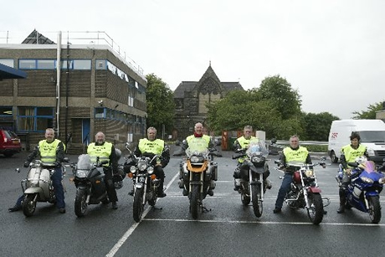
It is recognised that as vulnerable road users injuries sustained, even when not at work, have a direct impact at the workplace in terms of loss of productivity, a negative impact on morale and potential for protracted periods of sickness absence and rehabilitation. Calderdale Metropolitan Borough Council is currently developing a ‘rider awareness’ programme in partnership with the West Yorkshire Police Bikesafe team. The programme comprises both classroom based theory analysis using DVDs and an on-road practical assessment. The programme will ensure that powered two wheeler users are better equipped and skilled to manage the particular road risks they face as vulnerable road users.
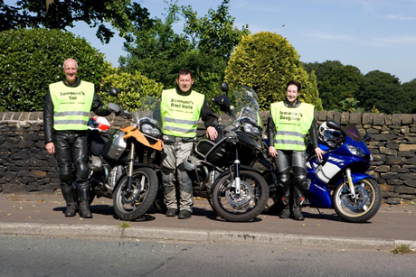
Calderdale Metropolitan Borough Council believes that this is the first such partnership to address road risk specific to powered two wheeler users. The development of the initiative follows the model outlined in the RoSPA MORR guidelines.

