Case Study - Cogent Breeding Ltd

Profile
Company Name: | Cogent Breeding Ltd
Website: | www.cogentuk.com
Business Sector: | Agriculture
Postal Address: | Heywood House, Chowley Oak Business Park, Chowley Oak Lane, Chester
Postcode: | CH3 9GA
Fleet Size Overall: | 177
HGV: | 0
LGV: | 51
Company Cars: | 40
Private vehicles used for business purposes: | 86
Board Member with Responsibility for WRRS: | Andrew Turner
Position in Company: | CEO
Tel / Mob: | 01829 773400
Point of Contact: | Ann Moore
Position in Company: | Fleet Manager
Tel / Mob: | 01829 773454
Email: | ann.moore@cogent.com

COMPANY OVERVIEW
Cogent Breeding Ltd are an agricultural based company and operate the UK's largest bull stud. Its key operations are based near Chester in rural Cheshire and is the base for their world-class laboratories. Cogent's ground-breaking technology in sexed semen allows farmers to target their breeding programme more effectively, deriving multiple benefits for both the farmer and his cattle.
It was founded in 1995 and forms part of the Grosvenor Estate, a private company owned by The Duke of Westminster. The business has come a long way, operating from just a farm to become one of the UK's leading suppliers of bovine genetics. Cogent has a rapidly growing global reach- currently providing high-quality British products to some 40 countries worldwide.

NATURE OF OPERATION AND DRIVING ACTIVITIES
Cogent Breeding operate a fleet that consists of 51 Light Goods Vehicles (LGV’s) all of which are fitted with Fleet smart trackers and internal forward facing CCTV cameras, 40 company owned/leased vehicles, and a grey fleet of 86 private vehicles which are currently used for business purposes.
Of its 180 UK staff over 70% are required to drive due to the nature of their work and are also classed as lone workers. Most of the LGV vehicle journeys are on rural minor roads; often leading to remote farms. LGV drivers each cover in the region 40K miles per annum, usually on similar or repetitive routes encompassing early starts as well as scheduled delivery days.
The sales teams and technical support staff each cover on average 30,000 miles annually in a fleet currently leased with VW Group leasing.
Privately owned vehicles are used periodically for work purposes, for example by administrative support functions attending training or visiting clients. These “grey fleet” vehicles and their drivers are included in Cogent’s work related road risk policies and procedures.

ORGANISATIONAL STRUCTURE
Cogent Breeding Ltd operate internationally as well as in the UK. Andrew Turner (CEO) heads their UK organisation structure.
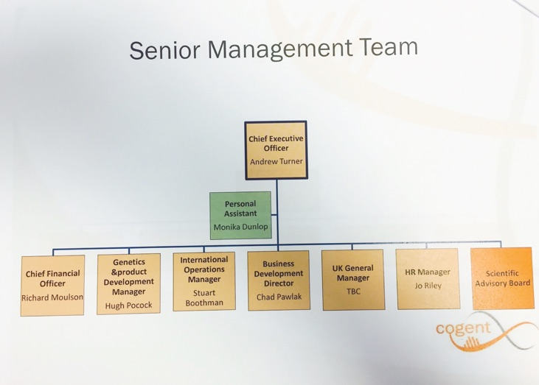

WORK RELATED ROAD SAFETY POLICY & PROCEDURES

Driving At Work Policy
Cogent Breeding’s Policy for Driving At Work is signed by the CEO Andrew Turner. It applies to all employees who are, or may be, required to drive a vehicle on company business – including non-company owner vehicles (Grey Fleet).
The Policy is brought to all employees’ attention during initial induction, all drivers who drive a vehicle for work purposes are required to read and sign the risk assessment, including those who may drive their own personal vehicle.
Cogent Breeding contract Driving Monitor as their driver risk management partner, the policy is held on Driving Monitor’s online dashboard.
A key inclusion in the policy is clarification that whilst the policy does not apply to non-business driving it encourages all staff to apply the policies principles for all driving, including commuting.

Driving At Work Risk Assessment
The policy is part of the companies overall safety system and was developed initially after the companies occupational safety risk management procedures identified Driving at Work as one of the highest risks faced by their employees ranking it on their risk register as equal to working with livestock.
The risk assessment identifies the hazards associated with Driving at Work, for example; driving at night, long distance driving, poor weather, distractions, breakdowns, lone working and influences of prescription medicines. It is a comprehensive yet simple document that successfully links Driving at Work to their occupational safety management system.
The risk assessment signposts the Driving At Work policy as a safe system of work that applies to all employees.

WORK RELATED ROAD SAFETY GUIDANCE FOR DRIVERS
The main source of guidance for Cogent Breeding’s drivers is the Driving At Work policy document. It has sections on:
- Driver competence expectations
- Licence checking
- Insurance requirements
- Vehicle Maintenance
- Mobile Phone Use
- Distractions
- Speeding
- Tiredness and Journey times
- Vision requirements
- Drugs and Alcohol
- Vehicle Tracking
- Reporting of Incidents and Accidents
- Driver journey checklists
In addition to this Cogent have an internal magazine called “Cogent Voice”. This carries regular road safety articles such as the reverse parking policy and the recent drug driving laws.

SPECIFIC EXAMPLES OF PROCEDURES

Driver Risk Assessment
All Cogent employees who drive a company vehicle or their own vehicle on company business sign a licence checking mandate and are assessed using an online system operated by Driving Monitor before they start their allocated role. The assessment includes fitness to drive, driver attitude, hazard perception, and role requirement (driving hours).
Should the assessment identify the need the driver receives specific training, firstly on line webinar based and then 1:1 in vehicle training.
This assessment procedure applies to all drivers including those who drive their own vehicle; in this case it extends to checking MOT and insurances as well.
Assessments are repeated annually for those with zero penalty points on their licence, 6 monthly for those with 6 points and quarterly for those on 9 or more points.
Drivers are expected to undertake a “dynamic risk assessment” (i.e. real time) of each journey to take into account changing circumstances, such as developing weather, road conditions, vehicle conditions etc.
Ergonomic assessments of drivers seating positions and vehicle seats are catered for particularly where a driver may have an ongoing health condition.

Mobile Phone Policy
Cogent’s policy is no use of mobile phones while in control of a vehicle unless the vehicle has a factory fitted hands free voice activated device. Cogent’s policy is to discourage the use of integrated mobile devices while driving and to make and receive calls drivers must pull over to a place of safety before doing so. The guidance extends to safe use of satellite navigation systems and Smartphone.

Long Distance Driving
Long distance driving is actively discouraged by Cogent, the policy advocates 15 minute rest periods every 2 hours, discourages driving between midnight and 6am. Cogent supports the use of overnight accommodation for one-way journeys in excess of four hours.

Vehicle Tracking and Monitoring
All of the LGV fleet vehicles are fitted with Fleetsmart tracking telemetry systems and forward facing cameras.
The Driving At Work policy clarifies that the data obtained from the use of this technology is used to monitor driver behaviour, speeding instances in order to identify further driver training interventions.
The camera systems are used to proactively engage with the fleet insurers in their claims management processes.
It is Cogent aim to extend the tracking system and cameras to the 40 company owned/leased vehicles (predominantly the Sales team) during 2016.

Reverse Parking
Cogent operate a reverse parking procedure on every one of its sites, and every car park has clearly signposted this for visitors too. The initial induction procedure for new employees covers this procedure.

AUDITING AND REVIEW

Vehicles
All company owned vehicles are subject to formal condition checks at end of lease and for in lease owner swops. This check extends to all hire vehicles at point of hire.

Policy and Procedures
The Fleet Manager provides a monthly Fleet Update report to the main Health and Safety Committee Board.
The Driving At Work policy is reviewed and updated annually by the main Board, the Health and Safety Sector Groups, Business Unit representatives and the Grosvenor Health and Safety Director.

PERFORMANCE MEASURES
Collision data and other associated fleet maintenance costs are captured by the VW leasing accident management unit and are collated monthly by the Fleet Manager. This data is summarised by department and categorised by incident type.
A monthly report is generated using this data that is shared with all departmental heads.
All vehicle collisions are reported on the Grosvenor Group H&S system and all key managers and the Grosvenor Health and Safety Director are notified immediately by email.

ACCIDENT REDUCTION
Cogent Breeding’s approach to managing its at work driving risk is in the early stages and while it is too early for tangible business benefits to be identified there has been a noticeable downward trend in collision rates with a consequential reduction in administrative time. Cogents insurance company have recognised the safety initiatives introduced to the fleet including the introduction of telematics and cameras. They have seen a huge reduction in claims experience and this has now been reflected in the insurance premiums and renewal.

FINANCIAL AND OTHER BENEFITS
Non-financial benefits include Cogent being held up as a model of best practice by the wider Grosvenor Group, with other sectors asking for details of how they too may adopt similar approaches.
The Grosvenor Agricultural Sector Health and Safety committee have recently had a presentation from the DFBB Campaign Manager to outline the business benefits of managing road risk.
A recent review with their Fleet insurers identified a significant improvement over the last 6 month period and with insurance renewal due in June/July Cogent recognise they are in a strong bargaining position to reduce their future premiums.

LESSONS LEARNED
Cogent’s main Board recognise that this approach has brought about a diminishing exposure to one of its highest business risks.
The link to its occupational H&S Management System was key in making it a recognised business process and delivering buy in from its employees
The Fleet Manager and many of the Operational Managers all think it should have been done earlier and have played key roles in reviewing the Driving policy, making recommendations and promoting the delivery of safer driving across the company.

CURRENT AND FUTURE DEVELOPMENTS
The 40 company owned/leased vehicle specification, used predominantly by the Sales team, is due for renewal in 2017/2018. The Fleet Manager is now aware of the safety and business benefits of specifying appropriate technology and will be including a requirement for front and reversing sensors and is looking at providing AEB to all replacement vehicles as they become due.
The approach adopted by Cogent Breeding is being widely reported in the Grosvenor Group and will influence others to follow suit.

ADDITIONAL INFORMATION
Fleet World Honours is an annual award scheme that recognises organisations that have made a particularly noteworthy effort to improve its fleet’s road safety record.
Cogent Breeding were awarded The Small Fleet Award in the Fleet World Honours of 2016 and were presented with their award at a ceremony held in the Royal Automobile Club in Pall Mall London on 19th April 2016.
Fleet Manager Ann More said they were thrilled to have been nominated for the award and that the recognition would spur them on to continue to improve in all areas of health and safety not just driving. Ann said “Our staff’s well being is always to the forefront of everything we do and this award reflects our continuing commitment to them”

