Case Study - Enterprise

Profile
Company Name: | Enterprise
Business Sector: | Utilities, Local Government, Central Government
Postal Address: | Gordon House, Sceptre Way, Bamber Bridge, Nr Preston, Lancashire
Postcode: | PR5 6AW
Fleet Size Overall: | 5551
Small CV: | 3025
Large CV: | 347
RCV: | 537
Specials: | 412
Company Cars: | 1230
Private vehicles used for business purposes: | See below

Company Overview
Enterprise Managed Services plc, more usually known as Enterprise is a privately owned company. In its current form, it is the result of the merger of Enterprise with ARM Services in 2000. In 2007, the Company was acquired by a consortium led by 3i and de-listed from the London Stock Exchange.
Enterprise is the United Kingdom’s largest dedicated maintenance frontline service provider to the public sector and utility industry. Enterprise’s services touch over 15 million people, some 25% of the population of the United Kingdom.
Enterprise has 13,000 employees working from 170 locations across the United Kingdom providing services and ensuring that people’s essential daily services are delivered. Enterprise works closely with its customers and delivers services to them as follows:
- Utility Companies – The provision of water, gas, power and telecoms renewal, upgrade, repair and maintenance.
- Local Government – The provision of environmental services, facilities management, social housing and local roads maintenance.
- Central Government - The management and delivery of facilities management for the Ministry of Defence (MOD), rail maintenance and repair and strategic highways maintenance.
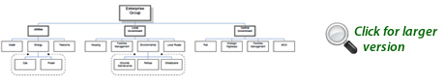
Enterprise has over 40 years’ experience working with its customers, offering a range of asset maintenance and repair services from a single maintenance contract right through to a full supply of bundled services. Enterprise focuses on developing transparent partnerships with its customers. This collaboration allows Enterprise to provide services tailored to their priorities and obligations, which deliver best value and improved efficiency.
Enterprise utility teams provide United Kingdom-wide network repair and replacement to companies such as Severn Trent Water, BT and National Grid. Enterprise provides a wide range of highways maintenance services to local authorities, Transport for London and the Highways Agency. Its services to the public sector include street scene activities; refuse collection, grounds maintenance; and social housing repairs and upgrades. Enterprise also has long-term partnerships with customers such as Liverpool City Council; The Royal Parks; Wolverhampton City Council and several London Boroughs.
Throughout its services, Enterprise is responding to the challenges of reducing its environmental impact, increasing efficiency and providing customer-focused services by innovative thinking and the use of new technology.
The Enterprise service offering has been developed with the aim of providing a single-point of responsibility for a wide range of activities, thereby providing best value to its customers. Enterprise uses leading edge systems and bespoke technology to manage job scheduling, performance measurement and reporting and service and supply chain integration.
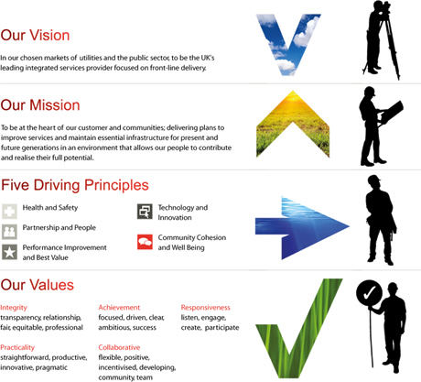

Nature Of Operation And Driving Activities
Enterprise has 13,000 employees; most of whom either drive as part of their work role or in a private capacity. Enterprise recognises that improving driving behaviour at work will improve the safety of its own employees, their families and all other road users.
Enterprise carries out the majority of its works within local communities. It prides itself on working closely with them and its strategic partners. Its aim is to be a considerate workforce. It has a fleet of approximately 5,500 company vehicles and a number of private vehicles which are used for company business. This represents a significant number of Enterprise vehicles being driven on the roads, within local communities, every day.
The Enterprise fleet consists of vehicles ranging from company cars to refuse collection vehicles. Its drivers, therefore, have a variety of patterns of Driving for Work, which include long range motorway driving; dual carriageway and ‘A’ road driving; and short distances within local communities.
Enterprise recognises that all these scenarios carry their own specific risks and challenges for the company, its drivers and the local environment in which they work.
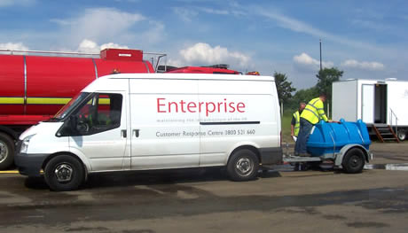

Organisational Structure
Between 2003 and 2007 Enterprise reviewed its policies and personnel system to take in to account guidance provided by the Health and Safety Executive (HSE); the Department for Transport (DfT) and the Institute of Directors (IoD) in regards to the management of work-related road safety in the publications listed below:
- Driving at Work – Managing work related road safety - INDG382 published by HSE and DfT.
- Leading Health and Safety at Work – INDG417 published by HSE and IoD.
Enterprise had long recognised that it had a “Duty of Care” obligation under the Health and Safety at Work etc. Act 1974 and within the Management of Health and Safety at Work Regulations 1999 to manage and control the risks to its employees and others who may be affected by its operations, including those risks described as “Road Risk”.
Enterprise took action to ensure that ‘Road Risk’ was effectively managed within company. In outline, this involved aligning all processes to address work-related road safety within the structure of the company’s existing safety management systems. Enterprise’s Divisional Managing Directors are responsible for ensuring that road risk control measures are effectively implemented throughout their business areas and for taking corrective action when deficiencies are identified. The aim of these measures is to ensure that the ‘Road Risk Policy’ and the associated ‘Road Risk’ control procedures:
- Reduced the number of road-related accidents and incidents that occur within the business each year.
- Reduced the severity of the road related accidents and incidents that occur within the business on an annual basis.
- Improved the safety of Enterprise employees whilst driving on behalf of the Company.
To achieve this, Enterprise was clear that there needed to be a culture of safety shared by all employees and that it should develop and manage its “Road Safety Culture” as an integral part of its overall health and safety management systems. As such this meant that Enterprise would apply similar control measures and commitment to “Road Safety” as it already committed to health and safety in general throughout the business.
The Group Health, Safety, Environment and Quality Director (HSEQ Director) is responsible for the development of the road risk policies and for developing initiatives to assist the Company to reduce their road related accidents and incidents. The executive action is carried out by the Company Health and Safety Manager on his behalf, working in conjunction with the representatives from the following:
- Fleet.
- Transport Compliance.
- Human Resources.
- Training.
- Insurance teams.
- Divisional representatives.
The responsibility of the individual driver is also stressed. Drivers are made aware of their roles and responsibilities through a combination of the following mechanisms:
- The mandatory health and safety induction.
- Safety alerts.
- Target Zero Road Safety briefings
- The updated Driver’s Handbook.
Enterprise recognised the need to look at fleet safety in a more structured and specific way. In 2009 the company introduced a Road Risk Steering Committee (RRSC). The RRSC membership is drawn from among the senior managers in Enterprise’s Health and Safety; Fleet; Transport Compliance; Insurance; and Operations divisions. It is chaired by the Enterprise Health and Safety Manager and directed by the HSEQ Director. As such, RRSC has direct access to the Board of Directors of Enterprise. The RRSC is the decision making body in terms of all driving related policies and procedures.
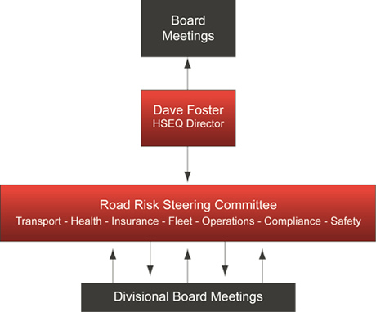

Target Zero
Board of Directors of Enterprise. The Board of Directors of Enterprise set a goal for the company’s health and safety personnel, systems and procedures of eliminating accidents and incidents within the workplace. To achieve this goal, Enterprise launched its Target Zero initiative in June 2003.
Target Zero actively encourages employees to avoid unsafe acts and unsafe conditions - rule breaking and violations - which are the triggers which ultimately give rise to accidents and incidents within the workplace. But it also supports them in achieving this.
Target Zero has been built around encouraging the use of Enterprise’s Health and Safety management systems and the implementation of associated risk control measures. Enterprise recognized that unless it provided its employees with the tools to control the risks associated with its diverse operations effectively, the management would not be able to prevent accidents and incidents. Target Zero therefore covers all aspects of Enterprise’s activities, including driving.
A key objective of Target Zero is to be proactive by preventing accidents and incidents occurring within the workplace, rather than reactive to their occurrence. Enterprise believed that the costs of being proactive would be significantly less that than those of dealing with accidents and incidents once they occurred. In addition, it was better not to have to correct the factors that gave rise to an employee or member of the public being injured and deal with the associated costs of doing this, both from a business point of view and from a publicity perspective.
The Board of Directors of Enterprise launched a Worker Involvement in Safety and Health (WISH) Suggestion Scheme as an integral part of the Target Zero initiative. This took place within all Enterprise offices and depots to enable all employees to provide the company with feedback and to enable them to contribute to the continual development of their company’s health and safety culture.
Since the launch of the initiative, Enterprise has achieved significant reductions in its RIDDOR reportable accidents and incidents whilst continuing to grow the company significantly. Since the introduction of Target Zero, Enterprise’s turnover has grown from £315 million to £1.2billion.
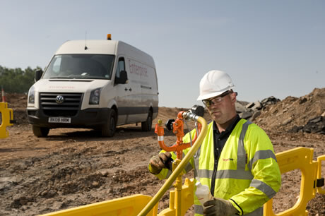

Behavioral Safety Programme
Enterprise introduced a behavioral safety programme in late 2009. This programme contributes towards the company’s culture of safety because it takes a collaborative, engaging approach to changing people’s attitudes and behaviour towards health and safety. It encourages personal ownership of safety standards and raises awareness of the impact that unsafe actions can have on those around.
To embed the importance of this programme within the management and to encourage a ‘safety first’ approach, Enterprise delivered a three day Safety Leadership Course to all managers across Enterprise and a one day Behavioural Safety course for all employees and operatives throughout 2010. Enterprise is also establishing a number of Improvement Groups (IGs) made up of employees at all levels across the Group. The IGs will identify the priority areas that Enterprise needs to address to improve safety in the workplace. These sessions allow employees to contribute their ideas for safety improvements, empower them to challenge safety behaviours and give them the skills and confidence to influence change.

Work Related Road Safety Policy & Procedures
It is very clear to every Enterprise employee who drives a vehicle for work purposes on behalf of the company that they are responsible for their actions and accountable to the Chief Executive through a clearly defined management hierarchy.
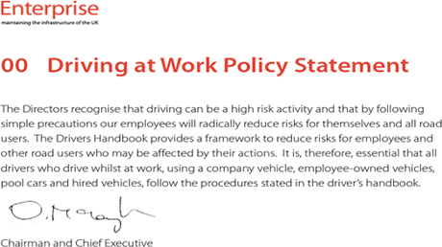
The policies and procedures for Driving for Work are available to every Enterprise employee in the first instance, through the ‘Transport Compliance’ area of the Enterprise Intranet. In addition, they are contained in the Enterprise Driver’s Handbook. Enterprise provides all company vehicle drivers with a copy of this document. In addition, all employees are required to sign a declaration to confirm that they have read and understood the information contained within it. This is mandatory. There are no exceptions. All Enterprise drivers understand that they have made a commitment to comply with all instructions given in the Driver’s Handbook.
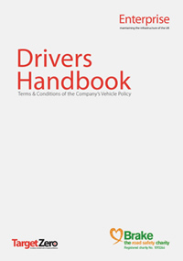The following information is contained in the Driver’s Handbook. The list below is not an exhaustive list and the document is amended regularly:
- Driving at work policy.
- Company responsibilities.
- Driver responsibilities.
- Accident/damage procedure.
- Taking vehicles abroad.
- Driving licences.
- Personal taxation.
- Road fund licence.
- Speeding and parking fines, congestion charging & toll fees.
- Vehicle security and theft.
- Towing and load security.
- Fuel.
- Vehicle maintenance.
- Breakdowns.
- Tyres.
- Windscreens.
- Driver health.
- Drink, drugs and medicines.
- Seat belts.
- Mobile phones.
- Speed limits.
- Weather.
- Tiredness & taking breaks.
- Tachographs/record books and drivers hours rules.
- Private vehicle use.
- Reversing/blind spots/stopping distances.

A Communication Strategy
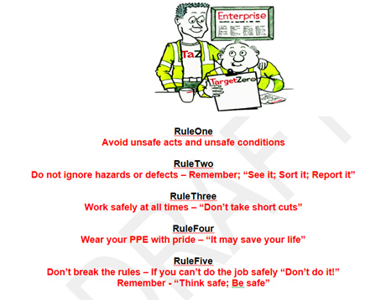
Enterprise has recognised that policies have no substance unless they are communicated effectively to the work force. There is, therefore, a clear communications strategy to ensure that the company’s ethos and culture in regards to safety and driving for work is brought to life. The message is initially put across to all employees through their induction training sessions. Thereafter, mechanisms such as Transport Safety Alerts; Target Zero briefings; poster campaigns and the use of the Enterprise Intranet are used to raise awareness and gain reductions in the numbers of accidents / incidents.

Work Related Road Safety Guidance For Drivers
Driver Induction
Enterprise has a comprehensive Driver Induction programme which is delivered before an employee is allowed to drive as part of their duties. This programme covers company policy on issues such as:
- Using mobile phones and Sat Navs.
- Tailgating.
- Driver fatigue.
- Vehicle checks—vehicle check sheets are filled in daily.
- Traffic lights.
- Cyclists and motorcyclists.
- Driving under the influence.
Drivers of specialist vehicles, also receive specific training related to their roles for instance, reversing assistance. There is also a suite of documents available for guidance which are available on the Enterprise Intranet and in hard copy. These include:
- Driving licence FAQs.
- Driving licence—what can I drive?
- Thinking of towing?
- Tachograph and record books.
- Drivers hours — domestic hours.
- Who needs to wear a seat belt?
- VOSA guides to roadworthiness, ‘O’ licences and tachographs and driver’s hours.
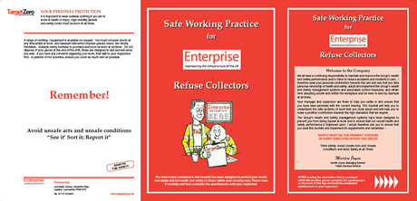

Tool Box Talks
Enterprise focus the content of Tool Box Talks to target issues affecting the company’s performance as well as seasonal issues such as ‘Winter Driving’ and ‘Driving under the influence of Drink and Drugs’. This targeting is based on analysis of the company’s accident statistics. For example, in late 2010 analysis of insurance statistics showed that the company had experienced a disproportionate number of rear-end shunts. The first campaign of 2011 has therefore targeted stopping distances and the five second rule.

Specific Examples Of Procedures
Driver Licence Checks. Enterprise check the driving licences of all its employees who drive for work. This process takes place whether the employee drives a company vehicle or uses their private vehicle for work. It also covers a spouse who is entitled to use a company car. Enterprise contracts IDS to carry out the DVLA checks on six monthly basis if a driver has 6 or more points on their licence or on a 12 monthly basis for a clean licence. The Enterprise Transport Compliance Team regularly review the information produced by these checks and concentrate on the number of points acquired and the underlying causes for them, particularly in terms of behaviour. Enterprise categorises certain types of driving offence as placing a driver in a higher risk category.
In order to ensure that only authorised employees drive its vehicles, Enterprise has extended the use of its driving licence checking regime. The aim is to confirm that an individual driver not only has the correct licence to drive the vehicle he/she is being allocated but that he/she has a current licence. Having completed the required driving licence checks the driver would then be deemed to be an authorised driver.
This process would capture the following: -
- Company Vehicle Drivers.
  - That they have had their driving licence checked within the last 12 months.
  - That they have had their eyesight checked within the last two years.
- Car Drivers who have opted out of the Company Car scheme.
  - That they have had their driving licence checked within the last 12 months.
  - That they have had their eyesight checked within the last two years.
  - That they have a current insurance certificate in place that covers them for driving on business.
  - That they have a current MOT certificate and maintenance records in place for their vehicle.
- Employees using their own vehicles on Company business on a casual basis. Wherever possible Enterprise directs that employees should not be allowed to use their own vehicles on a casual basis for business purposes. The grounds for doing this are that the Company cannot verify at short notice that the employee’s vehicle has been suitably maintained or insured. If it is necessary to use an employee’s vehicle on a casual basis it is necessary to record / capture the following: -
- That they have had their driving licence checked within the last 12 months.
- That they have had their eyesight checked within the last two years.
- That they have a current insurance certificate in place that covers them for driving on business.
- That they have a current MOT certificate and maintenance records in place for their vehicle.
- Agency Drivers. As agency drivers are likely to be at a higher risk of accidents and incidents than permanent employees Enterprise has established a policy that all agencies which provide it with temporary drivers are explicitly required by contract to issue their drivers with a “Driver Permit”. The contracted agency must have conducted the following checks in line with the Recruitment and Employment Confederation requirements:
  - Taken references for the driver from their previous two years employment.
  - Checked and copied the drivers driving licence and associated records and ensured that it is still valid.
  - Carried out written or oral tests to verify the driver’s knowledge of road safety and the highway code.
  - Insisted that the driver completes a form to confirm that they are fit to work.
  - Retained copies of the driver’s qualifications and experience.
  - Matched the provision of drivers to Enterprise’s specific needs
Driver Mandate. All employees are required to sign the Enterprise Driver Mandate form. This also includes individuals who do not drive on behalf of the company. They sign the form and declare themselves as non-drivers. This ensures that Enterprise has a record of everyone who is not officially sanctioned to drive for work, just in case an individual uses their own car for company business without permission. This means that Enterprise can demonstrate that the individual knew that he/she should not be driving for work should an incident occur.
Accident Reporting. All accidents and incidents are reported to the Enterprise Customer Response Centre (CRC). Each incident is given a unique numerical identifier and this is then used in all subsequent investigations and insurance claims. The CRC records all the details relating to the incident and an electronic copy of the report is sent through the management chain. This includes the Line Manager of the Enterprise employee involved in the incident. All near misses, unsafe acts and unsafe conditions are also recorded by the CRC. These are monitored within the management systems to enable issues of concern, especially driver behaviour, to be addressed before an incident occurs.
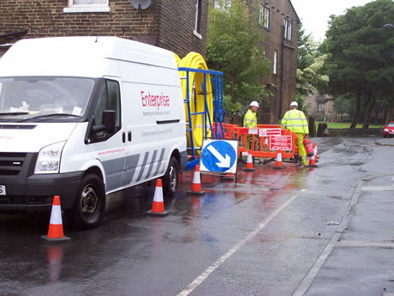

Auditing And Review
Audit – Monitor – Review. Enterprise employs a robust audit and inspection schedule which is conducted at several different levels. To ensure that road risk is being effectively managed throughout the company, compliance with Enterprise policy is audited and reviewed as an extension of its current HSEQ auditing and monitoring regime. Performance against targets is reviewed on an annual basis as a minimum at Group level and on a monthly basis as an integral part of the Divisional HSEQ Review Meetings.
The Health, Safety, Environment and Quality Team conducts regular audits on the operating divisions of Enterprise. These audits consist of systems audits and focussed audits. They include all aspects of driving and also cover the inspection of vehicles on site. The Enterprise audit process has been recognised as being exemplary by the Certification Bodies for the standards held - (OHSAS 18001; ISO9001; and ISO14001) and they have reduced the number of surveillance visits as a result.
The Transport Compliance Team and Depot Managers also undertake random internal inspections to ensure Enterprise complies with all the requirements of its Operating Licences. These include:
- Vehicle checks.
- Drivers hours and regulations.
- Tachographs and record book of drivers hours.
- Driving licences.
- Cleanliness.
- Towing.

Performance Measures
In its first year, the RRSC set a performance target of improving the way vehicle related incidents were recorded. It was clear that many incidents were not being reported to the Customer Response Centre.
A Bump Pack was introduced across the business. This pack was intended to encourage employees to report all incidents and to make it easy for them so to do. In addition, it provides a simple, clear and easy executable check list to assist a driver identify the causes, results; actions and information required to report and record an incident. Supporting the Bump Pack is a process called Line Manager Accident Debrief. This requires a driver to report any incident to their Line Manager as soon as possible and within 24 hours. The Line Manager is to complete an initial debrief with the driver within 2 days. All managers and supervisors are to attend mandatory accident debrief training, which Enterprise has arranged with an external training consultant.
As the result of implementing this policy, Enterprise expected to see a small rise in the Accident Frequency Rate (AFR) but improvements in the way it dealt with incidents. It anticipated, particularly, more time-focussed reporting. End of Year statistics confirmed this assessment.

Accident Reduction
The RRSC has set a target of a 15% reduction in vehicle related incidents across Enterprise’s area of operations. This is to be achieved in a number of ways and each element is designed to be monitored on a monthly basis by using the statistics gathered by the Enterprise insurance team and from analysis of accident reports.
The reduction is going to be achieved by a number of methods including:
- Analysis of incident data—this enables campaigns to be targeted where the most accidents are occurring.
- A series of Tool Box Talks and driver briefings.
- Telematics being fitted to company vehicles.
- More vehicles being fitted with speed limiters.
- All drivers being assessed – this will enable training to be targeted in the specific areas where the highest risk is indicated.
- The accident debrief—driver behaviour is improved when there is a robust system of post-accident interview.
- More stringent monitoring of driver’s hours.
- Increased vehicle related audits and inspections.
- Behavioural safety training—for all employees.
- Improved vehicle procurement procedures—‘fit for purpose’.
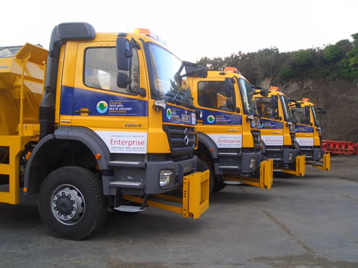

Financial And Other Benefits
Although there has been small increase in AFR anticipated as a result of the introduction of the Bump Pack, Enterprise was able to make financial savings as a result of the way in which it managed and dealt with accidents. The figures at the end of December 2010 show savings of
Cost per Vehicle £101.97 -13%
Overall claims £470,433 -12%
These savings have given Enterprise the opportunity to use the resource to fund some of the improvements in 2011. In addition, Enterprise is working closely with its insurers (Aviva) and its risk brokers (Marsh) with a view to reducing its annual insurance premium on the basis of the way in which it manages its road risk. To improve this relationship, representatives from both companies are invited to the RRSC meetings.

Lessons Learned
In retrospect, Enterprise believes that the most important lesson to be learned from its experience in managing the safety of employees who drive for work, is that it is vital not to look at road safety in isolation from the way the company manages other Health and Safety issues. There must be an holistic approach to safe systems of work and a vehicle must be looked at in the same way as any other workplace. Most companies place a high priority on the Health and Safety of their employees and most will have robust systems and procedures already in place to manage them. It makes sense, therefore, to use this existing framework to develop road safety management systems.
The analysis of accident data has shown that an increase of incidents occurred when Enterprise acquired other areas of business and new staff and vehicles came under its control. It is evident that once a new business comes under Enterprise control, there is need to assess the new drivers, check their licences and the suitability of their vehicles as soon as possible.
Enterprise has recognised that there is an important link between vehicle procurement and Health and Safety performance. It is vital to provide a correct safety specification for the job for which the vehicle is required. Many potential safety issues have arisen because vehicles have not been fit for purpose. The RRSC has representatives from Health and Safety, Fleet and Operations and much progress has been made as the result of discussions on how safety issues affect procurement in this forum.

Current And Future Developments
Gap Analysis of Risk. Enterprise has recently undertaken gap analysis of its road risk procedures which was carried out by an independent expert on behalf of the company’s risk brokers (Marsh). Although the company has received an initial positive verbal feedback, it is currently awaiting the release of the full report. Enterprise’s strategic improvement plan for the next twelve months will be based on the suggestions for improvement contained within this report.
Telematics. Enterprise is close to choosing a telematics system which will be fitted to company vehicles. An agreement has been signed off by the Board of Directors of Enterprise and the process should be completed in the next twelve months.
Driver Risk Rating. Enterprise is embarking on a driver risk rating programme for all of its company drivers which will be associated with a training process for those drivers at most risk. The company is currently reviewing several systems before deciding which one fits their needs.
Partnership. Enterprise has been heavily involved in developing the Freight Transport Association (FTA) Van Excellence Code of Practice. An Enterprise Transport Compliance Manager will be credited in the final version of the document for their input.
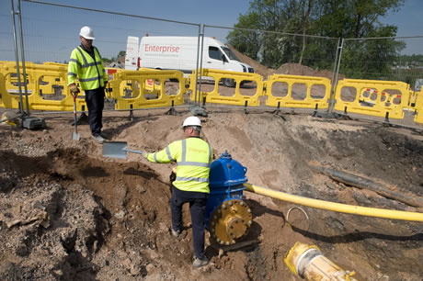

Additional Information
Awards and Accreditations
Royal Society for the Prevention of Accidents (RoSPA). Enterprise has gained RoSPA Awards for the last 14 consecutive years consisting of the following:
• Gold Medal Award - 2006, 2007, 2008, 2009, 2010
• Gold Award - 2001, 2002, 2003, 2004 and 2005
• Silver Award - 1999 and 2000
• Bronze Award - 1997 and 1998
Investors In People (IiP). Enterprise has successfully achieved Investors in People accreditation four years running. This recognises good management practice and a positive approach to team work, learning and development.
Business in the Community (BITC). As part of its further commitment to Corporate Responsibility, Enterprise is a member of Business in the Community (BITC).
Van Excellence. As a member of the Freight Transport Association, Enterprise joined other companies to develop ‘Van Excellence’, a new initiative that aims to raise standards and improve the public’s perception of van drivers. Enterprise is the first company to gain full accreditation to ‘Van Excellence’.
NJUG Communication Award 2010. Enterprise has received two Gold awards for ‘Focus on Customer’ and ‘Corporate Responsibility’ at the recent National Joint Utility Group (NJUG) Awards. Enterprise won the award in the ‘Communications’ category, which represents the importance of keeping the public informed on all aspects of works.
2010 CEMARS. Enterprise has gained accreditation to the Achilles Certified Emissions Measurement and Reduction Scheme (CEMARS) standard for carbon management.
TPAS Accreditation. Enterprise was awarded a Kitemark for Contractor Accreditation by the Tenant Participation Advisory Service (TPAS). It scored highly during the accreditation process, achieving a pass rate of 93% across 69 units used for assessment.
Working Together for Manchester Excellence Award 2010. The Enterprise waste and recycling team in Manchester has been awarded the ‘Working Together for Manchester’ Excellence Award by Manchester City Council for increasing recycling rates in the City.
2010 Sustainability Award. Enterprise's Ministry of Defence (MOD) partnership MODern Housing Solutions (MHS) has been awarded the Sustainable FM "Most Sustainable Private Sector Organisation" award for 2010.
2010 Utilities Considerate Contractors. Enterprise has been named 'Most Consistent Contractor' at the 2010 Utilities Considerate Contractors awards ceremony. This is in addition to two previous Utility Contractor Gold Awards and a Utility Merit Award that have been won during the last five years.
London Excellence Awards 2010. EnterpriseMouchel, Enterprise’s joint venture company with Mouchel plc, has been awarded a prestigious ‘Excellence' Award for Corporate Social Responsibility at the London Excellence Awards 2010.
Considerate Constructors 2010. Staffordshire Highways, Enterprise’s innovative virtual joint venture with Staffordshire County Council, has won a Silver Considerate Constructors Award 2010.
Lancashire Dealmakers Awards 2010.Enterprise has won recognition from the corporate, finance and business community at the North West Business Insider ‘Dealmakers Awards Ceremony’. Enterprise won the ‘Deal of the Year 2010’ award for its acquisition of Bethell Power Services in 2009.
2010 Green Apple Award. Enterprise received this award for its recycled material initiative for its National Grid contract in the North West and West Midlands. For this initiative Enterprise screens, crushes and processes excavated materials to be used as backfill material. It has recycled in excess of 53,000 tonnes so far, significantly reducing its impact on the environment. Enterprise has saved in excess of £1.5M usually incurred by landfill tax.
2010 Environmental Business Award. Enterprise’s innovative virtual joint venture, Staffordshire Highways, received the ‘Environmental Business Award’ at the Sentinel Business Awards. The award recognised the innovative Gully Waste Recycling service that was implemented in 2009. This collects and recycles the waste found in the 160,000 gullies in the area that collect water and sediment waste.
2010 Green Dragon Award. Enterprise’s local roads work on behalf of the Isle of Anglesey Council has been acknowledged at the Wales Business and Sustainability awards. The award recognises the innovative work Enterprise has done relating to reinstatement materials and alternatives such as recycled rubber kerbstones and quarry wastes.
2010 Contractors Health and Safety Scheme (CHAS). Enterprise is CHAS accredited.
SaBRE Certificate of Support. Enterprise has received the SaBRE Certificate of Support in national recognition of Enterprise's commitment to be a supportive employer of the Armed Forces' Reserves.
British Safety Council. Following very extensive professional audits by the British Safety Council, Enterprise has gained the prestigious BSC 5 Star Awards in: 2001 and 2007.

