Case Study - Essex County Council

Profile
Company Name: | Essex County Council
Business Sector: | Local Government
Postal Address: | County Hall, Chelmsford, Essex
Postcode: | CM1 1QH
Fleet Size Overall: | 855
Private vehicles used for business purposes: | Approximately 7,000 grey fleet vehicles

Company Overview
Essex Council Council’s Corporate Leadership Team is made up of the following directorates;
- Chief Executive’s Office
- Adult Social Services
- Adults, Health & Community Wellbeing
- Environment, Sustainability & Highways
- Finance
- Policy, Community Planning & Regeneration
- Schools, Children & Families
- Information Services & Programmes
- People & Transformation
- Customer Services
- Public Health
Essex has 75 Elected Councillors representing, and responsible to, all of the people who live in their division. The County Council’s elected members carry out a number of different roles.
Essex County Council aims to deliver their priorities through three EssexWorks delivery programmes;
- Our People
- Our Economy
- Our World
Every year, as part of the EssexWorks programme, nine pledges are made to the Essex public, one against each priority in each delivery programme.

Organisational Structure
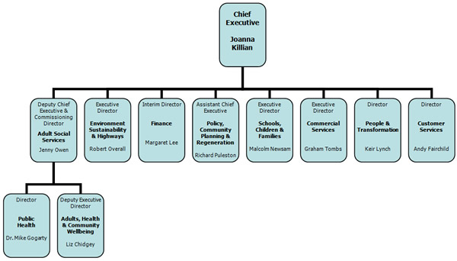
Environment, Sustainability and Highways
Environment, Sustainability and Highways (ESH) is unique in that the services it delivers improve the quality of life of everyone in Essex, everyday. Protecting, managing and shaping the County’s past, present and future, ESH is responsible for delivery of the following EssexWorks and Local Area Agreement outcomes:
- Protecting Essex’s environment
- Reducing and recycling waste
- Improving transport
- Promoting sustainable economic growth
- Providing an emergency planning & business continuity service
The directorate exercises Essex County Council’s statutory responsibilities as waste disposal and highways authorities and delivers statutory functions for traffic management, development control, consumer protection and trading standards. The directorate also provides an emergency planning & business continuity service.
The Executive Director, Robert Overall is responsible for six key services within ESH,
- Environmental Operations
- Finance
- Sustainable Planning and Development
- Highways & Transportation
- Change, Performance Management & Business Services
- Major Programmes & Infrastructure
Cabinet Members for this Directorate
County Councillor Tracey Chapman
Chief Whip and Cabinet Member for Environment and Waste
County Councillor Norman Hume
Cabinet Member for Highways and Transportation
County Councillor John Jowers
Cabinet Member for Planning and Communities
County Councillor Jeremy Lucas
Cabinet Member for Heritage, Culture and the Arts
County Councillor Peter Martin
Leader of the Council
Environment Sustainability & Highways Organisation Structure
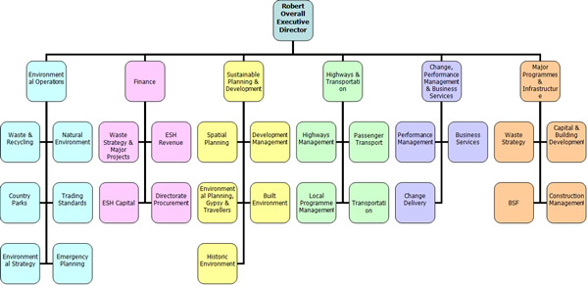

Nature of Operation and Driving Activities
Vehicle categories operated by Essex County Council, schools and the Community transport schemes in partnership with the Council include;
- Heavy Goods Vehicles (HGV)
- Light Goods Vehicles (LGV)
- Car derived vans
- Multi-purpose vehicles
- Passenger carting vehicles
- Large buses and coaches
- Cars
- Plant and Equipment
- Purpose-built vehicles such as mobile libraries
Essex County Council Fleet Operations are responsible for Community Link and Community Transport in Essex.
Community Link provides specialist transportation throughout Essex. The Community Link service was established to maximise the use of Essex County Council’s in-house vehicle fleet and drivers. The fleet is managed to ensure efficient use of the vehicles and also undertakes contracted work to meet specific accessibility needs and supports community transport provision locally.
Community Transport is a non-profit making system of providing a range of transport services for anyone who is unable to access conventional public transport. For some people, who are rurally isolated or unable to access conventional public transport, community transport schemes provide the answer. Community transport is characterised by people working together to solve their own transport needs and are always nearly dependent on voluntary help.
The County Council also has a large grey fleet of employee owned vehicles; these employees drive as part of their duties or drive to locations to deliver services.

Work related Road Safety Policy and Procedures
Essex County Council believes that all its employees have a part to play in contributing to making the organisation a safe and healthy place to work. Every employee is responsible for maintaining their working environment and for following safe working practices.
Policy statements in addition to advice and guidance are available to employees on the following topics;
- Alcohol and Drugs
- Alternative modes of Transport
- Carriage of Passengers/Goods
- Convictions and Penalties
- Driver Assessment and Training
- Eyesight
- Fatigue, Illness and Stress
- Fitness to Drive
- Head Restraints
- Incident Reporting
- Journey Planning
- Licence and Document Checks
- Mobile Phones
- Seatbelts and Child Car Seats
- Speeding
- Vehicle Maintenance and Roadworthiness
- Weather Conditions
Lease Car Provision Scheme – available to those employees who are completing over 4000 business miles per annum or senior management grade. The lease is for 3 years and staff can choose from Peugeot, Vauxhall, Toyota and Lexus vehicles excluding sports versions, convertibles and Jeeps.
It is the policy of the Car Provision Scheme to promote the opportunity of driver training to all users of the Scheme. This is an informal session of theory and practical learning covering defensive driving and tips for increased safety on the roads.
The driver training is offered free of charge to the employee and the aim is to improve the safety of employees whilst driving, whether for business or private mileage. The session is a half-day with one hour ‘classroom’ group of around 5 or 6 people then a time of two to three hours on the road 1:1 with an instructor, who will give a short demonstration drive and the employee driving the remainder of the session, receiving useful tips and advice.
The course covers ‘defensive’ driving, which is basically how to make your own position on the road as safe as possible, regardless of what other drivers are doing, plus anything else the employee would like to concentrate upon. It will also cover any changes in road law and the Highway Code, etc. The session is not a test so you cannot fail, but if you are recommended for further training, the County will pick up the cost of the first session.
Grey Fleet Drivers – a large number of council employees use their own personal vehicle for business purposes. Essex County Council encourages employees to use public transport for journeys where this would prove practical and cost effective.
Drivers who use their personal vehicles for Council business must ensure that their vehicle is insured for business use, has a valid vehicle excise licence (tax disc) and a current MOT certificate (if necessary) as well as servicing and maintenance at the recommended intervals. These documents are required to be shown on a six monthly basis and random spot checks may be made.
All journeys are undertaken with the approval of a line manager who will authorise payment of a claim when submitted. Car parking fees will be reimbursed when necessary. However, any car parking and/or road traffic fines remain the sole responsibility of the individual.
Alternatives – The Essex County Council Staff Travel Plan aims to encourage sustainable travel by offering employees a range of options to consider for commuting and business travel. These options include;
- Teleconferencing facilities
- Borrow a brolley scheme – short term umbrella loan to encourage walking
- A selection of pool bikes are available to use for off-site visits
- Cycle parking is available at most Essex County Council offices
- Interest-free bike loan scheme
- A course of 5 free lessons run by Cycle Training East
- Public transport season ticket loans
- Bus travel - 10% discount on all monthly, quarterly & annual season tickets
- Train travel - 10% discount on all season tickets
- Car sharing scheme with free car sharing parking spaces available
- Short term vehicle hire

Work related Road Safety Guidance for drivers
Work Related Road Safety Guidance is contained within the Essex County Council Advice to Drivers leaflet, supported by further publications and materials on specific areas. These are issued at the induction stage of employment.
Essex County Council has an intranet service in which electronic versions of documents are readily available for staff members to view. In addition to this, posters and leaflets on various topics including drink driving, speed and visibility are displayed in all Council buildings. Updates and important issues are also raised in the council‘s employee magazine – ZEST and when necessary in the employee electronic newsletter – 7 days.
Essex County Council realises that it needs to be proactive when managing the occupational road risk for employees. When a specific risk is identified, the county will run training or group talks/sessions for those who aretargeted by the specific risk. Once the risk has been reduced for this target group then the information will be disseminated to all employees.

Specific examples of procedures
Driver/Vehicle Documentation Checks – This form is to enable line managers to keep a record of annual driver/vehicle documentation checks for staff that they manage. This is required as part of the Council’s Driving Standards Code of Practice. It applies to employees who use their own personal vehicles for company business (grey fleet). It is the responsibility of the line manager to keep this record until another form is completed the following year.
Link to Essex County Council Document Check Sheet
Lease Car Driver Training
Assessment for lease car holders was introduced in 2004 in an aim to reduce insurance claims after concern over the number of lease cars being involved in incidents. Reductions were evident in the claims figures in the following years.
When it was introduced the training was voluntary, restricted to the Essex County Council employee only, and designed to fall in line with the employer’s responsibilities under the Driving Standards Codes of Practice and MORR principles. Today the assessment is compulsory for both the main driver and named drivers such as spouse or offspring who hold a full licence.
The assessment covers Essex County Council policy, and includes general driving information, eco driving and an accident scenario. This is followed by a practical aspect which includes an eyesight test, basic car maintenance and driving assessment/training.
The training is run every two weeks throughout the year with six delegates per course attending.
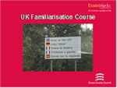
UK Familiarisation Driver Training
UK familiarisation training is very similar to the lease car training but aimed at employees recruited from other countries who are to be provided with lease cars. It is intended to ensure that the driver is able to adapt to driving on British roads and, most importantly is safe to do so.
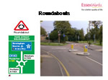
Prior to a practical assessment there is a classroom-based theory session covering British rules of the road, UK traffic legislation, road layouts and signing. If an instructor feels that the driver does not meet the safety standard they are suspended from receiving a lease car until they have had some additional tuition that brings them up to the required standard.
35 Essex County Council employees have attended the UK Familiarisation Course since September 2009.

Auditing and review
Each Directorate has a Health and Safety Co-ordinator. The co-ordinator has overall responsibility for co-ordinating health and safety in the Directorate and representing the Directorate on strategic health and safety issues on the Council’s Health and Safety Steering Group.
The Co-ordinator is responsible for:
- Control
- Co-operation
- Communication
- Competence
- Planning and Implementation
- Monitoring
Highways & Transportation Health and Safety Steering Group - The aim of the Steering Group shall be to support the Senior Management Team on its health and safety strategy and in relation to implementing the Essex County Council Health, Safety and Welfare Policy in the Environment, Sustainability and Highways Directorate.
Essex County Council Fleet Operations - Where a fleet vehicle is owned or leased by Essex County Council, the fleet operations team will ensure that the vehicles are appropriately maintained.
Daily vehicle checks are an important part of any vehicle maintenance arrangements; all identified defects are to be recorded on a “Driver’s Vehicle Defect Report Form”. Those defects that are within the competence of the driver to remedy should be remedied, and a notation made on the defect form on the action taken.
Defect forms are to be forwarded to the Line Manager who will determine whether immediate action is necessary or if the defect can wait until the next routine service visit.
Drivers of fleet vehicles that are owned or leased by Essex County Council are required to ensure that they maintain accurate and concise records for each vehicle they drive covering its daily use. This includes the following documents;
- Driver’s Vehicle Defect Report Form
- Driver’s Daily Vehicle Inspection Report Check List
- Log Book and Mileage Return
- Fuel Receipts
Essex County Council undertakes document checks on all employees that drive vehicles on council business. This includes;
- Driving Licence Checks
- Insurance Document Checks
- MOT (if applicable) Document Checks
- Servicing Records
- Any Driver Training Certification (equipment)
Drivers of Council owned vehicles must undertake a Driving Assessment Test to access their competency in the class or classes of vehicle they are required to drive. This includes full and part-time employees, casual and voluntary drivers.
The Driving Assessment Test is required for the following types of vehicles;
- Heavy Goods Vehicle (HGV)
- Medium sized goods vans
- Passenger-carrying vehicles (8 – 17 seats)
- Car, light van or MPV
- Towing (trailer up to 750kg MAM)
- Towing (trailer 750kg to 3,500kg MAM)
The Driving Assessment Test must be refreshed after four years to ensure consistency of standards; the test lasts for approximately an hour and a half and is performed by a fully qualified driving instructor.

Performance measures
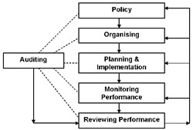
Essex County Council Managers are responsible for ensuring that suitable and sufficient risk assessments are in place for driving activities and that these are adequately communicated to staff.
The Essex County Council Health and Safety Unit audit all service areas and functions. The audit process includes verification of compliance with the council’s policies on managing road risk including ensuring adequate document checking regimes are in place, drivers are appropriately trained and competent, vehicles are managed and serviced appropriately, etc.
The flow chart below shows the key elements of good health and safety management and how they link together. We use this model within Essex County Council to assist us in managing our risks.
Some of the information that Essex County Council monitors includes;
- The number of employees attending driver training
- Total number of accidents per year
- Types of vehicles involved in accidents
- Total cost of accident claims per year
- Yearly insurance premium costs

Accident reduction
Essex County Council has an online reporting system enabling the information regarding the incident to come directly to the Health and Safety Service. The system streamlines the process and enables more accurate statistical information to be produced.
First an incident form will need to be completed. Then as part of the manager's responsibilities, each incident will also need to be investigated. There are a series of pages available on the intranet to assist in the completion of the forms.
Link to Essex County Council Incident form
Link to Essex County Council Investigation template
All Essex County Council staff are required to promptly report all work-related transport and road traffic incidents to their direct line manager, regardless of the type of vehicle they were travelling in.
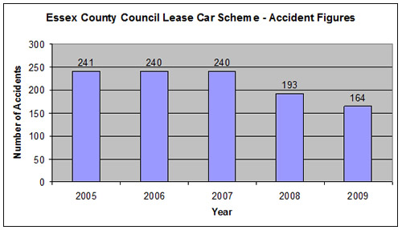
As of January 2010, Essex County Council currently has approximately 580 lease car scheme drivers.
Although the number of lease car accidents has fallen in the past two years - with fewer than 30% of these drivers having accidents – these drivers are an area that Essex County Council will in the future identify to provide further training to in order to continue the reduction of this number.

Financial and other benefits
Essex County Council is continuously working hard to reduce the number of accidents that their employees are having.
Benefits for Essex County Council in managing these risks include;
- Enhanced public image
- Less travelling time
- Increased employee awareness of health and safety issues
- Higher staff morale and motivation
- Lower staff absences
- Overall improved business performance
Please see below a series of graphs that detail the number of claims in the last five years and also our financial information for this time period.
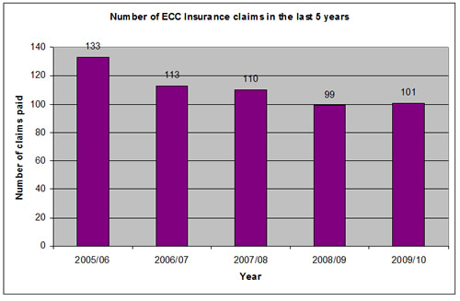
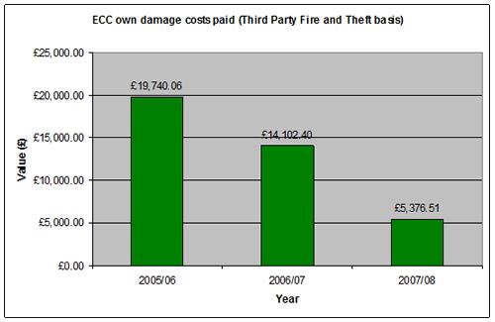
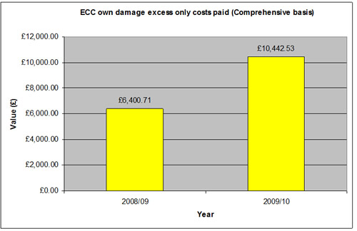
NOTE: Some claims for years 2008/09 & 2009/10 are still outstanding regarding the recovery from the responsible third party and once recovered this will reduce the own damage costs. Claims can take months to settle.
The only noticeable trend in the recent claims is the theft of catalytic converters.

Lessons learned
The Driving Standards Code of Practice was introduced in conjunction with our Health and Safety policy. It had to be introduced at senior management level and cascaded to all managers. These managers then introduced the Driving Standards Code of Practice through the induction process to all Essex County Council employees. This process is difficult to monitor in such a large organisation, the information available to mangers and employees has assisted in this process.
Changing employees’ attitudes to travelling on company business is a difficult task; initial changes made by Essex County Council have resulted in:
- 3% saving in our commercial fleet reduction programme
- 8% reduction in spot/pool hires
- 2% increase in car sharing
- 3% increase in teleconferencing
Essex County Council wishes to improve on these numbers and have set some stringent targets to achieve;
- 15% reduction in car fleet by 2012
- 10% reduction in grey fleet by 2012
- 10 % reduction in commercial fleet by 2015
Managing work-related road safety to its full extent is a mammoth task, which in an ever changing environment takes time, commitment and implementing quick wins, in addition to long-term goals to continue reducing the risks.

Current and future developments
We are currently ensuring that all employees have knowledge and access to the details of our occupational road risk policy and understand the risks associated with driving for work, ensuring that they are easily accessible on the internet system and also available in alternative formats for other employees.
Essex County Council is piloting The Office of Government Commerce’s five-step process to tackle grey fleet. The Council understands that most drivers have undertaken no further driver training, other than that required to pass their driving test.
Essex County Council has just piloted a training workshop specifically targeting those who are under 25 years of age and drive on company business. Research suggests that young drivers overestimate their own driving ability and consequently underestimate risks.
These sessions would be used to highlight issues such as personal driving vs. company driving, employee and employer responsibilities, distractions, prime causes of accidents, journey and time planning, using different vehicles and theory refresher training.
It is anticipated that this workshop will be rolled out as Young Driver/Rider Workshops across the county for local businesses during 2010/11.

Additional information
In October 2009, Essex County Council won the Public Sector Fleet of the Year (500+ vehicles) award at the Green Fleet Awards. This achievement is recognition of the progress Essex County Council has made across a host of areas in reducing business mileage and the environmental impact of our travel. The approach has enabled mileage and emissions reduction through providing alternative, more sustainable travel options to the grey fleet.
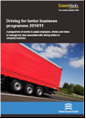
Essex County Council works hard to assist local businesses in managing their occupation road risk, by offering a number of solutions aimed at policy makers, fleet managers, and directors, in additional to offering onsite talks for drivers of vehicles.
These solutions, run across the county include;
- Full day “Driving for Better Business” seminars
- Full day HGV & PSV Operator seminars
- Business Day Events aimed at drivers at company premises
- Two hour workshops on individual WRRR topics
- Targeting young driver/rider business workshops
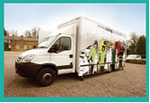
The Essex Casualty Reduction Board (ECRB) comprises a member and / or lead officer from each of the core partner organisations. The core partner organisations currently include:
- Essex County Council
- Essex Police
- Essex County Fire and Rescue Service
- East of England Ambulance Service
- The Highways Agency
The ECRB was implemented in 2007 to tackle the high numbers of killed or seriously casualties on Essex’s roads. Since introducing their casualty reduction strategy which incorporates partnership working in addition to publicity & campaign work, education, engineering measures and the Community Wheels project, a significant reduction in casualties has occurred. The Community Wheels vehicle allows us to visit a host of communities and target audiences to deliver key road safety messages.
For more information on the business initiatives and other road safety messages please visit the Essex Casualty Reduction Board website.

