Case Study - Kier Harlow

Profile
Company Name: | Kier Harlow
Business Sector: | Building maintenance, Construction and Environmental services
Postal Address: | Mead Park Depot, River Way, Harlow, Essex
Postcode: | CM20 2SE
Fleet Size Overall: | 135
HGV: | 8
LGV: | 2
Company Cars: | 8
Private vehicles used for business purposes: | 52

Company Overview
Kier Harlow Ltd became operational on 1 February 2007 and provides repairs & maintenance for:
- Social housing including general repairs and maintenance, work on empty properties, gas and electrical works, surveying and refurbishment works
- Environmental services including street cleansing, landscaping & grounds maintenance, arboriculture, graffiti & fly-tipping removal, pest control and litter clearance
- Planned works who take on larger building and refurbishment contracts that are awarded as appropriate from Harlow council and other clients
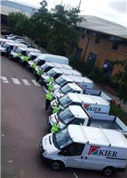
It is a public / private partnership contract with Harlow District Council and has been secured for at least seven years with the council holding a 19.9% share in the company.
The workforce are mainly a TUPE'd workforce, meaning that they have moved over from the council directly for the term of the contract and maintain their same job roles and terms and conditions. We currently have 385 direct employees with approximately 10 agency and 170 subcontractors who work on a wide range of projects.

Nature of Operation and Driving Activities
Kier Harlow has a large number of differing vehicles throughout the business to undertake the wide range of services that we provide.
We have refuse vehicles, tractors, mowers, chippers, fork lift trucks, cherry pickers, street sweepers, graffiti machines and gulley suckers.
A large number of company vans are part of the fleet (over 60). There are also various company vehicles and private vehicles that are used on company business.
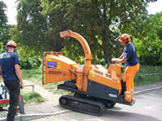
We are required to reach all areas of the town, from major roads, to small estate roads, to cycle paths, play areas and woodland areas to carry out our works. This therefore has significant risk from our driving activities particularly due to our large interaction with the public.
Generally our work is during the daytime, but often includes weekends or nights (for example street sweeping in the town centre) or emergency works (maintenance or tree works) at any time of day.

Organisational Structure
Kier is fully committed to providing a work environment that is safe and healthy for all employees and those affected by our activities and also ensuring the time and resources are available to make this happen.
Health and safety is driven from the top downwards and directors ensure that objectives are set for all employees and subcontractors to achieve a strong H&S culture.
We ensure that the following health and safety reporting structure is in place and that all levels of the business hold and understand their duties under both the law and the Kier management system.
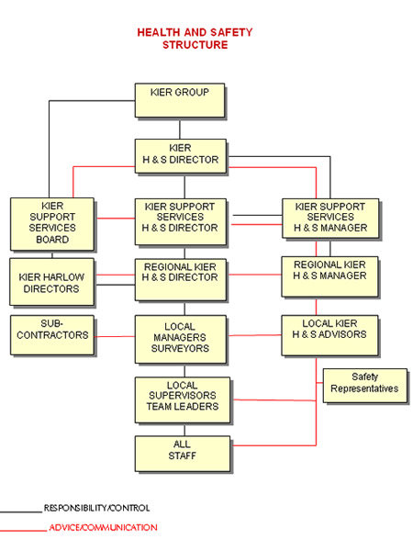
This shows how the H&S team report directly to a board director responsible for H&S, which is present at all levels of the business from Kier group at the top, to the local businesses at the bottom.
Stella Hinson, the regional H&S advisor, works for the Kier building maintenance south region, covering our main businesses in Harlow and Harrow, plus minor works in Stevenage and Broxbourne. Her day to day responsibility is to Kier Harlow and she is assisted in this by Jim Gamble, trainee H&S advisor.
James O'Donnell is the regional director responsible for H&S, who takes overall responsibility for H&S and has a key duty of driving H&S improvements through this business. He takes an active role and is involved in H&S meetings, reviews and inspections and also ensures that H&S is first in all meetings within Kier Harlow.
Road safety is seen by our business as key to our general H&S due to the risk associated with our work on and around the roads, pavements, fields and cycle tracks and therefore is a major point on our H&S strategy and training plan.

Work related Road Safety Policy and Procedures
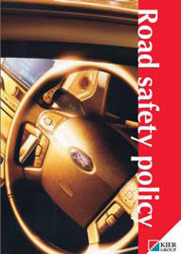
Kier has a road safety policy in place which covers the whole of the Kier business; construction companies, residential building, civic engineering, and support services including building maintenance and Environmental services.
The policy was introduced following various attempts to carry out basic road safety requirements, such as checking driving licences and ensuring suitability of vehicles, which were completed to differing standards in each section of the business. Some results were good, but generally they were disappointing and therefore a full group policy was established to enable clear explanation of requirements for all managers and drivers alike.
This made clear the requirements on our drivers, such as checking their vehicles and ensuring their maintenance. It also covers issues such as parking and the use of mobile phone - which all had been unclear in the past and subject to complaints from the public and the enforcing authorities.
The policy includes sections on:
- Insurance and driving licences
- Authorised drivers
- Towing
- Selecting the correct vehicle
- Ensuring the vehicle is fit for use
- Journeys and planning
- Fitness to drive and Fatigue
- Competent drivers
- Speed limits
- Carriage of dangerous goods and material storage
- Housekeeping
- Manual handling
- Working loads
- Driver responsibilities
- Legal responsibilities and the Highway code
- Mobile phone use
- Training
- Accident/incident reporting
- Breakdown
We also have local procedures which are specific to our business. These discuss issues such as driving in public areas and the dangers of mowing on slopes. These are held either in our local H&S policy or within localised risk assessments and safe systems of work.
Locally we decided to highlight the importance of road safety due to a number of reasons, including discussions with the local road safety team in Harlow who expressed concerns about Kier Harlow vans regularly being stopped and warned about speeding and the use of mobile phones whilst driving.
As a H&S topic the risk was regarded as a high priority - due both to our interaction with the public and the number of road incidents compared to other incidents at work. We had also had a number of incidents leading to time off work.
However improving road safety is also key to our public perception in the town and improving our image in the community.

Work related Road Safety Guidance for Drivers
All the drivers at Kier Harlow have been issued with a copy of the road safety policy. In addition to this we have various methods of relaying information to our drivers including:
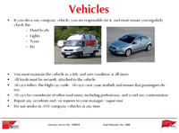
Induction
Information on road safety is included in the H&S inductions for every new starter. This ensures that the basic knowledge is in place and includes information on public protection.
(Photo shows a section from the induction on road safety)
Toolbox talk
We complete regular toolbox talks with our entire workforce. The idea of these is that they are brief (approximately 20 minutes) and relevant to the work and the operatives involved. They are presented on a A3 flipchart making them easily movable to the place of work - bringing the training to the workplace.
The toolbox talks are designed to hold all the relevant information in a very pictorial way and to enable front line supervisors to present this to their staff with only a short briefing beforehand.
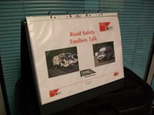
The talk on road safety was designed internally specifically for the needs of our business, backed up with information and statistics provided for us by Essex county council road safety team.
Each and every toolbox talk completed is signed for by both the receiver and the deliverer of the talk. These records are collated and recorded on a spreadsheet, which can be interrogated to report any outstanding talks or the completion dates and therefore when refreshers are required.
Posters
We utilise the posters that are available on the THINK! Website to draw attention to various road safety topics as and when relevant, such as speeding, use of mobile phones and drink driving (which is always issued around Christmas time).
Text messages
The majority of our staff hold mobile phones or PDAs for their jobs, we make use of this in the H&S department by issuing regular text messages with safety reminders, such as about parking or protecting the public.
Intranet
Our road safety information is also all available on our intranet which all Kier employees with a computer have access to.
Demonstration days and events
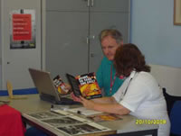
Kier Harlow has worked closely with Essex county council and West Area road safety team to provide further information for our operatives.
European H&S week - we arranged for reaction tests and eye sight tests, plus supporting posters and leaflets to be issued to our operatives and office staff as part of our commitment to European H&S week in 2008. This proved very effective in getting the message across, and also brought some fun to the message.
Community wheels - Essex county council arranged for the 'community wheels' vehicle to visit our depot in Harlow and present powerful presentations to our workforce through videos, interactive maps and personal experiences from the road safety teams, fire brigade and the ambulance service.

Specific examples of procedures
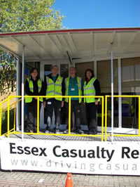
Key areas that we believe we have made major progress in are as follows:
Licence and insurance checks
Although all new starters were asked to bring in copies of their driving licences, this was originally only for those using Kier vehicles, and only checked initially and by the human resources department.
This has now undertaken a major review in line with the road safety policy and Kier group requirements.
This is now controlled via our transport department. They check all driving licences yearly, of every person driving on company business whether in their own vehicle or Kier Harlow vehicle, to ensure that no licences have been withdrawn or other problems. They also check insurances of private vehicles to ensure that they have been insured for company business, which originally a number were found not to be.
Driving competence
As most persons who have a driving licence are also allowed to drive vans, this caused the company some concern as a van handles very differently to a car. We had a number of incidents with damaged wing mirrors and with dents and scratches to the left hand side of vans (caught when turning left where a van handles differently to a car).
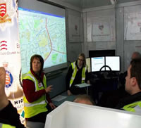
We run a local 'driving test' via our transport assistant in the Kier Harlow yard as a basic awareness test and to highlight a number of common problems. This has proven effective.
Wearing seatbelts
See 'lessons learnt'
Use of mobile phones
Kier Harlow operatives generally have to use their mobile phones on a regular basis, to communicate with both their line management about the jobs they are working on, and to talk to the customer (the residents) about arrival times and delays.
A number of operatives were stopped by the local road safety team and by Kier Harlow management due to using mobile phones whilst driving.
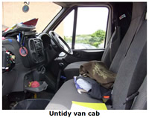
We have really clamped down on this via the education of operatives (and management) and also via the supervisors who phone the operatives, encouraging them to check if the operative is driving before proceeding.
Carrying materials
A safety issue that has traditionally been a problem in our business is carrying materials on roof racks on vehicles. This is due to poor securing of the load or of overloading the racks.
It is also a problem with our environmental policy due to decreasing the streamlining of the vehicles and therefore increasing fuel usage and therefore cost and carbon emissions.
Kier Harlow therefore decided to remove the use of roof rack unless specifically authorised by management. This is also the case with our subcontractors who were proving a problem with overloading and overall a large improvement has been shown.
Housekeeping
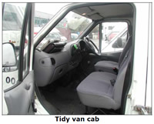
H&S inspections are carried out by all levels of management, from supervisors to Kier board directors.
A part of this inspection is to check housekeeping, both of the work area and of any vehicle that is being used. At the start of the contract in February 2007, the vans generally were very untidy and not looked after.
On day one of the contract all vans were brought into the depot, thoroughly cleaned and marked up with the Kier branding. This was to improve the image of the company and also to give operatives some pride ownership of the vehicle, via everyone knowing who they are and who they are working for.
The vans (and other vehicles) were then regularly monitored via the management team to ensure tidiness, both of the rear and in the drivers cab. The importance of H&S and image was reiterated to those not keeping a clean work space and if improvements were not seen, disciplinary action was taken.
Most vans now inspected are very clean and tidy and operatives generally taking pride of 'their van/vehicle'.

Auditing and review
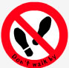
We have a number of ways of auditing or reviewing our road safety policy and procedures including:
- Yearly review of the H&S policy and procedures, including the road safety policy
- 6 monthly H&S audits on each department of Kier Harlow
- Regularly H&S inspections by every member of the management team at Kier Harlow
- Van inspections by supervisors and managers, particularly following problems or complaints
- Weekly vehicle inspections by operatives using each vehicle, from JCBs to vans
- Don't walk by campaign - encouraging all employees and subcontractors to report problems, near misses and unsafe events
- Yearly driving licence checks
- Yearly insurance checks
- Trackers on vans to help reduce the length of time driving
- Themed campaigns - e.g. full audit on seatbelts or parking
Comments from the Trade Union convenor at Kier Harlow;
The Health and safety here at Kier Harlow is second to none. The culture change from Harlow Council was huge, Kier take the health and safety of its workforce very seriously. We have experience a whole feast of positive changes when it comes to Health and Safety.
We have seen changes to vehicle safety in that management monitor seat belt compliance by unscheduled surveillance. We now have trackers in our vehicles so speeds can and are being monitored. We are using the information collated by these trackers to cut down on the amount of miles each operative has to cover to complete their daily work load. Vehicles are inspected on a regular basis to see that they are clean and tidy with no loose articles in cabs. Bad weather alerts are given out when necessary.
High visibility jackets must be worn in the yard and the walk ways have now been marked out along with zebra crossings.
All together we are extremely happy with the improvements to health and safety.
Jimmy Gamble - Union Convener.

Performance measures
Kier Harlow is also working hard on improving the company image through road safety. This is being focused on being courteous to the public and the local community.
We are looking at our complaints procedure to try to reduce the number of complaints due to poor driving, parking or being thoughtless about the local community. We have only just begun collecting the information, but hopefully will be able to show progress here.
For example we have in the past been criticised for some of our drivers parking on blind bends, blocking disabled access ramps, parking on kerbs or for taking over car parking areas because of too many vans parked. These are obviously all situations that we want to avoid and ensure that we have a good perception from the public.

Accident reduction (as result of WRRS measures)
Kier Harlow has managed to drive the general number of accidents within the company down dramatically, due to increased education and safe systems of work. We are also working to achieve the same results with road safety.
We are pleased that we only have a low number of accidents leading to injury due to driving activities anyway, however a consistent number of incidents since the start of the contact has dropped to only one to date this year.
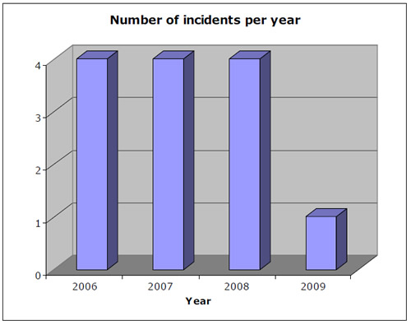
Two of the incidents in previous years have also lead to the injured persons taking significant time off work and therefore this lead to other financial considerations such as; reduced efficiency, increased cost of labour to cover, investigation costs, medical costs etc.
 | Number of incidents | Number of Kier caused incidents
2007 | 60 | 42
2008 | 74 | 59
2009 | 31 | 20
The above shows the number of recorded incidents (that didn't lead to injury) from Kier Harlow vehicles. Again, it is pleasing to see a dramatic reduction this year of 1/3 less incidents to date.

Financial and other benefits (as a result of WRRS measures)
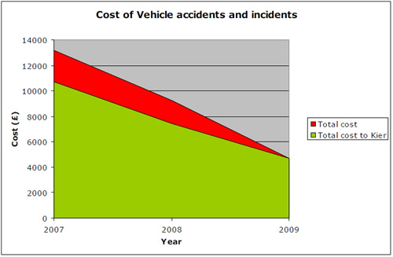
The above graph shows the significant costs to Kier Harlow of our vehicle incidents. We are pleased to see this come down dramatically since our work on road safety started and therefore hopefully this will continue.
A number of the incidents are not due to Kier Harlow operatives (for example break ins or third party causing damage) and therefore this is recorded above, but it must be noted that these costs are not always recovered and reiterates the importance of safe parking and awareness of not leaving anything on display in the vehicle.
A review of the incidents shows that some of the larger bills for repair are from small errors of judgement or distraction, such as reversing into a bollard.

Lessons learned
Once our road safety policy was in place and the key messages had been passed out to our operatives it was noticed that a large number of people were regularly not wearing their seatbelts - in vans and in larger vehicles.
We decided to really clamp down on this and do a number of exercises to try to improve it.
Initially drivers were stopped at the road side coming out of the works depot and questioned to why they weren't wearing their seatbelt and educated on the importance of it. It was quickly found that there was a misperception with a number of our van drivers that seatbelts were not required.
This area of weakness was addressed via our toolbox talks, with specific information on seatbelts, plus information booklets and posters.
There were also a few vehicles, such as street sweepers that were not fitted with seatbelts. After reviewing the regulations it was found that they were not legally required due to the age and type of vehicle, however the senior management team made the decision to fit these retrospectively to make these drivers safer and also to highlight how seriously Kier Harlow takes the wearing of seatbelts.

Current and future developments
Spreading the message
We are currently trying to work closer with our subcontractors - we have approximately 150 individual persons per month and over 160 potential subcontractor companies on our approved list.
There are a number of very small companies (and large companies) on our list who have lower levels of H&S to our own and therefore we are trying to work closer with them to provide information, instruction and training and assist with posters and other facilities where they are required.
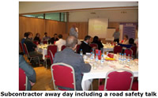
The first part of this process is our 'subcontractor away day' as part of European H&S week, where we are putting together a H&S presentation and supporting information for our subcontractors, alongside some food and a round of golf. A key part of this presentation will be around road safety and simple ways they can make a difference.
Decreasing long journeys
Various members of the Kier Harlow team, particularly senior management, have to undertake a lot of long distance driving to attend meetings at other Kier building maintenance sites.
We see this as a major challenge to overcome and it is one of our next projects. We will be working alongside Kier fleet to improve this and reduce driving distances.
Kier Harlow attempt to carry out conference calls, rather than travel to meetings where possible and staff are reminded about the importance of taking regular breaks, which is a start, however a further review is required.

