Case Study - Kier Islington

Profile
Company Name: | Kier Islington
Business Sector: | Building Maintenance & Construction
Postal Address: | 33-37 Brewery Road, London
Postcode: | N7 9QH
Fleet Size Overall: | 174
HGV: | 0
LGV: | 0
Company Cars: | 2
Private vehicles used for business purposes: | 26

Company Overview
Kier Islington Ltd became operational in 2000 and provides repairs & maintenance and comprehensive building cleaning services for:
- Social housing including reactive works, work on empty properties, gas and electrical works, surveying and refurbishment works
- Building cleaning including to communal buildings such as libraries, town hall and schools across the borough of Islington
- Planned works taking on larger building and refurbishment contracts that are won through competitive tender
- We currently have 429 direct employees with approximately 97 agency and 120 approved subcontractors who work on a wide range of projects.

Nature of Operation and Driving Activities
Kier Islington has a wide variety of vehicles in order to deliver the different services outlined above.
The majority of our vehicles are 'transit-type' vans. There are also various company vehicles and private vehicles that are used on company business.
We are required to access all areas within the London Borough of Islington, from major highways, to small estate service roads. The volume of work we undertake combined with the geographical spread and the density of our locale mean that driving and road-safety related risks must be very carefully managed. Generally our work is during the daytime, but often includes weekends or nights when attending to emergency repairs.

Organisational Structure
Kier Islington is fully committed to providing a work environment that is safe and healthy for all employees and those affected by our activities and also ensuring the time and resources are available to make this happen. Health and safety is driven from the top downwards and directors ensure that objectives are set for all employees and subcontractors to achieve a strong H&S culture. We ensure that the following health and safety reporting structure is in place and that all levels of the business hold and understand their duties under both the law and the Kier management system. This shows how the H&S team report directly to a board director responsible for
H&S, which is present at all levels of the business from Kier Group right through to local businesses.
David Tapper is the regional H&S advisor for Kier Building Maintenance London region, covering our main business in Islington. Reporting to David are Ray Davis, Health and Safety advisor and Judith Bilson, trainee H&S advisor.
Rob Leitch is the regional director with overall responsibility for H&S. Rob plays a key role in implementing, maintaining and strengthening a strong Safety, Health and Environment (SHE) culture throughout the business. He takes an active role and is involved in H&S meetings, reviews and inspections and also ensures that H&S is first in all meetings within Kier Islington.
Road safety is seen by our business as key to our general H&S due to the risk
associated with our work on and around the roads, pavements and housing estates. It is a vital component in our H&S strategy and training plan.

Work related Road Safety Policy and Procedures
Kier has a road safety policy in place which covers all Kier Businesses. The policy was introduced following various attempts to meet out basic road safety requirements, such as checking driving licences and ensuring suitability of vehicles, which were completed in an uncoordinated and ad hoc fashion in each section of the business. Some results were good, but generally they were disappointing and therefore a full group policy was established to enable clear explanation of requirements for all managers and drivers alike. This made clear the requirements on our drivers, such as checking their vehicles and ensuring their maintenance. It also covers issues such as parking and the use of mobile phone - which all had been unclear in the past.
The policy includes sections on:
- Insurance and driving licences
- Authorised drivers
- Towing
- Selecting the correct vehicle
- Ensuring the vehicle is fit for use
- Journeys and planning
- Fitness to drive and Fatigue
- Competent drivers
- Speed limits
- Carriage of dangerous goods and material storage
- Housekeeping
- Manual handling
- Working loads
- Driver responsibilities
- Legal responsibilities and the Highway code
- Mobile phone use
- Training
- Accident/incident reporting
- Breakdown
We also have local procedures which are specific to our business. These detail correct approaches to issues such as driving in public areas and safe and appropriate parking in communal car parks. These are held either in our local H&S policy or within localised risk assessments and safe systems of work. Locally we decided to highlight the importance of road safety due to a number of reasons, including concerns about Kier Islington van drivers being seen using mobile phones. Work related road safety (WRRS) is regarded as a high priority - due both to our interaction with the public and the number of road incidents compared to other incidents at work. Furthermore, improving road safety is also key to our public perception in the borough and improving our image in the community.

Work related Road Safety Guidance for Drivers
All the drivers at Kier Islington have been issued with a copy of the road safety policy. In addition to this we have various methods of relaying information to our drivers including:
Induction
Information on road safety is included in the H&S inductions for every new starter. This ensures that the basic knowledge is in place and includes information on public protection.
Toolbox talks
We complete regular toolbox talks with our entire workforce. Key to ensuring the message gets across is keeping the talks short (max 20 minutes), straightforward and relevant. This is achieved through:
- A3 flipchart presentation for convenience
- Visual aids including, diagrams, photos and examples.
- Road Safety talks designed internally specifically for the needs of our frontline staff who spend much of their working day 'on the road'.
Every toolbox talk completed is signed for by attendees. These records are collated and recorded on a spreadsheet, which can be interrogated to report any outstanding talks or the completion dates and therefore when refreshers are required.
Posters
We utilise the posters that are available on the THINK! Website http://www.dft.gov.uk/think/ to draw attention to various road safety topics as and when relevant, such as speeding, use of mobile phones and drink driving issued in tandem with wider company procedures on drink and drug taking).
Text messages
The majority of our staff hold mobile phones or PDAs for their jobs, we make use of this in the H&S department by issuing regular text messages with safety
reminders, for example about considerate parking and the importance of wearing seatbelts.
Intranet
Our road safety information is also all available on our intranet which all Kier employees with a computer have access to.
Environmental awareness
We provide guidance to all drivers on techniques to minimise the environmental impact of driving. These tips, such as smooth and steady acceleration and braking are also designed to ensure our vehicles are driven in a safe and responsible manner. The eco driving tips are included in the appendix.
Our works order system allows us to designate work to the best placed operative to complete the works order. This is done by tracking the operative using our hand held devices (PDA's) thus avoiding unnecessary travelling to and from each job as orders are placed with the nearest operative. The use of these devices also allows for the individual to log on and off for work each day, again avoiding unnecessary travelling to and from the works depot.
Demonstration days and events
Kier Islington has worked closely with Kier Group and Transport for London road safety team to provide further information for our operatives. For example, cycle proficiency training and a 'Green Mile' incentive scheme have been set up to encourage people to adopt more sustainable forms of travel where this is possible.

Specific examples of procedures
Key areas that we believe we have made major progress in are as follows:
Licence and insurance checks
Although all new starters are asked to bring in copies of their driving licences, this was originally only for those using Kier vehicles, and only checked initially
and by the human resources department. This has now been changed following a major review in line with the road safety policy and Kier Group requirements.
This is now controlled via our transport department. They check all driving licences yearly, of every person driving on company business whether in their own vehicle or a company vehicle, to ensure that no licences have been withdrawn and are still valid. They also check insurances of private vehicles to ensure that they have been insured for company business. This follows company-wide initiatives on this matter.
Use of mobile phones
Kier Islington operatives generally have to use their mobile phones on a regular basis, to communicate with both their line management about the jobs they are
working on, and to talk to customers about arrival times or any delays. We have enforced the message that mobile phones must never be used whilst driving thorugh the education of operatives (and management) and also through the supervisors who phone the operatives, ensuring they check if the operative is driving before proceeding.
Carrying materials
A safety issue that has traditionally been a problem in the industry is carrying materials on roof racks on vehicles. This is due to poor securing of the load or overloading the racks. Overloaded roof racks also negatively affect the fuel consumption of vehicles, with higher costs and poorer environmental results. Kier Islington therefore decided to prohibit the use of roof rack unless specifically authorised by management.
Housekeeping
Kier Islington strongly believes that good housekeeping is the cornerstone of a responsible and effective approach to health and safety. H&S inspections are carried out by all levels of management, from supervisors to Kier board directors. A part of this inspection is to check housekeeping, both of the work area and of any vehicle that is being used.
All vehicles have Kier branding and vehicles are cleaned on a weekly basis in order to present a positive image of the company.
The vans (and other vehicles) are regularly monitored via the management team to ensure tidiness, both in the storage bay and in the drivers cab. The importance of H&S and presenting a clean and tidy image is reiterated to those not keeping a clean work space and if improvements were not seen, disciplinary action is taken.
Most vans now inspected are very clean and tidy and operatives generally take pride in their vehicle. This is positively reinforced through the 'Tidy Van Award' scheme, run once a month where the operative with the tidiest van receives a £25 gift voucher and acknowledgement from the management team.

Auditing and review
We have a number of ways of auditing or reviewing our road safety policy and procedures including:
- Yearly review of the H&S policy and procedures, including the road safety policy
- 6 monthly H&S audits on each department of Kier Islington
- Regularly H&S inspections by every member of the management team at Kier Islington
- Van inspections by supervisors and managers, particularly following problems or complaints
- Weekly vehicle inspections by operatives using each vehicle, copy of form attached
- Don't walk by campaign - encouraging all employees and subcontractors to report problems, near misses and unsafe events
- Yearly driving licence checks
- Yearly insurance checks
- Trackers on vans to monitor and help reduce the length of time driving
- Themed campaigns - e.g. full audit on seatbelts or parking

Performance measures
Environmental impact
We have been measuring and improving the environmental impact of our driving and transport activity for a sustained period, as shown in the two graphs below.
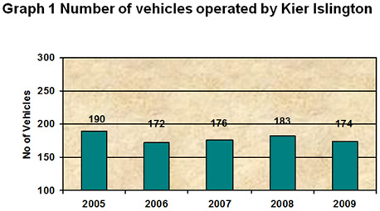
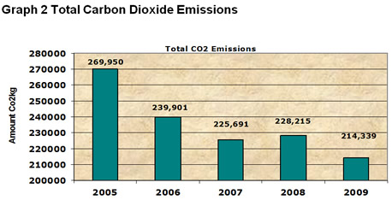
The reduction in our fleet's CO² emissions has been achieved partly through the adoption of LPG and electric vehicles. The changing make-up of our fleet and its 'greening' is detailed in the pie chart below. It can be seen that we have given considered thought as to where we can reduce the carbon footprint of our vehicles. This can be seen through the fact that a wider range of vehicles are now available for use, meaning more fuel efficient vehicles with smaller engines can be used for appropriate travel.
March 2005
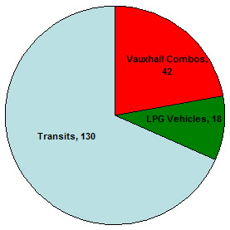
December 2009
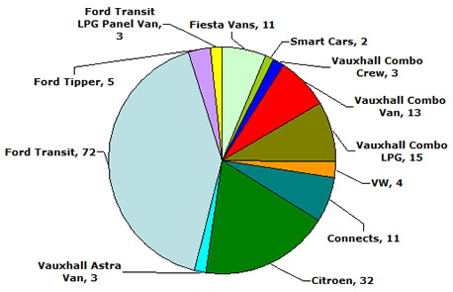

Accident reduction
Kier Islington has managed to drive the general number of accidents within the company down dramatically due to increased education and safe systems of work. For example, all accidents are monitored on an ongoing basis as demonstrated in graph 3 below. We are also working to achieve the same results with road safety.
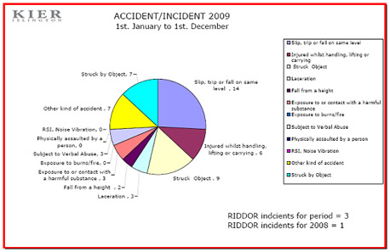
Accidents involving vehicles are detailed in the graph below
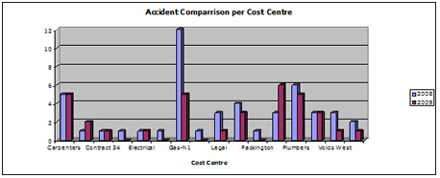
As can be seen, there has been a reduction from 2008 to 2009

Financial and other benefits
On the basis that every recorded accident will cost the company a minimum of £250, the total cost in 2008 was 12,000 (based on 48 accidents). In 2009 the total cost dropped with the reduction in vehicle accidents to £8500. This represents a saving of £3500 due to Work Related Road Safety Measures.

Lessons learned
Through general H&S initiatives, Kier-led Work Related Road Safety campaigns and our involvement in the Driving For Better Business campaign we have been able to reduce vehicle accidents to raise awareness of the importance of road safety. In essence, driving safely and considerate use of our vehicles is now central to who we are and what we do.

Current and future developments
Working with subcontractors/supply chain partners
All Management Instructions, procedures, systems and policies are cascaded to subcontractors by the commercial team.
Decreasing long journeys
Various members of the Kier Islington team, particularly senior management, have to undertake a lot of long distance driving to attend meetings at other Kier building maintenance sites. We see this as a major challenge to overcome and it is one of our next projects. We will be working alongside Kier fleet to improve this and reduce driving distances.
Kier Islington attempt to carry out conference calls, rather than travel to meetings where possible and staff are reminded about the importance of taking regular breaks, which is a start, however a further review is required.
European Health and Safety week 2010 We aim to have a number of WRRS events during European Health and Safety week
Tying the strands
Our aim is to ensure that a holistic approach to the way we use our vehicles is adopted. In this way, we will be able to make improvements that reduce accidents, improve business performance and help the environment.

Merits and Awards
In October 2009 Kier Islington won the Sustainable Transport award at the Giant Green Business Awards hosted by Islington Council and supported by Business link. The award is based on how seriously Kier Islington takes sustainability and the adaptation of our operations whilst taking account the effect of climate change on our business.
In November 2009 Kier Islington also won the "London Archant Business awards". Which stands for the Best Environmental Business of the Year.
See link http://www.london24.com/businessawards/Environmentaldefault.aspx.

