Case study - Mitie

Profile
Company Name: | MITIE Group PLC
Business Sector: | Support Services
Postal Address: | 1 Harlequin Office Park, Fieldfare, Emersons Green, Bristol
Postcode: | BS16 7FN
Fleet Size Overall: | 6398
HGV: | 31
LGV: | 3512
Company Cars: | 2286
Private vehicles used for business purposes: | 600

Company Overview
MITIE: the strategic outsourcing company.
Providing everything from strategic consultancy, to world-class delivery on the ground, our strategic input can add value at the highest level, while our practical management expertise can save our clients money and maximise their returns.
Our people are passionate about what they do, committed to working in partnership with their clients, and will always look for a fresh answer to a new challenge.
We work with our clients in three ways; some take full advantage of our whole range of expertise; others may only need one aspect of what we do:
- strategy and consultancy;
- facilities and project management;
- services.
In other words, we think, we manage, and we deliver.
At MITIE health and safety is a priority for every business and our board and management view the safety of our employees as paramount. Accordingly, fleet risk, as one of our most significant risks has a major focus across all businesses. Looking after our people in whatever work they undertake for MITIE makes good business sense.

Nature of Operation and Driving Activities
Driving activity typically comprises use of a number of vehicle categories. Light commercial vehicles are used to transport our people to and from the workplace. The vehicle will also be used to deliver parts, tooling and materials. Within our security business, a number of LGVs are utilised on a continuous 24 hour basis. Heavy goods vehicles (HGVs) are small in number; predominantly site based and operated under restricted ‘O’ licence rules. The majority of HGVs are mobile generators, with a small number of specialist vehicles such as fire engines and gully emptiers in use. Company vehicles are used in the traditional way. A small number of pool cars are also used. In addition MITIE will arrange provision of a hire car for employees without a company car who occasionally need to undertake business travel.
In summary MITIE has one of the largest fleets in the UK, comprising a 55:45 split in favour of commercial vehicles. As all MITIE services are undertaken on client premises, access to reliable and fit for purpose vehicles, together with a robust fleet risk management programme, is imperative.
Excerpt from the Drivers Handbook:
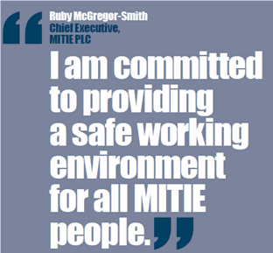

Organisational Structure
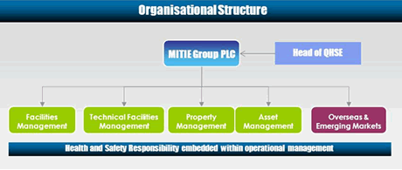
Health and safety is the ultimate responsibility of the Chief Executive, supported by the Executive board. Achieving high standards of health and safety performance is simply seen as a part of good overall management, and this position is established via MITIE’s Quality, Health, Safety & Environmental (QHSE) policy statement, signed by the Chief Executive. To deliver continual improvement in performance, MITIE’s health and safety management system is certified via a third party to the requirements of OHSAS 18001. Such certification provides demonstrable and independent assurance that a robust health and safety management system is in place. Health and safety (including fleet risk) management is the first agenda item at every board meeting, therefore ensuring risks, associated control programmes and performance are reviewed on a formal basis. Divisional and business boards also take this same formalised approach, thus ensuring full visibility on risk management issues with a high level of senior management oversight.

Work Related Road Safety Policy And Procedures
As part of MITIE’s health and safety management system, an overall policy with supporting procedures, guidance documents and handbooks exist. The procedures establish mandatory requirements for MITIE businesses to follow, covering principal risk areas. These areas are established on a formal basis via a risk register, with work related road safety identified as the most significant risk. As such, road safety requirements are established via a formal procedure. As part of our drive for continual improvement in health and safety performance, our fleet risk management procedure was revised and re-launched in March 2010. We consolidated and simplified existing arrangements to provide an overall management standard for all fleet risk management related issues within MITIE. The procedure was compiled by a cross functional team of key stakeholders including Fleet Management, Quality, Health, Safety & Environment (QHSE), Human Resources, Procurement, Insurance and Operations, signed off by the Executive board. The procedure is made available to all employees via our intranet and covers a number of areas, including driving safely, driving licence management, managing cash for car allowances, road traffic accidents, vehicle service and maintenance, managing specialist vehicles (e.g. minibuses, LGVs etc) and safe loading of commercial vehicles.
The main elements of MITIE’s approach to work related road safety management can therefore be summarised as:
- Fleet management
- Operational control
  - Fleet management procedure
  - Driver risk assessment
  - Licence checking
- Training
- Inspection vehicle and licence
- Audit
- Monitoring review of performance

Work Related Road Safety Guidance For Drivers
We recognised that the previous fleet procedure, whilst setting the parameters for fleet management within MITIE, was not a document that could sufficiently engage our diverse employee population. We therefore set out to produce a more readily accessible document, summarising the key aspects of our fleet approach in a way that would engage the target population: MITIE’s 10,000 drivers. In March 2010, we therefore launched our first ever Driver’s handbook, as part of a revised employee welcome pack. The handbook is designed to provide simple, clear and consistent information in easy to understand language. The information within the handbook is supported by a series of related pictures and graphics to highlight specific areas.
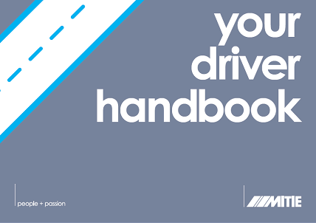
The handbook explains the key requirements for MITIE employees to follow when undertaking one of the highest risk work activities – driving. It sets out the Chief Executive’s expectation and requirements for all employees driving on MITIE business:
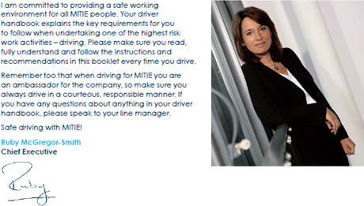
MITIE’s expectations of all drivers are established via the following sections:
(a) Who can drive? This section covers licence provision, health declaration, driver’s declaration and approval by line management. Authorisation from the Insurance department is also required in specific circumstances.
(b) Driving responsibly: reminding the driver to act as an ambassador for MITIE at all times when behind the wheel.
(c) Cash for car allowance: requiring drivers opting out of the company car scheme to follow the same guiding principles as company car drivers, as set out in the fleet management procedure.
(d) Vehicle induction: requiring drivers to be aware of the vehicle they are driving and all of the related vehicle functionality before the journey commences. Specific induction training for certain vehicles is provided.
(d) Maintenance and care of vehicle: stating that the driver is responsible for ensuring the vehicle is maintained in a roadworthy condition whether the vehicle is company or privately owned. Requirements for routine vehicle inspections are set out for the employee and for the line manager.
(e) Servicing of vehicle: servicing is the responsibility of the driver. Specific additional guidance is provided for specific categories of vehicles e.g. 3.5 tonne trucks.
(f) Journey planning: providing requirements for planning the journey, ensuring the need for driving, and driving times are minimised. Use of the telephone, video conferencing and public transport is encouraged. Guidance on driving in adverse weather and on specific road types is provided.
As part of our commitment to improving our drivers’ safe behaviours while driving for both business and pleasure, we have also introduced a business wide driver behaviour workshop in partnership with recognised leaders in this area RoSPA. The workshop has been designed to reinforce MITIE’s commitment to work related road safety and provide safe driving guidance to drivers.
In addition to training and employee handbooks, we regularly communicate with drivers on specific areas of risk such as winter driving and tyre awareness. All information is made available via MITIE’s intranet - MiNet.
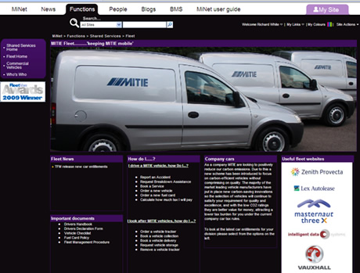

Specific Examples Of Procedures
As above, MITIE has two main documents for fleet management, the fleet management policy and the driver’s handbook. Specific elements of our policy are:
Driver:
- Risk assessment: risk assessment lies at the heart of MITIE’s health and safety programme. Driver risk assessment therefore plays a critical role in identifying driving hazards, prioritisation based on risk profile, and implementation of controls to reduce the risk as far as is reasonably practicable.
- Training and education: training plays an essential role in the management of road related safety. MITIE undertake a variety of training courses to inform, instruct and educate our business drivers. This ranges from basic policy and requirements during induction, through to vehicle specific induction, classroom and in-car driver training.
- Journey planning: the safest car journey is the one that isn’t made. For this reason our policy recommends use if alternatives to face to face meetings where appropriate. However, we also acknowledge that, as a client facing organisation, we need a visible presence. As such our policy provides requirements on journey times, breaks etc.
Vehicle:
- Vehicle selection: our drivers have a choice of cars dependent on their grading. These cars are chosen on a whole life cost basis alongside their environmental credentials and NCAP safety rating, to ensure that our drivers are safe, our environmental impact is managed and the costs to the organisation are in check
- Inspection: routine, planned vehicle inspections are required as an element of our fleet policy.
- Audit: driver safety and fleet management issues are audited as part of the on-going health and safety management system. In addition our Business Risk function will routinely audit fleet risk management for assurance purposes.
MITIE’s risk based approach to fleet management also incorporates the effect of the environment on driver safety. Awareness of the hazards of winter driving and safe behaviour required to reduce the risk of an accident have been addressed via a winter driving campaign for all MITIE drivers, including awareness posters and tool box talks:
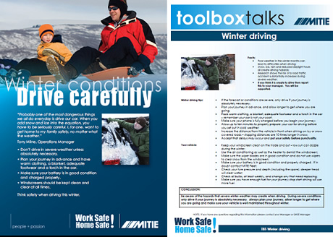

Auditing And Review
MITIE operates a wide ranging audit programme both internally via the business risk and QHSE functions, and externally as part of our certification to the occupational health and safety management standard OHSAS 18001. The business risk and QHSE audit programmes are risk based, targeting resources where they’re most needed. Occupational road risk is the highest risk item on MITIE’s QHSE risk register and, as such, forms a principal part of the audit programme. Results of internal audits are fed up to the relevant management level for review and action planning. Business risk audits are reviewed at Executive and PLC board level. The overall fleet risk management strategy and the results of the fleet risk programme are also communicated to and reviewed by the Executive and PLC boards.

Performance Measures
Key performance indicators for MITIE’s fleet risk management programme include:
- Type of accident – breakdown of incident causation;
- Frequency of accident – ratio of accidents per fleet size;
- Service/maintenance and repair costs per mile;
- ‘Bent metal’ costs per vehicle;
- Third party costs per incident;
- Uninsured loss recovery costs;
- Average time to report an accident;
- Road traffic accidents involving personal injury;
- Near miss reporting;
- Driver licence checking.
The results of the above KPIs are reviewed at the relevant organisational level and function (e.g. Fleet, Insurance, QHSE) to ensure an accurate picture of fleet risk management occurs. KPIs form a major part of the Fleet, Insurance and QHSE board reports, to ensure areas of risk can be readily identified and actioned.
Key to delivering the above results is a close working collaboration and ownership between the relevant functional stakeholders within MITIE (e.g. Fleet, QHSE and Insurance). This close working relationship ensures a clear and consistent fleet risk management programme is delivered in a large, complex organisation. We believe this integrated approach and shared ownership is a fundamental part of MITIE’s success in effective fleet risk management.

Accident Reduction
As a result of this comprehensive fleet risk management programme, we have improved our KPIs relating to incident rates, both in number and severity. Benchmarking is central to understanding where MITIE sits not only among our peer fleet group but also the non-peer group. It is our belief that collision ratios provide an overall measure of the effectiveness of an organisation fleet risk management culture and performance. It is our understanding, based on peer group comparison and feedback from our insurers, that our current accident ratio performance, puts MITIE in the top quartile within our fleet benchmarking peer group. This has been achieved during a period of significant organisational growth, during which the size of the fleet has doubled.
Accident Reporting
All MITIE vehicles are supplied with contact details to our specialist accident management team via a 24-hour phone number, providing an immediate response at all times, 365 days a year in the event of an accident.
We have communicated the importance of reporting accidents as soon as they take place as this has a direct impact on the potential exposure to increased expenditure, especially if a third party is involved.
Accident reporting cards are provided for every driver of a company car or commercial vehicle. The card contains the fleet management providers details, together with information necessary to follow the correct procedure when reporting an accident, requesting breakdown support, booking a service etc. The card also contains an innovative tyre gauge to allow the driver to routinely check tyre tread.
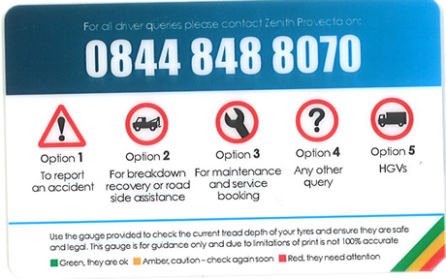

Accident performance
Each month MITIE produces data by division along with historical trend analysis to show incidents logged, time to log an incident, incident fault and detailed breakdown of incident causes to enable to focus the attention within the business on key areas. This data is also linked to detailed cost analysis to further add emphasis on reduce the financial impact of accidents.
Insurance data is managed via a motor claims dashboard. The dashboard contains up to date information on a range of key performance indicators across the whole of MITIE and also broken down by division. This allows effective monitoring of performance and targeted interventions to occur where required. The dashboard is available for interrogation by fleet stakeholders on MITIE’s intranet.
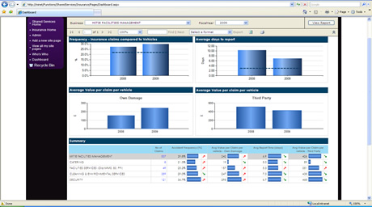

Financial And Other Benefits
As an organisation that puts people at the heart of what we do, MITIE believes the principal benefit of any fleet risk management programme is ensuring our people go home safely from work every day – we call this approach Work Safe Home Safe! It is our intention therefore to deliver a fleet risk management programme that places the safety of our people as the focal point.
We also recognise that a safe driver is a more economical driver through improved fuel consumption and reduced service, maintenance and repair costs. Fuel efficient driving results in fuel savings and reduced CO2 emissions. As a result of new vehicle procurement practices and driver training our fleet related CO2 emissions show a year on year improving trend.
Incident ratio has a direct influence on our insurance premium and we therefore recognise that an improving ratio has a direct financial benefit. We also recognise that the indirect costs of accidents are far greater than the direct costs and as such, our improving performance has direct benefits on our bottom line. We are in the process of developing more effective management information in order to fully assess all costs associated with occupational road risk.
Our online driver licence checking programme was introduced in 2009 through recognition of the inefficiencies and potential risk exposure in manually processing drivers’ licences. By moving to an online system we have significantly reduced the time taken to process driver licence information, freeing up administrative time for use elsewhere in the business. The system has also provided improved transparency and accessibility to circa 8000 driver’s licences allowing prompt intervention where required.
MITIE has recently seen a strong acquisitive growth pattern, resulting in the size of fleet doubling in the last five years. The focus from a fleet perspective has therefore been on integrating multiple new fleets into MITIE’s overall programme, assimilating new businesses into MITIE’s fleet risk management culture and giving the opportunity to recognise existing good practices in acquired businesses. During this phase of growth we have maintained our strong accident ratio performance.

Lessons Learned
During the evolution of MITIE’s fleet risk management programme, a number of important lessons have been learned along the way. The lessons learned are summarised below:
- Support from the top – senior management buy-in is critical for the success of the programme;
- Cross divisional buy-in – engage with operational stakeholders to ensure a consistent approach applies across the organisation;
- Cross functional teamwork – there are many interested parties within an organisation – involve them all;
- Set out a clear and consistent strategy – sort out the priorities early on using data and don’t lose sight of these priorities;
- Peer group benchmarking – compare where you are with peers periodically to act as a sense check that your strategy and programmes are still valid, or in need of adjustment;
- Share best practice – as a result of benchmarking, be prepared to share what you do with others and to receive feedback on your internal programmes;
- Check results of any improvement programme – measure the outcome of what you do, check this performance is on track and adjust where required.
- Be prepared to celebrate success to keep everyone motivated.

Current And Future Developments
In 2010 MITIE established a Fleet Risk Management Steering Group (FRMSG), supported by the Executive board. The committee is cross divisional and cross functional, with members comprising Fleet, QHSE, HR, Insurance and Business Risk, with an Executive board sponsor. Our fleet insurers are also represented. The FRMSG sets strategy for MITIE and develops improvement programmes.
As a result of the FRMSG, MITIE has undertaken a number of initiatives to improve fleet risk management, including:
- On-line licence checking;
- Provision of vehicle accident packs;
- Provision of reversing parking sensors in commercial vehicles – as a result of a review of the top threes causes of incidents;
- Revised fleet management policy;
- New drivers handbook;
- Driver Awareness Workshop;
- Managing occupational road risk workshop;
- Development of a fleet insurance dashboard – comprising easy to visualise current fleet KPIs;
- Process mapping claims reporting – streamlining the process;
- Formal fleet risk management benchmarking;
- Driver risk profiling using a series of data sets.

Future Developments
The immediate future of MITIE’s fleet risk management programme is likely to focus on embedding current initiatives during a time of organisational change. Future initiatives currently under consideration include:
- Driver portal – online access to all driver information;
- Advanced driver profiling;
- Fleet risk management dashboard;
- Improved driver induction;
- Fleet risk audit programme.

