Case Study - Masternaut UK Ltd

Profile
Company Name: | Masternaut UK Ltd
Business Sector: | Mobile Resource Management
Postal Address: | Priory Park, Great North Road, Aberford, LEEDS
Postcode: | LS25 3DF
Fleet Size Overall: | Masternaut provide solutions to in excess of 70,000 vehicles in the United Kingdom.
HGV: | Nil
LGV: | Nil
Company Cars: | Nil
Private vehicles used for business purposes: | Approx 100

Company Overview
Masternaut International is the European market leader in providing Mobile Resource Management solutions to over 120,000 commercial vehicles across 10 European countries. Its European headquarters is based in France, where the parent company of Masternaut International is Hub Telecom, part of the Aéroports de Paris Group. Aéroports de Paris is the 2nd largest airport operator group in Europe, listed on the Euronext Paris stock market and its major shareholder (>50%) is the French state. In 2008, Aéroports de Paris had revenues of €2.5 billion.
Hub Telecom is a specialised telecom operator for airports, ports and logistics centres both in France and across Europe. In 2009, Hub Telecom sales were €120 million. It employs over 550 people.
Masternaut International operates in 9 European countries and Australia. The European countries are:

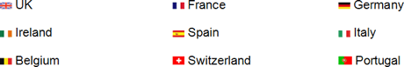
Fig 1 – Masternaut International in Europe

In the United Kingdom, Masternaut provides Global Positioning System (GPS) and General Packet Radio Service (GPRS) based Mobile Resource Management solutions, enabling its clients to manage over 70,000 mobile employees (with over 3,000 clients).
Masternaut leads the field in the development of the telematics sector. It has a wide range of clients from varying business sectors with differing fleet sizes. Clients use different solutions from Masternaut’s portfolio of products and services. Its solutions – recognised as industry ‘best of breed’ – are traditionally delivered on a fully hosted, fully managed web based platform providing precise information through Masternaut’s feature rich and intuitive platform.
Masternaut’s clients in the United Kingdom include many Blue-Chip companies:
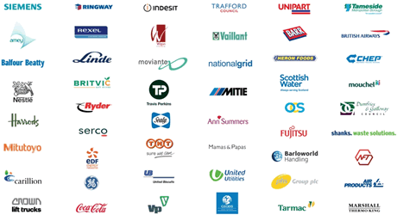
Fig 2 - Masternaut UK Ltd. Customers

The structure of the Aeroports de Paris Group organisation is shown in the Figure below:
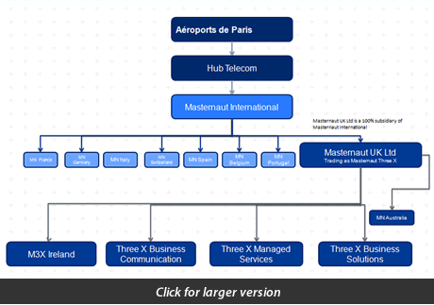
Fig 3 – Aéroports de Paris Group Organisation.

In October 2006, Masternaut UK Ltd (generally known as Masternaut) acquired Three X Mobile Communication Ltd. This company had specialised in delivering robust and reliable mission critical mobile solutions to companies such as Coors Brewery; Coca Cola; ATS Euromaster; and Siemens since 1984.
All Three X Mobile Communication Ltd.’s solutions are based on its proprietary platform and provide core components for store and forward message queuing; integration via a standard Extensible Markup Language (XML) interface; and fast deployment of mobile user applications via simple interface configuration. Its products are then delivered via Microsoft Windows mobile devices.
In February 2008, Masternaut acquired FibreCity Ltd, an on-site data hosting facility. This company had been in the Internet Service Provision and Applications market since it was founded in 1987. This acquisitionenabled Masternaut to provide further hosted back-office solutions which are fully integrated with its telematics and mobile software.
In April 2008, Masternaut made a further acquisition, purchasing ICM Business Solutions, a Microsoft Gold Partner and leading United Kingdom provider of Microsoft business application software. ICM Business Solutions offer a wide range of complementary web-based software mainly focusing on Microsoft Dynamics Customer Relations Management (CRM). Established in 1978, Three X Business Solutions employs a dedicated team with deep industry knowledge including extensive experience of Microsoft’s financial, logistics, e-commerce and CRM solutions sold under the Microsoft Dynamics brand.
Masternaut’s acquisitions have enabled Masternaut International to provide a variety of end-to-end solutions for its customers, all hosted in its own dedicated facilities. Where Masternaut does not have its own best of breed solution to solve a business problem it will integrate other third party products. For example, to enable automated Planning and Scheduling, Masternaut integrates to a range of solutions, including 360 Scheduling for Field Force Automation.
Masternaut is able to offer a full range of fully integrated, end-to-end business solutions providing organisations with a fully managed, future-proof solution which provides full visibility of their field service operations.
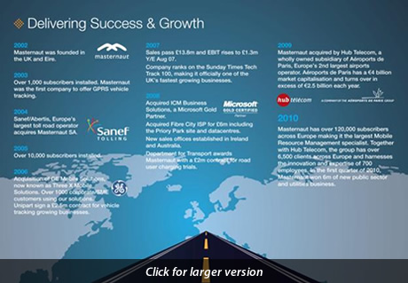
Fig 4 - A Brief History of Masternaut

Nature Of Operation And Driving Activities
Masternaut has a number of field based employees who drive their vehicles on company business throughout the day. In general, all vehicles are owned by the employees with Masternaut providing them a car allowance. Masternaut operates a fleet of approximately 100 vehicles, all of which are fitted with the Masternaut tracking solution which includes its patented, contactless Controller Area Network (CANbus) solution and the Masternaut Communications Centre.
Masternaut’s field based operations are mainly based across the following operational functions:
- Corporate Development.
- Business Development.
- Account Management and Customer Growth.
- Professional Services and Project Management.
- In Vehicle Solutions (Installation Engineers).
In addition to these functions, Masternaut runs an internal “Drive for Life” competition which provides all employees who opt in with a full tracking solution including navigation solution. Masternaut places great emphasis on safe driving and has a number of schemes to promote it. Further details are provided throughout this case study but these schemes include:
- Speed Monitoring.
- Green Scoring for each driver covered in the section on “GreenerFleet” below.
- Peer Monitoring of any speeding through Aberford, where Masternaut’s Headquarters is based.
- Duty of Care Monitoring, including excess speeding, excess journeys and long shifts.
- Mobile Phone use whilst driving.
- Car Sharing schemes through the Masternaut “Virtual Bus”.
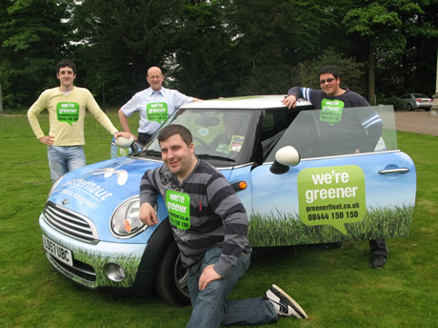
Fig 5 – “GreenerFleet” vehicle.

Organisational Structure
Masternaut currently employs 160 staff members (known as “colleagues”) in the United Kingdom. The Masternaut company structure is shown below:
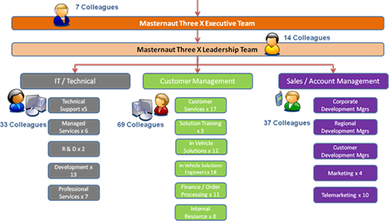
Fig 6 – Masternaut UK Ltd. Organisational Structure

Masternaut has offices in the following locations in the United Kingdom:
- Aberford, Leeds
- Belfast
- Skipton, North Yorkshire
The majority of day-to-day activities are performed at Masternaut’s headquarters in Aberford, Leeds, including all customer support. Its data centre is also based in Leeds. All Masternaut’s software development is based in Skipton, North Yorkshire. Masternaut also has a variety of field based staff across the UK.

Work Related Road Safety Policy & Procedures
Masternaut places great emphasis on safe driving for both its own employees and for each of the 70,000 vehicles it tracks across the United Kingdom. Its solutions provide the ability to use the data generated to promote safe driving. As such, Masternaut uses all its own technology to enable a number of schemes to promote safety whilst driving. These include:
Speed Monitoring. The Masternaut solution contains data (provided by Navteq) relating to all speed restrictions on each of the main roads in the United Kingdom. Masternaut highlights excessive speeding using a variety of methods. A fully integrated feature on the Masternaut ‘GreenerFleet’ website (included with the Masternaut tracking solution) relates to Duty of Care responsibilities. In this new feature, a user can view a graphical image of a driver’s activity and view any speeding infringements. This screen allows users to look at the speeding performance of an individual driver over all journeys for a particular day. The screen uses the latest available information about the exact speed limit for each road travelled, giving greater accuracy than previously possible.
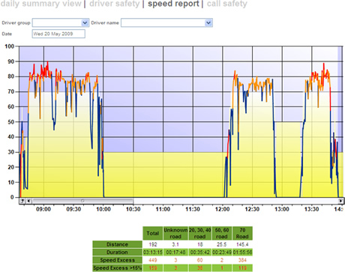
Fig 7 - Masternaut’s Speed Report

Masternaut’s mapping screens allow a user to display the route taken by a driver as a ‘snail trail’. This route can then be interrogated to display a point by point view of the journey, displaying the speed of the vehicle against the current speed limit, with any speeding incidents being displayed as red arrows. The user can then click on the arrow to view the actual speed driven as well as the speed limit for that road.
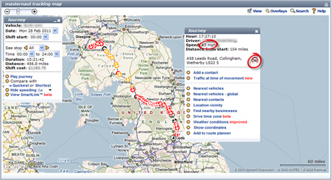
Fig 8 - Example of a route on the map – highlighting excessive speeding

An alert can be configured to send an email, SMS, pop up or RSS alert for any vehicle travelling in excess of a specified speed.
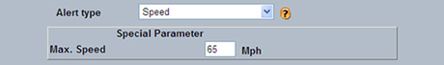
Fig 9 - Excess speed alert set up screen

Masternaut can also provide a full range of exception reports which can be sent directly to a specified in box on a regular basis.
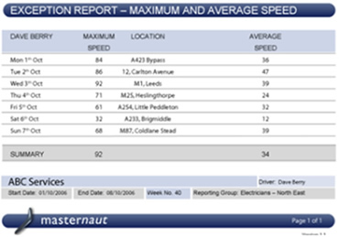
Fig 10 - Example Exception Report – Speeding

Drive for Life Scheme. On 01 Dec 2010, Masternaut began using the “Drive for Life” toolkit to run its own internal competition to recognise and reward the safest and most responsible drivers within the Company. This scheme is available to all Masternaut Customers. As part of the competition, over the next 3 months Masternaut will be looking at its colleagues’ driving habits across a range areas including speeding and engine idling, where fuel is wasted when vehicle engines are left running unnecessarily.
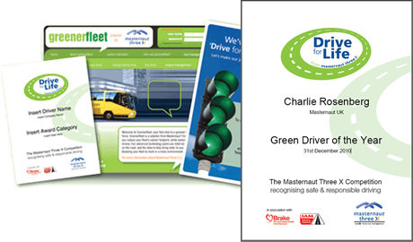
Fig 11 – Sample of “GreenerFleet” and “Drive for Life” promotional material

At the end of the 3 month trial, Masternaut will produce a driver league table to summarise everyone’s performance. The top performer will become a “Drive for Life” winner and will win 2 Masternaut Golden Day’s Leave. Masternaut will also make a donation of £150 to a Yorkshire-based charity of their choice. The competition winner will be the person demonstrating the lowest consistent “Green Score” over the trial period. The scores are calculated on the following three parameters:
- The average vehicle Mile per Gallon - which is based on a default vehicle type mpg if the information is not available. The drivers of fuel inefficient vehicles are therefore penalised at the outset.
- The number of speeding events. Speeding events are calculated when a vehicle speed is above the speed limit of the road driven on.
- Vehicle idling. Idling is measured when a vehicle stays stationary for a period longer than 2 minutes with its engine running.
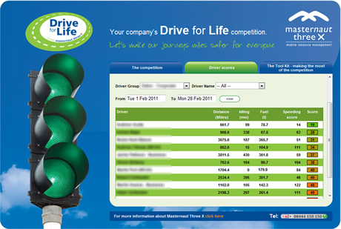
Fig 12 – An example of a Client’s Drive for Life screen.

For more details on the Drive for Life scheme please go to www.masternaut.co.uk/driveforlife/index.aspx
Peer Monitoring of any Speeding through Aberford Village. Masternaut provides an internal social media site known as Masternaut Virtual World that provides information on all colleagues including their job roles and contact details and also provides colleagues with the ability to record thoughts, success stories, birthdays and photos. Within Masternaut Virtual World any vehicle that has been speeding through Aberford is highlighted and colleagues can pass comment on that event – these comments act as a self policing reminder for everyone to ensure the speed limit is met in the village.
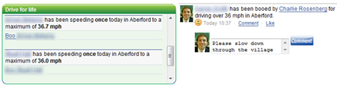
Fig 13 – An example of a Masternaut Virtual World screen.

- Duty of Care Monitoring. Masternaut provides a Duty of Care module, which includes monitoring of excess speeding; excess journeys; and long shifts as part of the solution. This module provides a daily summary which shows how all drivers have performed on a particular day. The standards measured include:
- Excess Shift –the driver has worked for in excess of 10 hours on that day, starting with the first ignition on and ending when the engine is switched off.
- Excess Journey –the driver has driven for more than 2 hours and 15 mins without taking a break.
- Excess speed – this counts the number of times the vehicle has been recorded as exceeding the speed limit on that day.
It is also possible to monitor the number of infringements each driver has committed over the last 30 days. This allows management to see whether the events on this day are a one-off or a part of a repeated pattern.
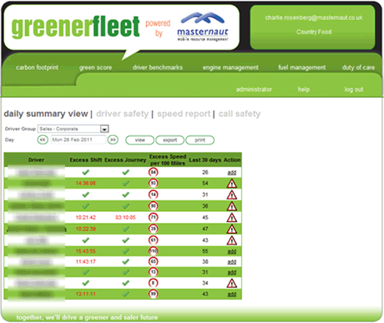
Fig 14 – Duty of Care Daily Summary View
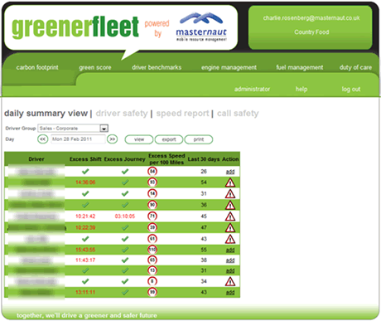
Figure 15 - Duty of Care Detailed Driver Audit

Mobile Phone use whilst Driving. Masternaut is able to import mobile phone bills into the Duty of Care module to monitor any mobile phone use whilst driving. Masternaut management can then view information such as SMS text messages sent whilst driving and focus on cutting this out to ensure continued safety whilst driving.
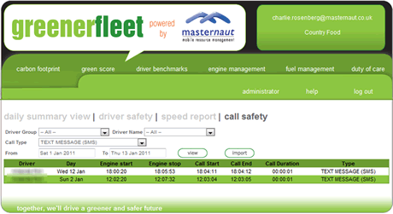
Fig 16 - Duty of Care Detailed Breakdown of Driver Use of Mobile Phone.
Car Sharing schemes through the Masternaut “Virtual Bus”. Masternaut operates a “Virtual Bus” scheme that enables colleagues who live in similar areas to car share on a daily basis. This is a successful scheme with a number of virtual buses in action. Robert Sanders, one of the founding passengers of the scheme has said,
“The virtual bus scheme is fantastic as it reduces my fuel bill from £80 a month down to £40. I also think it’s great for the environment as it helps us as a company to reduce our Carbon Footprint. It has great social impact as it allows me to converse with colleagues who don’t normally sit near me. This gives me an insight into other areas of the company’s operations which I don’t normally deal with.”
Masternaut have a bus commuting from Dewsbury every day and another bus with four passengers coming from Hull – this allows a significant fuel saving for those colleagues. In addition, Masternaut’s “Virtual World” has the ability for colleagues to ‘Report a Sin’ such as not car sharing:
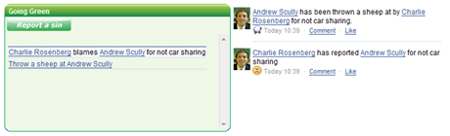
Fig 17 – Masternaut’s Virtual World Comment Page.

Work Related Road Safety Guidance For Drivers
An extract from the Masternaut Transport Arrangement Guidelines which cover the standards expected from staff using their vehicles on the Company’s business is given below:
It has been estimated that up to a third of all road traffic accidents involve somebody who is at work at the time. This may account for over 20 fatalities and 250 serious injuries every week. This means 1000 deaths and 12500 serious injuries per year. The more miles you drive the more you are exposed to hazards on the road. In order to reduce the risks involved in driving, Masternaut have produced the following guidelines for staff and these have been integrated into the current health and safety policy.
These conditions apply to all staff driving company vehicles, hire vehicles or own vehicles used on company business.
- A current license for the class of vehicle driven must be held and produced annually for inspection by the Finance Department.
- The Insurance Certificate for private vehicles used on company business must be produced annually for inspection by the Finance Department.
- An MOT Certificate for private vehicles driven on company business must be produced annually for inspection by the Finance Department.
- Any convictions for driving offences must be disclosed to the Finance Department/HR Manager as soon as practicable following a conviction.
- Vehicles driven on company business must be checked daily for defects to tyres, brakes, steering and lights. Vehicles which do not meet legal standards must not be driven.
- The use of mobile phones is restricted to hands free operation only when driving. The directors of Masternaut do not expect you to answer a hand held mobile telephone whilst driving, this is classed as a disciplinary offence from 1 December 2003. Where hands free vehicle kits are provided and used, it is still necessary to consider safety and not use the device if you are likely to be distracted, arrange to park the vehicle and carry on the conversation whilst parked safely.
- Staff must be able at all times to satisfy the eyesight requirements set out in the Highway Code.
- Staff must not drive, or undertake other duties, while taking a course of medicine that might impair their judgment. In cases of doubt staff should seek the view of their GP.
- You should not drive if you are tired. Be aware of periods when drivers are most likely to feel sleepy, sleep-related accidents are most likely to occur between 2 am and 6 am and between 2 pm and 4 pm. If you are feeling sleepy, stop your vehicle and get some fresh air and rest even if this might upset your schedule.
- Drivers should not feel pressurised to complete journeys where weather conditions are exceptionally difficult.
- Staff must not drive under the influence of alcohol or drugs.
- Staff must observe speed limits at all times.
- If you have worked an exceptionally long day and need to drive a long distance to get home contact your line manager for advice/authorisation for overnight stay.
- Are you satisfied that sufficient time is allowed to complete your journey safely?· Are your schedules realistic? Do journey times take account of road types and condition, and allow for rest breaks? The Highway Code recommends that drivers should take a 15 minute break every two hours, Masternaut endorses that advice.
- Vehicles must be locked when not occupied, high value items should be removed to a secure area when vehicles are parked overnight.”

Specific Examples Of Procedures
An example of the Human Resources staff briefing which Masternaut have provides to its customers to use as a framework briefing document is shown below:
Employee monitoring can cover ongoing monitoring of employees’ use of telephones, fax, e-mail, the Internet and vehicle location monitoring. It is the policy of this company to install Vehicle Location Monitoring to its vehicles to ensure we maximise our efficiency, provide the best possible service to our customers and protect our vehicle assets and employees. It will also provide valuable data to enable us to maximise our carbon footprint strategy.
Vehicles covered:
EMPLOYEE OWNED VEHICLES
Employee own vehicles where a car allowance is paid and business mileage is claimed.
Benefits:
- Where business mileage is paid Inland Revenue P11D information.
- Demonstration purposes.
- Identification of whereabouts.
- Identification of vehicle whereabouts if stolen.
DRAFT STATEMENT
“The Company shall be entitled at its discretion to fit a vehicle location monitoring to any motor vehicle owned by the employee where a car allowance is paid by the Company to the Employee. The Employee agrees the Company may for management and sales demonstration purposes monitor the business and private usage of the vehicle utilising the information provided by that system.”
COMPANY OWNED VEHICLES
Benefits:
- Efficiency and cost management
- Potential reduction in vehicle insurance
- Private usage
- Identification of whereabouts especially if the vehicle is stolen
- Data recording and emergency services where the vehicle is stolen
- Data information including Greener Fleet and CSR
- Accurate data to formulate costs in contract rebid situations.
DRAFT STATEMENT
“The Company shall be entitled at its discretion to fit a satellite tracking system to any motor vehicle provided by the Company to the Employee. The Employee agrees the Company may for management and sales demonstration purposes monitor the business usage and private usage (where appropriate) of the vehicle utilising the information provided by that system.”
COMMUNICATION
It is important to consider the following areas prior to any communication under the Data Protection Act 1998. You must comply with the provisions of the Data Protection Act 1998 when considering monitoring employees. You must also be aware that sensitive personal data may also be collected during employee monitoring, whether intentionally or accidentally. Care should be taken to avoid this if possible.
CODE OF PRACTICE
The Information Commissioner has published a Code of Practice. (The “Employment Practices Code”) which suggests ways in which the requirements of the Data Protection Act can be met.
EMPLOYEE PRIVACY
The Employment Practices Code states as a principle that “employees have legitimate expectations that they can keep their personal lives private and that they are also entitled to a degree of privacy in the work environment”. Any monitoring you undertake should adhere to this principle.
BASIC REQUIREMENTS
The starting point is that it will usually be intrusive to monitor employees, so any adverse impact on employees must be justified by the benefits to the Company.
You should do the following before introducing any form of monitoring:
- make one individual (or a few named individuals) in the Company responsible for authorising all monitoring;
- be clear about what business benefits will be achieved by monitoring;
- ensure that the monitoring you are intending to do is the minimum necessary to achieve your business objectives;
- if possible, put your reasoning in writing (the Information Commissioner calls this an “Impact Assessment”);
- if possible, consult with employees’ representatives or union representatives, before introducing monitoring;
- when the monitoring starts, tell the employees when and why they are being monitored and how the information you collect will be used;
- do not then use the information for any other purpose;
- if disciplinary action may result from the information gathered, make clear to the employees the standards of work/attendance they are expected to achieve;
- if an employee is being disciplined as a result of monitoring, make sure the employee has the opportunity to see the “evidence” before the disciplinary meeting;
- keep to a minimum the people who are authorised to have access to the collected data. Ideally, to avoid personal conflicts, the person who has access to the data should not be the employee’s line manager;
- make sure the people who have access to the personal data are trained and are aware of the confidentiality requirements and their obligations to comply with the Data Protection Act 1998; and you should ensure that you will be able to meet the subject access requirements in the Data Protection Act 1998. This means that you must have an easy way of finding all the personal data which relates to a specific employee, if that employee asks for it (you may charge an administration fee of £10.00 and you have a maximum of 40 days to provide the information after such a request is received).
MONITORING WITHOUT EMPLOYEES’ KNOWLEDGE
The Company will not monitor employees without their knowledge, unless the Company has reason to believe that employees are engaged in criminal activity. In such instances, any monitoring will take place under the guidance of the Police and will be carried out in accordance with the Data Protection Act 1998.
MONITORING WITH EMPLOYEES’ KNOWLEDGE
The Company reserves the right to introduce monitoring from time to time. Before doing so, the Company will:
- identify the purpose for which the monitoring is to be introduced;
- ensure that the type and extent of monitoring is limited to what is necessary to achieve that purpose;
- where possible, consult with affected employees in advance of introducing the monitoring;
- where there is monitoring of private use obtain the employee’s consent; and
- weigh up the benefits the monitoring is expected to achieve against the impact it may have on employees.
The Company will ensure employees are aware of when, why and how monitoring is to take place and the standards they are expected to achieve.
If disciplinary action results from information gathered through monitoring, the employee will be given the opportunity to see or hear the information in advance of the disciplinary meeting and make representations about it. The Company will ensure data collected through monitoring is kept secure, and access is limited to authorised individuals.

Auditing And Review And Performance Measures
Masternaut utilise the Vehicle Tracking solution and its “GreenerFleet” module to monitor performance and review.
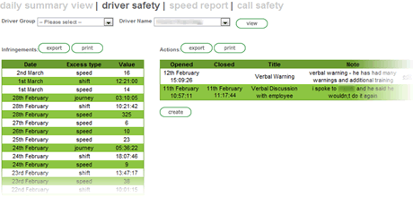
Fig 18 - Detailed Driver Audit

Driver League Tables are produced and used to help evaluate the quarterly “Drive for Life” competition. The solution provides Masternaut with the tools to monitor, audit and review all its drivers. This has been demonstrated throughout this case study by means of the screens shown in the Figures.
Masternaut’s Human Resources team and its Board of Directors use the data generated in the form of league tables to discuss any excessive or continued speeding trends with the Company’s employees. The league tables are used to highlight any areas where any retraining is required. Each Department Manager is responsible for filtering this down to his/her team and, more importantly, for administering any internal discussions or reviews with the individuals involved.
Masternaut uses the ‘Drive for Life’ competition to promote safe and efficient driving performance with a quarterly prize for the best drivers. As the data is being reviewed for this purpose any exceptions to the Company’s standards are highlighted. Staff action can then follow.

Accident Reduction
Masternaut is extremely fortunate in never having had one of its vehicles involved in a serious accident whilst in company time. Masternaut believes that this is as a result of the data generated from its solutions and of the fact that all drivers are able to view information which highlights their speeding and mobile phone use. The information provided helps focus the minds and attitudes of employees when driving for work. It ensures that drivers slow down and drive safely and that they do not use their phones whilst driving. This helps to reduce the risk of accidents.
In addition, all field based drivers have undertaken advanced driver training provided by Drive & Survive.
Extracts showing how Masternaut and its customers use the solutions to reduce accidents follow:
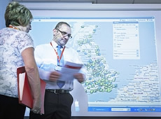Romec drives safety with Masternaut tracking on 1000 service vehicles. Romec, one of the UK's largest facilities management companies, has improved the safety of its mobile workers after equipping 1000 service vehicles with Masternaut satellite tracking. The Masternaut Three X real-time service is part of Romec's health and safety measures for its workforce. It has already reduced speeding by 82 per cent and fines by 26 per cent, with a 28 per cent reduction in road traffic accidents (RTA) involving Romec staff.
"We've installed Masternaut GPS vehicle tracking systems for all engineers. This will work alongside our scheduling software and allow us to provide 24 hour accountability. The impact of the system has been extremely positive in reducing speeding and RTAs involving our people and associated endorsements and fines," says Lee Russell, IS Business Partner, Romec.
The web-based Masternaut service gives Romec's engineering services team a live view of its vehicles and drivers, enabling real-time monitoring of actual progress against work schedules. With the system, managers in the National Service Centre, Stockport, are able to see vehicles travelling to and from customers sites and receive automatic alerts on screen and in real time.
"The National Service Centre protects 500,000 assets throughout the UK and with Masternaut we get a bird's eye view of engineers where ever they may be at any time. The always-on vehicle tracking service not only supports our duty of care policy, it also helps to encourage engineers to drive carefully and consider other road users," says Lee Russell.
Romec is one of few organisations that can deliver a range of facilities services across a national network. By providing services to blue chip clients, the company has built a reputation based on technology enabled performance, reliability and flexibility. Romec provides a complete range of facilities management services - from specialist project management, cutting edge printing and manufacturing through to consultancy, design, installation and maintenance of your building, fire and security systems.

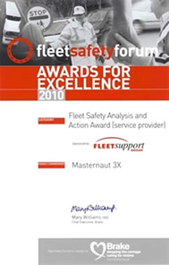Brake recognises Masternaut at prestigious Fleet Safety Forum Awards
Masternaut was highly commended at the recent BRAKE Fleet Safety Forum Awards, a division of road safety charity Brake, which recognises the achievements of those working in the rapidly developing field of road risk management.
Masternaut was highly commended in the Fleet Safety Analysis and Action category, in recognition of its developments around driver safety and Duty of Care. The company's vehicle tracking solution includes unique technology that helps to monitor driver behaviour to improve safety, improve fuel economy and reduce carbon emissions.
Vehicle tracking specialist Masternaut was also behind 'Drive for Life' the world's largest safe driving competition which saw 60,000 drivers compete to be crowned 'the UK's safest driver'. Drivers were monitored over a three month period. The winning driver won £1250 which was matched with a £1250 donation to BRAKE.

Financial And Other Benefits
Masternaut has offered all its employees the opportunity to have a full vehicle tracking solution installed in their vehicles. This solution includes a navigation package. This offer provides both the company and its employees the opportunity to gain financial savings from the use of the solution. The following examples show where employees have made savings:
- Insurance. The Masternaut full vehicle tracking solution is registered by most insurance providers as an accredited after-market tracking device. As a result of having this solution installed, many employees are offered a discount on their insurance. The levels of savings differ for each policy and driver. Some receive a reduction ontheir premiums of up to 14%. An example is a young driver, 21 year-old Viv who works in Masternaut’s finance team and who does no driving for business purposes. She has had a tracking solution installed in her vehicle and has seen a reduction in her insurance premium of £60 a year.
- Fuel Cost Reduction. Spiralling fuel costs have resulted in a need to improve driving styles to reduce fuel consumption. Masternaut are using the data generated from the solution, specifically MPG, speeding and idling to highlight to employees where an improved driving style can vastly improve MPG and, therefore, reduce fuel costs. On average, its field based employees drive approximately 3,000 miles per month. Over the previous three months, Masternaut has seen an improvement across the fleet’s MPG of approximately 10%. This provides a fuel saving in the region of £40-50 per month for each driver. Alex Walker, Head of Masternaut’s Customer Growth Team says, “By regularly reviewing my on-line data I am now more aware of the impact of high speed driving on my MPG, when I see this in black and white it makes me realise the financial and social impact of speeding and as a result I have dramatically changed my driving style and improved my combined MPG from 34.4 to 41”
Masternaut’s customers also have a similar experience and generate financial savings through use of Masternaut’s technology.
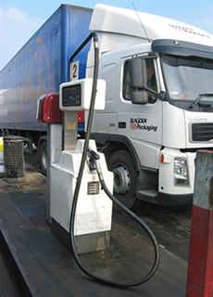Masternaut tracks over 100 million fleet miles saving £4 million of fuel a month
Masternaut is using its web-based vehicle tracking service to track more than 100 million fleet miles each month resulting in major fuel savings for customers. This amounts to £4 million each month and around 750,000 gallons of fuel. The Masternaut service reduces unnecessary fuel consumption through more efficient, safer and eco-friendly driving, saving an average of 10 per cent on fuel use.
"This is clear proof that vehicle tracking is an essential aid to reducing unnecessary fuel use and costs. Through better route planning, improving driving behaviour and removing waste the Masternaut service is slashing the cost of transport for our customers by more than £4 million a month. Few other technologies could claim to have such a positive impact. In addition, the decrease in fleet carbon footprints is good for society in general," says Martin Port, the company's MD.
Two years ago, Masternaut broke new ground with its GreenerFleet environmental management tool for recording and monitoring CO2 emissions and driving behaviour. This unique product is popular with fleet operators as it provides both live and historical information showing vehicle and driver activity. Its wide adoption has led to the company launching and running the world's largest safe driving competition, which was won this year by United Biscuits truck driver David Blake. Road safety charity Brake and IAM Drive & Survive, the professional training division of the Institute of Advanced Motorists, support the competition.
"We are pleased to be at the forefront of reducing fuel costs and helping make our roads safer. Managing a fuel-efficient and safer fleet should not cost operators the earth and Masternaut holds the key to all-round savings. Our real-time technology helps manage speed, braking and idling. For professional drivers it also helps to monitor that they are taking breaks and conforming to the Working Time Directive," says Martin Port.
More 60,000 vehicles in the UK are fitted with Masternaut tracking units. The company specialises in vehicle and asset tracking technologies that help companies manage their assets more efficiently and reduce Carbon emissions. One of its clients United Biscuits managed to cut out three million unnecessary road miles using the system. Other famous clients include Harrods, Nestle, Indesit, DHL, PHS, fellow entrepreneur Duncan Bannatyne and Dragon's Den Winners Igloo Thermologistics.

Current And Future Developments
Masternaut will continue to develop features of the solution to enhance driver safety and fuel and operational efficiencies. An example of a current development which has recently been launched, is the Driver Efficiency Reporting and League Tables process. This identifies driver behaviour as having a huge influence on fuel consumption.
Through improved driving Masternaut’s customers can reduce fuel, save money, whilst being greener and improving their duty of care.
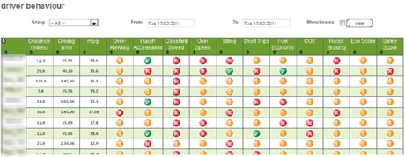
Fig 19 – Example of Driver Efficiency Reporting and League Table
This will provide a debrief style view which can be used to provide an ‘at a glance’ summary view of each driver and can then be drilled down to provide more detail on each driver.

NOTE:
All Screen Shots shown in the Figures in this Case Study are for Demonstration Purposes only.

