Case Study - Michelin Tyre PLC

Profile
Company Name: | Michelin Tyre PLC
Business Sector: | Tyre manufacturer
Postal Address: | Campbell Road Stoke On Trent
Postcode: | ST4 4EY
Fleet Size Overall: | 340
HGV: | 0
LGV: | 110
Company Cars: | 230
Private vehicles used for business purposes: | 100

Company Overview
As a leading worldwide tyre manufacturer, with around 17% market share, Michelin employs 110,252 (full-time equivalents for 2008) highly qualified staff across all continents. The organisation has 68 production sites in 19 countries and a sales network covering 170 countries.
The UK Company, established in London in 1905, today operates three manufacturing sites (Ballymena, Dundee and Stoke), two main warehouses (Basildon and Stoke) and a sales operation (Stoke), with approximately 3,000 employees. Michelin manufactures and sells tyres for most kinds of vehicles, publishes maps and guides and operates a number of digital services.
In the space of a century, Michelin has become the leader in the tyre industry.
Present all over the world, Michelin mainly manufactures tyres, but also products designed to make travelling easier.
As the tyre industry is indisputably linked to the automotive industry, it is essential to study the automotive market to understand the evolution of tyre sales.

Product Lines
An organisation split into product lines, each responsible for their market.
Each Product Line is set up as a "business unit" and thus has all the functions necessary to develop its sales on its markets (marketing, development, production and commercialisation). Certain Product Lines may be subdivided into UOTs (Tactical Operational Units) handling a specific market or geographical zone. There are the following Product Lines:
Each Product Line has its own sales force, but may also use the two Michelin distribution networks: Euromaster in Europe and TCI ( Tire Centers Incorporated) in the United States.

Geographic co-ordination
6 Geographical Zones (ZGs) ensure that the Group Service orientations are deployed consistently in the different regions, provide the means necessary to support the Product Lines and their UOTs and accompany the geographical development of the Group's activities.

A Technology Centre serving the whole Group
The Technology Centre generates and materialises technological innovations by linking the product and process. It makes scientific and technical expertise available to the Tactical Operational Units so that they can optimize responsiveness and profitability. The bases of the Technology Centre are distributed between North America, Europe and Asia.

9 Group Services
9 Group Services ensure that the functional policies inside the Group are consistent. They provide back-up in various fields of expertise.

The Partners and Group Executive Council
Michelin is led by Mr. Michel Rollier, Didier Miraton, Jean-Dominique Senard - backed by the Group Executive Council (CEG) which helps them to define the Company’s strategic orientations.

Environmental Statement
Michelin Tyre Plc recognises that a strong commitment to environmental issues is crucial and also makes good business sense. The Company uses electricity to power its manufacturing process and gas fired boilers to generate steam for vulcanisation. These impact the environment by depleting non-renewable fossil fuels and the combustion emissions lead to global warming.
Since 1998 the Company has reduced its energy use at the Dundee plant by 41 per cent and we currently generate around 25 per cent of our electricity from renewable sources through our wind turbines. The site has a professional environmental team and an energy manager to constantly drive this progress and they are engaged in a variety of energy-efficiency projects including new air compressors, which save up to 20 per cent over previous models, to further improve environmental performance and make a significant reduction in operating costs. We are also investigating possibilities for other renewable energy sources including wind turbines at our truck tyre plant in Ballymena in Northern Ireland.
Michelin is part of the EU- Emissions Trading Scheme, which is a cornerstone in the fight against climate change. It is the first international trading system for CO2 emissions in the world. The aim of the EU ETS is to help EU Member States achieve compliance with their commitments under the Kyoto Protocol. Each phase of this scheme includes a reduction in the CO2 emissions allocations for manufacturing sites, including Dundee. The current phase runs from 2008-2012.
The Company has an ongoing campaign to encourage all employees to spot energy wastage in the form of air/ steam leaks, poor use of light/heat, problems with machinery etc. The new scheme has already identified many (often simple and cheap) ways of improving energy-efficiency.
To monitor its environmental performance the Company uses the Michelin Environmental Footprint (MEF) to measure key environmental impacts of waste generation and recycling, use of water, energy consumption, volatile organic solvent emissions and CO2 emissions. Michelin has made a public commitment to reduce these indicators by 20 per cent between 2005 and 2011.

Challenge Bibendum
Challenge Bibendum was initiated by Michelin in 1998. It is a combined effort by players of the world of the automobile: manufacturers, equipment suppliers, energy providers and research centers. Its goals are to furnish political and economic policy makers, as well as opinion leaders, with objective information on the latest technological progress that will:
- reduce energy consumption of vehicles,
- protect energy supplies for road transportation,
- reduce carbon dioxide emissions,
- reduce local polluting emissions,
- enhance noise abatement,
- lower the number of accidents,
- improve traffic flows,
- adapt vehicles to specific uses.
Challenge Bibendum is a road show that for 5 days reunites more than 3,500 people representing industry, science, politics, administrations, associations and the media in order to provide a forum of exchanges on the challenges and solutions for sustainable road mobility. One of the features of Challenge Bibendum is the organization of rallies and technical tests for automobiles, buses, heavy trucks and city vehicles in order to determine the performance of vehicles equipped with new technologies in real conditions of use.
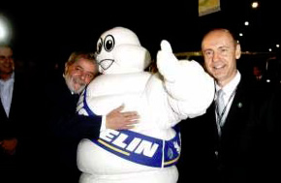The 10th Challenge Bibendum was formally inaugurated on Monday, May 31, 2010 at the Riocentro Convention Center, in the presence of Brazilian President Luiz Inacio Lula da Silva, Michelin Group Management and many local dignitaries, before an audience of some 3,000 people, of whom around 450 were journalists from all over the world.
The 11th edition of Challenge Bibendum will take place from May 18th to May 22nd, 2011 at the former airport Tempelhof in Berlin.
For more information, visit the sustainable road mobility web portal:www.challengebibendum.com

Nature Of Operation And Driving Activities
Cars – The majority of cars are used by our sales personnel to meet our customers all over the UK and Republic of Ireland. All cars are supplied according to need and suitability for purpose. For example, we have estates for staff that require capacity and we run 4x4 vehicles for those staff that regularly have to go off road. All cars meet a Euro N Cap rating of at least four stars with many having five. All cars have to be fitted with steering wheel height and reach adjustment and seat with a lumbar support and height adjustment. We encourage the fitment of cold weather tyres in the winter to assist in grip and safety especially to those cars in the north of the country. Many of our cars currently run two sets of tyres for the winter and summer.
The car fleet covers in the region of 4.7 million business miles per year and this equates to an average of just over 20,000 business miles per year per driver. VW and Audi cars are the main makes purchased with VW Passat and Audi A4 the popular models. CO2 emissions are capped at 120 g/km for account managers (80% of the fleet) and 150 g/km for the rest. Currently the average CO2 for the fleet is 135 g/km. The cars are typically kept for four years or 100k miles before being disposed of.
Vans – The van fleet is used by tyre technicians who supply an on site tyre maintenance service to our bus and commercial customers. This fleet is Vauxhall light commercials leased on a 3yr/60k contract. They are all ply lined and have full height solid bulkheads as they carry tyres, wheels, tools and equipment.
We do have some specialist vehicles that are required for specific tasks. Fire tenders on industrial sites, mini buses for industrial sites and the Michelin Training Centre in Stoke, electric trucks for moving waste on Company sites, a BF Goodrich Land Rover used for promotional purposes, a Porche 997 for track days.
We also run a van that is central to our fill up with air campaigns around the country that was specially built and is fully equipped with generators, compressors and other specialised equipment to deliver this service. The van is manned by a team of technicians who visit many sites throughout the UK to conduct tyre health checks. Supermarkets, motorway services, organisations and individual companies are visited allowing the team to inspect many thousand of tyres and offer expert on site advice to those drivers who may have a problem.

Organisational Structure
The Company is essentially split into two management functions. One deals with the sales and commercial side of the organisation and the other with administration. This is illustrated with the two following organisational charts.
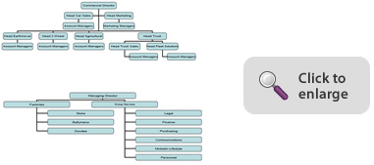
Other functions such as Logistics, Payroll, and Pension are outsourced.
Accountability for occupational road risk is managed by a Road Safety Committee comprising of the Health & Safety Manager, Fleet Manager and a Senior Manager who regularly report directly to the Commercial Director. Day to day management is delegated to line managers.
The Road Safety Committee submit regular KPIs to chart progress to a Company director who is the sponsor of the road safety programme. Other countries within the Michelin Euro Zone are also being targeted with road safety initiatives and these are co-ordinated at our HQ in Clermont Ferrand, France.

Work Related Road Safety Policy & Procedures
Michelin began to seriously review their occupational road risk policy in March 2004 after realising that extremely robust Health & Safety procedures that were common practice on the manufacturing side of the business were not being applied to the commercial side of the business.
We mirrored the company car culture in that the company car was treated like any other tool for the job and was taken very much for granted. Maintenance schedules were adhered to but generally there were other areas where there was no control. Our drivers would allow friends, relatives and even neighbours to drive the cars. Accident reporting was haphazard and there were no driving licence checks, no driver assessment, training, journey planning etc.
Whilst our accident statistics were always below the national fleet average we did experience one serious incident that resulted in our insurance excess being increased dramatically.
The strict health and safety regime we had in manufacturing resulted in an enviable low level of accidents in the UK factories and this culture had to be transferred to those drivers who travelled on Company business.

Work Related Road Safety Guidance For Drivers
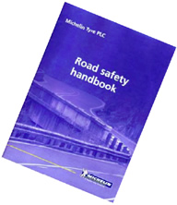A full occupational road risk assessment was completed and a Road Safety Policy document was devised covering all aspects of driving activity. This was introduced to all our company car drivers in January 2007 and is now part of the induction training for any new personnel.
Policies include vehicle issue, driving licence, assessment, fitness to drive, vehicle checking, accidents, journey planning, use of mobile ‘phones, safe speed etc.
Our drivers now know that road safety is of paramount importance to the Company and we view our drivers as a valuable asset. They now have detailed guidelines on a range of driving related activities.
All drivers are risk assessed on-line, have a driving medical including an eye test and have their driving licence checked directly with the DVLA. Follow up training is available to those drivers who are identified as a high risk on their assessments.
Journey planning is one example that derives benefits for the driver and Company. Drivers are encouraged to look at alternatives to driving long distances by utilising on-line conferencing facilities for example, travelling by train instead of the car and lift sharing to meetings. They are actively encouraged to consider overnight accommodation rather than complete a long return journey. As a result of these measures our average annual mileage reduced by 8% comparing 2009 with 2008.
Being a multi-national company we have many foreign visitors and in-pats. There are strict instructions which ban these employees from driving after long haul flights. We always arrange for our visitors to be met at airports and a taxi takes them to their destination.
If we have an in-pat we arrange a UK familiarisation driving course for the employee and their partner. This is a simple and cost effective way of keeping foreign employees safe on UK roads. The feedback we get from this course is excellent.

Specific Examples Of Procedure

Securing Buy-In
It was imperative that the Company management were fully behind our road safety programme and subsequently our application to become a Business Champion. As a responsible Company that takes all of its’ responsibilities seriously it was not difficult obtaining agreement but it cannot be emphasised enough how important this support from the top is.

Leading by Example
It was very important that as soon as we had a mandate from senior management that all managers set an example by demonstrating they had embraced the road safety policies. Training CDs were sent to all mangers with information on how to run briefing sessions with their drivers.

Risk Assessments
All managers have to complete a risk assessment for all their staff. This was a culture change for the commercial side of the business as these procedures were never previously required but are second nature in manufacturing. Whilst many of the drivers would fall into a generic risk assessment there are others who have specific job requirements that mean they would require individual risk assessments completing. To complete this task we had to run training sessions for all managers in how to complete risk assessments.

Mobile Telephones
This is an extremely important subject that we think has a major impact on road safety and is responsible for many crashes and fatalities. It is a particular subject we have taken very seriously from the start and although we had detailed guidelines in our policy document on the use of mobile telephones where we restricted their use to only answering incoming calls, we recently carried out a specific risk assessment of their use whilst driving hands-free and this resulted in our policy on the use of mobiles being changed.
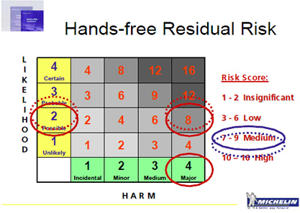
The risk analysis came in at an unacceptably high level and at a level we had no alternative but to take action. All mobile telephony is now prohibited in all company vehicles from the 1st September 2009 and we no longer fit hands-free kits to new vehicles coming onto the fleet.
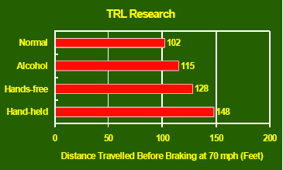
The results of TRL research above put the argument beyond debate. Their findings unequivocally show that the risk of using a hands-free mobile is greater than driving with the legal maximum of alcohol in the bloodstream. As a company we would obviously never condone drinking and driving and therefore it was an easy decision to ban mobile use in our vehicles.
This was a major change to the normal working practices of our drivers and was not without its’ problems as there was a certain amount of negative feedback. At the beginning of October 2009 we asked our drivers to complete a detailed questionnaire covering all aspects of the ban and the effect on their working days. The results were analysed and we found that we had a 62% response indicating that 38% of drivers had no problems. Of the 62% respondents two thirds felt they were experiencing difficulties with their customers but about half of these had found ways of overcoming these difficulties so in fact there were only about 32% of the original responses who felt they had an issue. As a result of the study we identified 63 solutions and ideas that the drivers themselves had suggested to resolve the issues and these were part of a communication exercise sent to all drivers.
We asked Crash Course to come along to our annual conference in December 2009 and give a road safety presentation to our company car drivers on safer driving in general with the emphasis on the dangers of using a mobile whilst driving. Crash Course is a team put together by Staffordshire Fire and Rescue and comprises of a chief fire officer, a police forensic road crash investigator, a victim of a serious road accident and a councillor who has to work with the relatives of the fatally injured. Their objective is educating drivers and promoting a safe driving message using their expertise and knowledge of road crashes, many of them fatal. Their work has had a significant effect on reducing serious road crashes in Staffordshire and they are now communicating their message nationally and indeed internationally. The Crash Course presentation is fairly hard hitting and comes with such gravitas that even the most cynical of company car drivers cannot be failed to be moved to change their bad driving habits. We certainly had excellent feedback as a result of the presentation from our drivers.
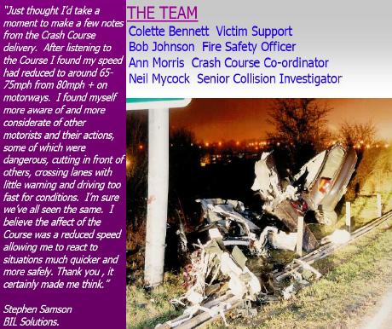
This photograph is quite poignant as the accident and fatality happened on the A500 at Stoke on Trent within a few hundred yards of our main facility and HQ.

Auditing And Review
Our Road Safety Committee meets regularly to discuss current issues and developments. A full review of all procedures was recently carried out and detailed amendments have been instigated. One of the major changes was the argument to ban mobile telephones as described above.
Regular risk assessments by line managers are encouraged and to assist in this all line managers were required to attend specific risk assessment training.
There is now a strong move to integrate road safety policies within the Michelin Eurozone with the UK taking the lead. A European committee of suitably qualified personnel is currently being put together.

Performance Measures
Detailed monthly KPIs are kept to monitor our performance. These cover numbers of risk assessments, driving licence checks, medicals, follow up training and accident stats. The information is collated at MD level and submitted to our group head office in France and serves as a monitor for the UK performance compared to other countries.
These procedures highlight the strong focus on occupational road risk and that the Michelin group now take this aspect of our responsibilities to employees and others affected by our actions very seriously.

Accident Reduction
We have experienced an accident reduction of nearly 52% since 2005.
Managers are now required to investigate all accidents with a view to prevent reoccurrence. This investigation also lifts the profile of these accidents, however minor, with the drivers and re-inforces the message that we are serious about what we are doing.
Although our accident rate for accidents per numbers of fleet is well below the national average we are striving to reduce this figure to a target of zero.
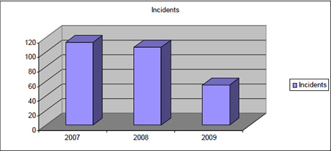

Financial And Other Benefits
Currently the costs of implementing our road safety programme are considerable but the full spend is in the process of being evaluated and it is therefore not possible at this stage to be able to put definitive figures on all the financial benefits.
However, our cost of direct accident damage since 2005 has been reduced by 46% which equates to approximately £30k. It would be fair to say that there has been a considerable saving in indirect costs such as hire cars, drivers time etc.
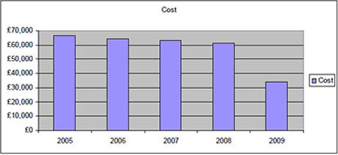

Lessons Learned
It is a difficult process to change the culture, it takes time and results do not come overnight. It is important to get buy-in starting at the top but once this is in place the whole process becomes easier. All managers have to be on board and once this occurs positive results are achievable.
Regular reviews are important and it is essential the steering group have a clear road map of where they are going.
A system of regular road safety communications to drivers is extremely important to keep the momentum going and re-inforce the message that the Company is serious about road safety. Throughout Michelin most meetings have health and safety as an agenda item. There are in-house magazines that are published on a regular basis and these carry some sort of relevant road safety message articles.

Current And Future Developments
We have a our own very professional training school that runs courses for existing staff, new staff and outside companies and organisations. We are looking to recruit an in-house instructor qualified to deliver driver training.
A new fleet management provider is soon to be appointed and we expect far better reporting and better integration with the whole Duty of Care process that will capture full individual information on repairs and maintenance to the vehicle, mileages, risk assessment, and medical and licence check. We shall be in the position of coordinating and capturing all this data for each driver. Points are awarded for any transgressions and limits built into the system trigger certain actions, the more points the more severe the actions with the ultimate sanction of withdrawing the right to drive on company business. Better co-ordination of information will mean that drivers will have to be more accountable and there will be no chance of sliding under the radar.
More audits on vehicle condition.
Roll out of the Road Safety Policy to all employees not just those who drive on Company business.
Going out into the community through our contacts with schools, colleges and business promoting a road safety message.
Detailed review of driver’s annual business mileage with the aim of reducing mileages in general and high milers specifically.
Proper evaluation of automated in vehicle driver coaching with web based applications that can deliver reliable information of real world driving habits. The intention is to be able to target individual drivers with relevant training, demonstrate cost savings by reducing accidents and fuel consumption thereby also reducing our carbon footprint.

Additional Information
Tyres play an essential role in safe road travel. In addition to working on innovations to offer increasingly safe products, we are also raising drivers’ awareness of the importance of correct tyre pressure and, more generally, encouraging motorist behaviour that helps make roads safer.
Since 1985 Michelin has been carrying out ‘Fill up with air’ operations throughout Europe, promoting the importance of regularly monitoring pressures and the general condition of tyres. Regular summer campaigns have taken place in the United Kingdom since 2006. Please find a recent press release about the 2010 campaign :-
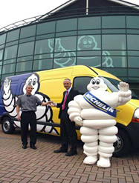2010’s Fill Up With Air roadshow promises to be the biggest ever, and Michelin hopes to use the opportunity to spread the message that UK motorists are throwing away more than ?440 million pounds each year by driving on underinflated tyres. The show is touring the UK and Ireland from May until October, with Michelin campaigning at every stop to raise driver awareness to the fact that incorrect tire pressure can wear tyres out more quickly and increase fuel consumption – the research also unearthed that more than 370 million litres of fuel are being wasted each year, contributing to an additional one million tons of CO2 being pumped into the atmosphere.
“Based on the findings of Michelin’s 2009 campaign, if all of the cars in the UK were running on correctly inflated tyres, motorists would save a considerable amount of money and as a result, CO2 emissions would also be reduced,” said Peter Snelling, head of communications at Michelin UK. “Last year we checked more than 5,000 cars and the results showed that a large percentage of motorists in this country are simply not taking tyre maintenance seriously”.
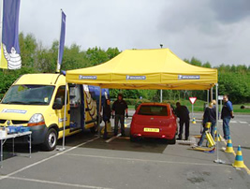This year the Michelin Fill Up With Air campaign is going to be the biggest to date with more than 50 locations included in the tour.
“It really is a matter of life and death and people should learn to check their tyres regularly and thoroughly, which is what we can help them to do,” Snelling concluded.
Another initiative, which works in partnership with a local council is Michelin Junior Bike. This focuses on helping young people learn road rules in a fun way, and encourages them to wear protective helmets at all times when cycling.
As a signatory to both the Global Road Safety Partnership and the European Road Safety Charter, Michelin continues to be committed to road safety issues throughout the world.

Downloads
Michelin Mobile Statement
Road Safety Handbook

