Case Study - Nestlé

Profile
Company Name: | NESTLÉ
Business Sector: | Nutrition, health and wellness
Postal Address: | Nestlé, Avenue Nestlé 55, CH Vevey, Switzerland
Fleet Size Overall: | 30,000+ worldwide (80+ countries) Europe, Asia/Pacific, Americas, Middle East/Africa
HGV: | 2,900
LGV: | 2,000
Company Cars: | 28,500+ (1,300 two wheelers)
Board Member with Responsibility for WRRS: | Mr Andrew Bradley
Position in Company: | Head of Group Risk Services
Tel / Mob: | 0041 21 924 33 34/ 079 308 99 80
Email: | andrew-richard.bradley@nestle.com

COMPANY OVERVIEW
Nestlé is a leading nutrition, health and wellness company, served by 440+ factories, 330,000 employees and upwards of 30,000 company vehicles in 80+ countries.
Nestlé operates upwards of 30,000 vehicles around the globe. The company calculated that in 2004, in Europe alone, it needed to sell 235 million Kit Kats to generate the revenue to finance its motor fleet collision risks. A range of initiatives have since been facilitated, initially through ‘early adopting’ businesses and now expanding globally.

NATURE OF OPERATION AND DRIVING ACTIVITIES
Nestlé vehicle fleet comprises 28,500+ company cars, 1,300+ two wheelers, 2,000+ commercial vehicles and 2,900+ industrial trucks across Europe, Asia/Pacific, the Americas and Middle East/Africa. Nestlé also has many transport and service contractors and sub-contractors, as well as joint ventures, who are all increasingly being engaged in road safety programs as part of their terms of business.

ORGANISATIONAL STRUCTURE
Globally, Nestlé’s business and fleet management strategy is relatively decentralised, with an overall framework for local execution, managed through a continuous excellence methodology. A road safety strategy is being implemented with a strong emphasis on policy, gap analysis, and utilising centrally supported online risk assessment and coaching for local leadership to engage their people.

WORK RELATED ROAD SAFETY POLICY & PROCEDURES
In 2004, Nestlé calculated that in Europe it needed to sell 235 million Kit Kats per annum to generate the revenue to finance its motor fleet insurances. This led to a stakeholder workshop in Switzerland, hosted by Nestlé Group Risk with support from Zurich Insurance, British Telecommunications and Interactive Driving Systems (IDS). The event helped lay the foundations for the programs described, based on the Haddon Matrix framework, which helped shape a 10 point checklist (Figure 1) and the application of Virtual Risk Manager (VRM) as a common and consistent tool with local language and content accessible to all Nestlé businesses globally.
Over the last 10 years, a range of initiatives have been facilitated, starting with some of the company’s most early adopting businesses and then expanding widely across the globe:
- Extent of risks identified from societal, cost, brand, business and reputational perspectives.
- Group Risk has put motor fleet loss prevention procedures, programs and processes ‘on the map’ across the world framed by the 10 point check list as a systems-based approach.
- Global road safety committee and key performance indicators established, chaired by Group Risk, with close collaboration from the Safety Health and Environment (SHE) and Fleet teams.
- VRM identified, and supported, by Group Risk as a program available globally for driver risk assessment, management, monitoring, coaching and improvement.
- Fleet safety toolkit developed for new locations entering the program. Toolkit includes: Fleet safety policy and pledge; 10 point safe driving program checklist (Figure 1); Driver handbook; Culture pack; VRM implementation plan; Safe vehicle selection policy; Nestlé case studies; Contractor standards and gap analysis for truck, bus and other service providers.
The checklist provides a framework/policy and a standard to undertake gap analysis against. This has been undertaken internally and in collaboration with Zurich.
Development of a mandatory standard on safe driving, applicable throughout the company.
Increasing internal collaboration between Risk, Fleet, SHE, HR and Procurement business functions.
Wherever possible, work closely with suppliers for vehicles to meet minimum safety standards, including: Euro NCAP 5* (or local equivalent where available), front air bags, anti-lock braking, electronic stability control, head restraints, seatbelts, fog lights, luggage restraints and air conditioning.
In-country stakeholders engaged to focus attention on road risk management.
Road safety increasingly being built into procurement standards for contractors, sub-contractors, joint-venture partners and other vendors.
Increasing focus on emerging markets with evolving road safety standards.
Inclusion of employee family members through online coaching, games and competitions in a range of business units including Nestlé Waters across Europe, the Nespresso factory in Switzerland, distribution services in the USA and Gerber Baby Products
Summary by risk factor from the 10 point checklist | Compliance
Policy, Objectives and Targets (KPIs) | 82%
Risk Assessment | 78%
Legal Compliance and Other Requirements | 90%
Communication | 83%
Mobility and Journey Management | 77%
Driver Recruitment, Selection, Induction and Training | 72%
Driver Management, Driver Work Instructions & Contract Driver Procedures | 75%
Driver Health and Wellness | 70%
Vehicle Selection, Management, Use and Eco Driving | 78%
Specific Risks | 73%
Overall | 78%
Figure 1 – 10 point safe driving programme checklist
In the UK and Ireland the Virtual Risk Manager (VRM) launch has engaged almost 4,000 people in road safety across 25 diverse sites and business areas, including truck, company car, cash for car and occasional drivers. The program has focused on engagement and risk visibility across a diverse and decentralised workforce. As well as following the model shown in Figure 2 the program has also focused on identifying all exposure levels, on utilising government driver licence records for compliance and risk management, and integrating collision and face to face training records into the system. All drivers are being coached using online materials covering topics such as Attitude, Speed and Bad Weather in the run up to winter. The most at-risk drivers are also being engaged based on their exposure levels, risk assessment outcomes, collisions and any penalty points showing on their licence. Management training is being piloted and undertaken to allow first line managers to engage with their teams.
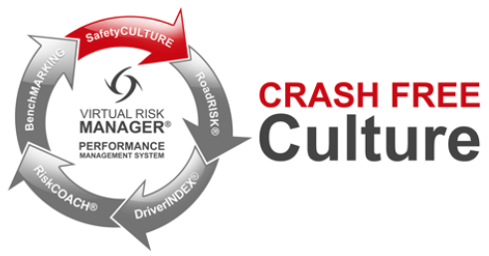
Figure 2 – The VRM ‘crash free culture’ process

SPECIFIC EXAMPLES OF PROCEDURES
Wherever VRM is used, Nestlé uses online tools, and the management information capture that they allow, reinforcing policy.
In particular, Phase 1 of VRM (Figure 2) focuses on organisational culture by engaging each driver to complete an online Privacy Notice, a Safe Driving Pledge to commit to doing the right things, a Risk Foundation policy awareness module to ensure they understand the policy and a Policy Acknowledgement Notice to confirm their intent to comply. Utilising the RoadRISK assessment tool assists Nestlé to identify the key risks to control as well as behaviours to reinforce.
Online coaching modules cover risk factors such as Attitude, Avoiding Damage While Parked, Bad Weather, Blind Spots, Distracted Driving, Eco Driving, Fatigue, Speeding and a range of Nestlé specific topics.
VRM provides managers with access to compliance and risk data. The Nestlé DriverINDEX integrates data from the online modules with license check, fuel utilisation, vehicle inspections, collisions, fines, telemetry and face-to-face training completions data. Where such government data is available (for example in the UK and USA) licence checks are undertaken electronically. Secure access is made available as required to central, regional and local leadership for compliance management, participant tracking and engagement.
Developing the online content also engages management teams in reviewing and refining safety policies and supporting documents. The program has rolled out widely across Nestlé touching large numbers of drivers with the global road safety committee continually building fleet risk management into the organisation’s DNA. The global fleet safety tool kit for new locations entering the program is evolving and increasing take up across the organisation. There is an on-going roll out of VRM across the organisation as shown in Figure 3.
In-country stakeholders are engaged to focus attention on road risk management at every opportunity.
Region | Americas | Asia, Oceania & Africa | Europe | Waters | Total
Total drivers on VRM | 20,513 | 7,178 | 5,509 | 5,073 | 38,273
Powered Industrial Truck | 2,335 |  | 10 | 561 | 2,906
Powered 2 wheeler |  | 1,377 | - | - | 1,377
Truck | 3,619 | 482 | 139 | 2,530 | 6,770
Car | 6,450 | 1,734 | 2,867 | 884 | 11,935
Countries in program | 25 | 14 | 14 | 19 | 72
VRM pre-launch WIP | 5 | 7 | 7 | 3 | 22
VRM Phase 1 – Culture | 4 | 4 |  | 7 | 15
VRM Phase 2 – RoadRISK | 3 | 3 | 5 | 1 | 12
VRM Phase 3 – RiskCOACH | 8 |  | 1 | 7 | 16
VRM Phase 4 – DriverINDEX | 5 |  | 1 | 1 | 7
% compliance | 54% | 55% | 54% | 74% | 60%
Figure 3 – Region by region implementations of VRM to date (WIP – launch is a work in progress)
As a barometer of progress with regards to quantifying compliance, the number of countries and drivers utilising VRM gives a good indication. Such compliance also drives road safety outcomes. The Nestlé Mexico case, first described by Bonales et al (2012) provides a good in-country example.

AUDITING AND REVIEW
In some markets Zurich has undertaken gap analyses to support, encourage and then evaluate or sustain the Nestlé fleet safety programs. The results are shown in Figure 4 below.
Such gap analyses are important for identifying and sharing good practices, internal and external benchmarking and highlighting areas for improvement – often where there are specific risk factors or the need for a program. Driver risk assessment and engagement programs are typical follow up interventions or in some cases identify the need for a detailed gap analysis.
In the Nestlé Mexico case below, the Zurich gap analysis evaluated and helped sustain a program that had already been running for several years.
Locality | Poland | Spain | Portugal | Italy | Ecuador | Mexico
Date | 2007 | 2011 | 2012 | 2012 | 2013 | 2013
Fleet Safety Policy | 84% | 22% | 43% | 70% | 83% | 89%
H&S Policy and Risk Assessments | 69% | 71% | 44% | 82% | 91% | 94%
Legal Compliance and Liabilities | 77% | 80% | 64% | 90% | 100% | 97%
Organisational Leadership/Culture | 67% | 59% | 55% | 72% | 97% | 96%
Journey/Mobility Planning | 61% | 91% | 61% | 66% | 100% | 98%
Driver Recruitment and Induction | 68% | 35% | 50% | 66% | 84% | 78%
Driver Supervision and Training | 64% | 69% | 67% | 58% | 77% | 88%
Driver Wellbeing | 60% | 62% | 68% | 74% | 87% | 93%
Vehicle Management | 76% | 45% | 75% | 74% | 96% | 92%
Claims Management | 71% | 37% | 51% | 62% | 86% | 88%
Marketing & Community Involvement | 51% | 6% | 5% | NA | 72% | 90%
Reversing | 50% | 68% | NA | NA | 79% | 65%
Cash for Cars | NA | 32% | NA | NA | NA | NA
Agency Temporary Drivers | NA | NA | NA | 48% | 91% | 95%
Telemetry Systems | NA | NA | NA | NA | 90% | 88%
Overall Score | 67% | 51% | 57% | 69% | 87% | 89%
Figure 4 – Zurich fleet risk gap analyses outcomes

PERFORMANCE MEASURES and ACCIDENT REDUCTION
As well as safety improvements and cost reductions, these outcomes are excellent for Nestlé for numerous brand, reputational and corporate reasons. They are also good for road safety in general by helping to raise the importance and potential of road safety at the national level and by sharing proven good practices with others (Bonales et al 2012). This is reflected in the high process-based scores Nestlé Mexico achieved in the gap analysis undertaken by Zurich reported in Figure 4 above.
More recently, other countries in the Latin American region, and Spanish speaking Europe, have joined the Nestlé VRM program, including: Spain, Argentina, Uruguay, Paraguay, Bolivia, Brazil, Panama, Guatemala, El Salvador, Honduras, Nicaragua, Costa Rica, Chile, Colombia, Peru and Venezuela. Ecuador, Dominican Republic, Trinidad & Tobago and Jamaica are preparing to implement. This represents over 11,000 drivers being engaged in road safety in the Latin American and Spanish-speaking world. Evaluation results from the VRM rollout in Central America have also been encouraging.
Figure 5 shows a clear reduction in the number of incidents per week after the VRM implementation – which achieved over 60% participant compliance within a few weeks.
Other similar case studies from Europe (Poonaji 2009) and globally (Sacha 2014) have also been shared with the wider fleet and road safety community as Nestlé has taken a partnership and external facing approach.
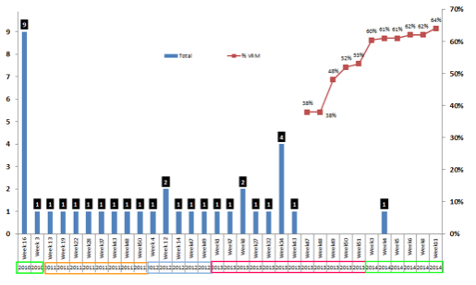
Figure 5 - Nestlé Central America collisions before and after the launch of VRM

FINANCIAL AND OTHER BENEFITS
Case study from Nestlé Mexico and Latin America
Nestlé Mexico, with 3,900 cars, trucks, vans, buses and motor cycles, faces some of the world’s most dangerous traffic conditions. It showed strong management leadership and commitment to implement the following program:
- Analysis of collision statistics to determine deviations.
- VRM (Figure 3) implemented across all businesses including contract drivers.
- Vehicle purchase criteria, to include safety, environmental impact and security.
- In-classroom courses and communications for supervisors, the sales force and contractors.
- Safe and defensive driving module integrated into training courses for sales personnel.
To make this process a success, Nestlé Mexico:
- Designated a committee for the project and to support the VRM implementation.
- Customised all program materials including Nestlé Safe Driving Policies, Golden Rules and Pledge to local language, cultural needs, policies and standards.
- Trained all relevant managers and supervisors on the use of VRM.
- Provided unlimited support through a designated Vice President as project 'Champion'
- Created a local 'Call Centre' for direct technical support for VRM participants.
- Developed a collision/incident registry system for monitoring.
- Used all marketing and communication channels to promote a Safe Driving Culture.
Nestlé Mexico achieved the following reductions during the first 12 months with fatalities falling from 3 to 0, injuries by 48%, collisions by 39% and claims frequency/costs by 22%.
More recent three-year evaluation data (Figure 6) shows the long-term sustained success of the Mexico initiative.
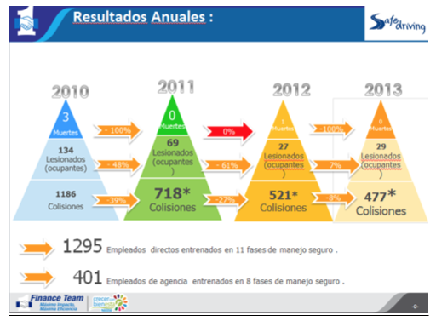
Figure 6 – Nestlé Mexico reductions in fatal, injury and minor collisions

LESSONS LEARNED
Nestlé is aware of its role in society, the community and the business networks in which it operates, and understands that collaboration is vital to road safety. Examples include relationships with Zurich, IDS, non-governmental organisations (NGOs), other agencies and contractors as well as its Road Safety Week initiatives.
Nestlé has identified a range of corporate social responsibility, cost and compliance reasons to focus attention on driver safety. As described, Nestlé has assessed its road risks around the globe and implemented effective, long term sustainable road safety programs – facilitated by gap analysis, online and other resources, committed local managers and the company’s partnerships with a range of external organisations.
Many good practice initiatives have been implemented, initially through the company’s ‘early adopting’ businesses and now expanding across the group. Key lessons learnt include:
- Fleet safety is a significant risk, and an important conduit for community road safety.
- The importance of motor fleet loss prevention procedures, programs and processes.
- Setting up a road safety committee with key performance indicators that facilitate collaboration and engagement across a range of diverse organisational functions, businesses and regions.
- Developing a fleet safety tool kit and gap analysis to support new entrants to the program.
- Building road safety into the organisation’s global SHE Standard.
- Utilising consistent but locally sensitive online tools to facilitate driver risk assessment, monitoring and improvement tools to engage large numbers of road users to create a crash free culture has potential for business and road safety policy.
- Evolving procurement standards increasingly including road safety for contractors and vendors.
Effective collaboration and partnership is vital for successful fleet programs. Industry leadership by Nestlé includes its participation in the US Global Road Safety for Workers project, NETS, the United Nations Road Safety Collaboration, GRSP, the Fleet Safety Benchmarking project, the 'Roads between us project', Global Road Safety Week, workshops hosted by Zurich and other key industry events
With regards to NGOs and other agencies, the following list is indicative of Nestlé initiatives:
Prominent player and steering committee member in the Global Road Safety for Workers research and conference in Washington in 2009 (Bradley 2009).
Participant at the United Nations Road Safety Collaboration.
Active member of and advocate for the Global Road Safety Partnership (GRSP)
Led the collaborative ‘Roads between us’ project in Ghana with Zurich, Activa and IDS. The stakeholder conference in Accra in 2012, and quarterly follow-up calls have initiated a range of fleet safety outcomes in Africa and beyond. This includes key local and international agencies as well as many of the world’s largest brands. GRSP has since taken over the governance of this initiative and the scope has widened.
The next conference was hosted by Nestlé and Zurich in Cameroon during the final quarter of 2014. Supported by GRSP and other local partners the event focused on the challenges of road safety in the French speaking African nations. The free to attend workshop had a particular focus on two wheelers with speakers from local government and industries around the globe.
Leadership in various industry initiatives including the Fleet Safety Benchmarking project, the Network of Employers for Traffic Safety (NETS) benchmark program, the VRM benchmarking group, Zurich fleet projects and supporting the Brake Road Safety Charity in the UK.
Support, including helping showcase the project and sourcing wrecked vehicles, for the World Rescue Organisation crash extrication initiatives in Ghana

CURRENT AND FUTURE DEVELOPMENTS
Increasingly, Nestlé works with its transport and other contractors, through responsible sourcing programs, to ensure they maintain high standards. Safety gap analysis, regular reviews and active engagement in online programs are all examples of how Nestlé is growing its road safety programs with key suppliers and in the communities where it operates. Such partnerships can be a powerful conduit for road safety through events such as Road Safety Week.
Most recently, the Nestlé Road Safety Week took place at its global headquarters in Switzerland to celebrate international day of ‘Safety & Health at work’ during April 2014. Each day of the week focused on a different theme including being healthy and fit to drive, distracted driving, drink and driving, seatbelts, safety at roundabouts and awareness of vulnerable road users such as cyclists.
The week included a range of exhibitions, interactive animations, simulators, information sessions, round tables, workshops, a discussion panel on Road Safety with participation from Nestlé senior leaders, supported by external experts from the Global Road Safety Partnership, Swiss Police and Zurich. It also included an award ceremony for the winners of the Nestlé colleague and family member road safety photo and drawing competitions to involve employees, family members and their children in road safety.
On-going and future plans are focused on sustaining the existing program and continuing to exploit new opportunities as they arise. Worldwide Nestlé currently has 80+ VRM programs in 70+ countries, covering a range of two wheel, car, van, truck, lift truck and bus driver projects in 30 languages and engaging approximately 42,000 drivers, operators and riders. To show the diversity of the programs, two of the most recent 2014 launches have been in the UK and China.
In China Nestlé launched VRM to third party 3,300+ drivers and has used the RoadRISK assessment results in discussions with the drivers on how to reduce their risks based on the specific exposures they face.
A range of other programs are also at various stages across Nestlé, many of which are described in more detail on the ‘Roads between us’ website (www.virtualriskmanager.net/nestleghana). These include supporting markets with telematics devices being utilised for a range of purposes, information sharing and benchmarking as required, the Safar Bakhair (Safe Journey) project in Pakistan and engagement with logistics and other supply chain contractors and sub-contractors.

ADDITIONAL INFORMATION
Since assisting with the initial fleet safety workshop in 2004, which was the starting point for the programs described, Zurich has supported Nestlé in a number of ways including a dedicated project manager to provide a focal point, advice, guidance and global consistency. Zurich has undertaken fleet gap analysis reviews in a number of countries (which have provided a range of benefits including objective identification of good practices, evaluation and areas of further opportunity. Nestlé has been an active participant at Zurich conferences, workshops and other events. This approach has allowed many other organisations to benefit from Nestlé good practices. Regular review meetings with Zurich also provide thought leadership, track progress and focus on next steps.
Nestlé has been very closely supported by IDS, through advice, guidance, consultancy, good practices, thought leadership, research and the provision of VRM. IDS was also heavily involved in many of the other initiatives described, including the initial Stakeholder workshop in 2004 and providing the research, frameworks and tools such as the Haddon Matrix and the original content for the 10 point safe driving program checklist (Figure 1).
Since then the program described has continued to evolve in a range of countries around the globe including more drivers participating in the online programs, the successful stakeholder event in Cameroon and a further fleet safety gap analysis undertaken in Brazil.
Note: This case study represents a snapshot in time based on the following paper:
Bradley A, Kahlon S P, Dubens E, Murray W, List N. At work travel safety – the Nestlé global case study. Paper presented at the Logistics Research Network (LRN) conference, University of Huddersfield, 3-5 September 2014.
All figures and events are up to date to that time.

PRINCE MICHAEL INTERNATIONAL ROAD SAFETY AWARD WINNER
On the 9th December 2014 His Royal Highness Prince Michael of Kent presented 'The Nestlé Global Road Safety Program' with an award at his Annual Awards Luncheon Ceremony held at The Savoy, London on Tuesday 9 December.
The Prince Michael International Road Safety Awards are presented to individuals, companies or organisations in recognition of their outstanding contribution to improving road safety.
Prince Michael’s judging committee commented that the Nestlé program was: ‘Very impressive and one of the highest standards seen in international corporations’.
They also suggested that it is: ‘an outstanding example to other businesses’.
The Nestlé road safety initiative, which is now in its 10th year, is focused on:
- Road safety committee, key process indicators and fleet safety tool kit developed for countries and business units entering the program.
- Driver, vehicle and journey safety built into Safety, Health & Environmental (SHE) Standard.
- Online driver risk assessment, monitoring and improvement process embedded across 40,000+ drivers in 70+ countries and 35+ languages.
- Standards developed for supplier fleets, with increasing focus on emerging regions.
- Industry leadership through good practice sharing initiatives.
The Award was received on behalf of Nestlé by Head of Group Risk Services, SHE Project Manager and UK Group Safety Advisor at the showpiece event, attended by about four hundred of the leading road safety professionals from the UK and around the globe.

UPDATE FOR JULY 2016
Since the original case study, Nestlé's insurer has undertaken a detailed evaluation of the global program. The results are shown in Figure 7, identifying significant and sustained reductions in its claim frequency and costs.
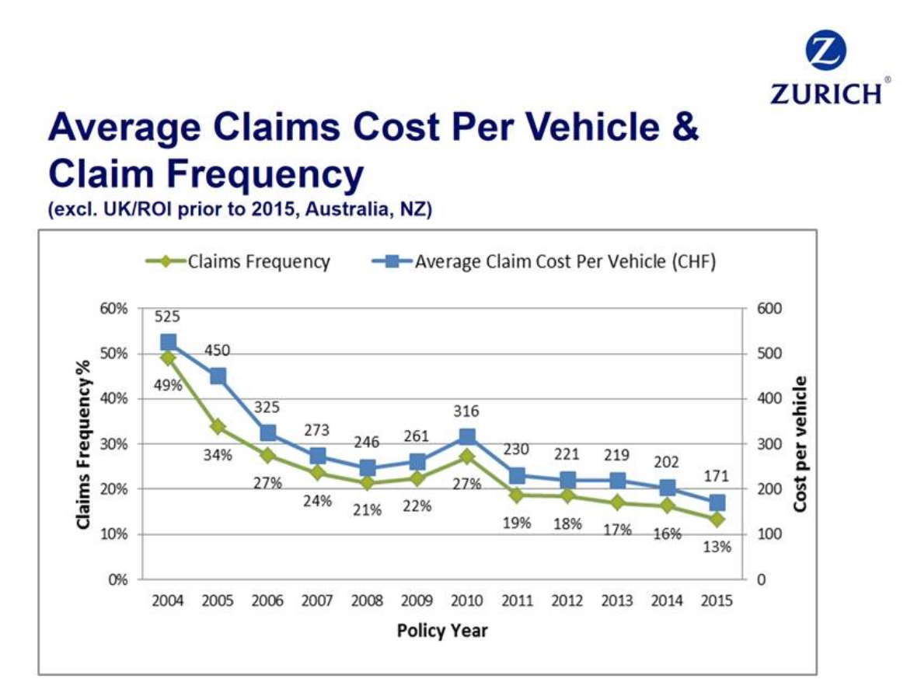
Figure 7 – Nestlé reductions in claims cost and frequency
Since inception of Program in 2004 there has been a year on year improvement in claim frequency and average claims cost per vehicle. According to the Zurich's Senior International Underwriter for motor fleet, the program is best in class, with the improvements due to the road safety culture and risk management initiatives that Nestlé has embedded.

