Case Study - Suckling Transport

Profile
Company Name: | J W Suckling Transport Limited
Business Sector: | Road Haulage (fuel distribution)
Postal Address: | Harwood House, Manor Road, West Thurrock, Essex
Postcode: | RM20 4BA
Fleet Size  Overall: | 53
HGV: | 53
LGV: | 0
Company Cars: | 8
Private vehicles used for business purposes: | 0

Company Overview
Suckling Transport is an independent haulage contractor which specialises in the provision of petroleum tanker haulage services. The Company's Head Office is situated close to the M25 motorway in West Thurrock, Essex. The company is registered to the quality standard ISO 9001:2008 and was the first U.K. firm to register to BS EN 12798 which specifically refers to the carriage of dangerous goods by road.
The Company operates a modern fleet of 50 tanker vehicles in the UK. The majority of this fleet are painted in the customers’ livery, with the remaining vehicles operating in the distinctive TankShare brand used by the Company.

Awards
- EuroTra Safety & Innovation Winner - 2011
- Prince Michael of Kent Fleet Safety Award Winner - Highly Commended - 2011
- Thurrock Business Awards for Safety in the Workplace - 2011
- Motor Transport Safety in Operation Award - 2010
- Transport for London (TfL) Freight Operator Recognition Scheme (FORS) Silver Membership - 2010
- Brake Fleet Safety Forum Award for Excellence 2009 - Fleet Safety Analysis & Action Award - Highly commended.
- Brake Fleet Safety Forum Award for Excellence 2009 - Road Risk Manager of the Year Award
- Energy Institute (formerly Institute of Petroleum) Awards 2009 - Safety Winner
- Charted Institute of Transport (CILT) Award for Excellence 2009 (Safety) - Finalist
- Transport for London (TfL) Freight Operator Recognition Scheme (FORS) Bronze Membership - 2008
- Brake Fleet Safety Forum Award for Excellence 2006 - Company Driver Safety - Highly Commended
- Department for Transport - Site Specific Advice Silver Award - 2004/2005
- Brake Fleet Safety Forum Award for Excellence 2004 - Crash Analysis Procedures Award Winner
- Green Fleet Award Winner Innovation - 2001
- Brake Fleet Safety Forum Award for Excellence 2001 - Risk and Crash Analysis Award Winner
- IFW Freighting Industry Awards - Environmental Award 1999 - Winner

The History
The company has been trading for more than 70 years. Thomas Suckling started J.W. Suckling Transport in 1938. His father had hired horses and carts with drivers to Thurrock Borough Council for 7/6 (37 pence) per week in the 1920's.
Thomas, the eldest of 11 children, followed his father into transport and his first lorry was a second hand Bedford delivering coal from his depot in London Road, Purfleet, Essex. So Suckling Transport has been delivering fuel since its formation. Thomas, with his father, would unload the coal wagons by hand, shovelling from wagon to lorry. It was a long hard day which ended by taking the lorry back to the yard and bagging the coal up ready to deliver to the surrounding area.
Suckling Transport became a Limited Company in 1974 and, shortly afterwards, was purchased by Harris Holdings (Grays) Limited. It operated a small fleet of powder tanker vehicles and a container haulage fleet until 1986.
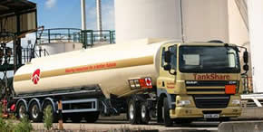
In 1986 the parent company decided to create a fleet specialising in the distribution of fuel for oil companies using the terminals on the Thames. Their subsidiary, Suckling Transport, seemed the obvious choice and the Company has enjoyed continuous growth in that sector to this day, working for major oil companies such as ConocoPhillips, Shell, Total, Petroplus Marketing and Scottish Fuels.
Following the launch of its innovative TankShare service in 2000 the company expanded its operations throughout the UK, and increased its customer base in the process.
In December 2008, Suckling Transport became a signatory to the European Road Safety Charter and identified the measures it intended to take to fulfil its commitment to reduce deaths on the road.

Nature of Operation and Driving Activities
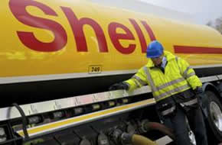
Suckling Transport has specialised in the transport of fuel by road since 1987 and delivers nearly two billion litres of inflammable liquid per year. It operates 53 articulated road tanker vehicles and employs over 150 people in the UK. The Company competes in a market sector dominated by large, multi-national companies. To compete successfully, it must differentiate itself and road safety seems to be the perfect way to do this.
The Company delivers fuel from ten oil terminals to filling stations and other commercial delivery points in the UK. The Company’s operates across a wide geographical base with operating centres as far apart as Aberdeen and Plymouth.
Most drivers work to shift patterns that involve working nights and weekends. The nature of the business is short-haul deliveries, fully loaded on the outward leg and empty on the return leg. Road tankers can be involved n rollover accidents, so rollover prevention training is provided to the workforce.

Organisational Structure
Suckling Transport is a wholly owned subsidiary of Harris Holdings (Grays) Limited.
Peter Larner, FCILT is the Managing Director of Suckling Transport and he has a hands-on approach to safety. He won the Brake Road Risk Manager of the Year award in 2009 and he is supported by General Manager Mick Smith, who is a qualified Dangerous Goods Safety Adviser, and Safety Manager, Perry Southgate and his assistant Sarah Andrews who holds a NEBOSH qualification.

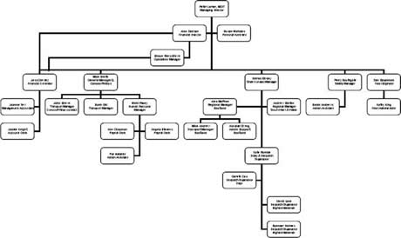

Work related Road Safety Policy & Procedures
Suckling Transport places safety above everything else. It demonstrates this commitment and communicates it to the workforce in practical terms, by not compromising safety in any way. The role of the Managing Director is to create a robust safety culture that is understood, and contributed to, by the workforce. It has become a generative safety culture, based on a consensual ethos, rather than proscription and is subscribed to by the workforce, rather than imposed on that workforce.
In practice, the policies and procedures are designed to ensure that our employees’ exposure to risk is minimised through assessments, including full site and route risk assessments for every address we deliver to. The company supports this through a management regime that ensures compliance with regard to EU drivers’ hours regulations, speeding, the use of mobile telephones and other issues that affect safety. The Company provides incentives to drivers to improve safety, holds driver toolbox talks and its managers conduct behavioural safety observations of drivers at work. It has effective methods for communicating safety to the workforce through our quarterly News Bulletin, a monthly Safety in Numbers newsletter and, more formally, through Health Safety and Environment committees, handbooks, policies and procedures. And, finally, it provides training to ensure all employees have the skills they need to perform their duties safely.
The Company uses the Haddon Matrix as the basis for its accident management gap analysis to ensure it responds across the whole of the business both in a pro-active manner and in an appropriate reactive one at, and after, an accident.
Company Car/Hire Car Policy
Within its fleet of vehicles the company has a number of company owned cars and vans and periodically uses hire vehicles. These vehicles may be for the use of a single employee or maybe used by other employees.
If the journey can be reasonably considered by public transport employees are encouraged to take up this option.
Where a vehicle owned and insured by the company or hired for company business is used then the following rules must be observed.
The driver must be in receipt of a valid driving licence, a copy of which has been recently submitted to the company.
All employees using company vehicles must be medically fit to drive e.g. not under the influence of prescribed, recreational drugs or drugs bought from the internet.
Anyone who has been drinking alcohol within the previous 12 hours must consider whether they are fit to drive.
The driver of the vehicle must ensure that a pre-start check has been carried out. This must include items such as:
- Fuel;
- Water and oil levels;
- Sufficient inflation of tyres;
- Lights clean and working;
- Windscreen wipers working;
- Note any accident damage to the vehicle;
- Vehicle log must be completed were applicable;
Whilst driving the employee must adhere to the company’s mobile phone policy. It is against company policy to use mobile phones, including hands free sets and Bluetooth whilst the vehicle is in motion.
Driving on company business can increase the working day. Should an employee need to use a company vehicle they must ensure that they consider the following guidelines:
- A car journey should be broken at least every 2 hours. This will allow the driver an opportunity to take a comfort break, rest and the opportunity for a caffeinated drink;
- When driving on company business the employee must take into consideration the work undertaken before or after the journey. Where the total working day exceeds 12hrs the employee must plan for a night away and make accommodation arrangements accordingly;
- Should an employee need to enter the London Congestion Zone on business it will be his/her responsibility to ensure the correct payment has been made to Transport for London (TfL). This zone is in operation from 07.00hrs to 18.30 hrs Mon-Fri and the charge can be paid for either on-line or through appointed agents outside the zone;
- Failure to pay will subject the company to a fine which will be passed onto the driver concerned;
- All parking and speeding fines will be the responsibility of the individual employee who had use of the vehicle at the time;
- All employees that use a company owned car/van or hire car must read the driving guide provided by the company, familiarize themselves with the vehicle;
- The company reserves the right to take disciplinary action against employees who demonstrate a poor accident, safety or driving offence record at any time during their employment;

Work related Road Safety guidance for Drivers
Suckling Transport provides its employees with a range of safety training. It employs a team of six Driver Instructors who assess employees’ driving skills at least once every two years but, more frequently, where a requirement for intervention training is indicated by the on-board computers fitted to the vehicles.
The Directors conduct an annual review of Quality and Safety and set Safety and Service targets for the coming year.
A drivers’ handbook is provided to all employees who also have access (at each terminal) to the Site Route Risk assessments and details of safe parking areas on route through the Company’s Safe Havens information.
The Company uses the Virtual Risk Manager software package in the recruitment stage to produce a short-list of applicants who then undertake an in-cab driving assessment. All newly recruited drivers undergo a minimum of one week’s training alongside a trained Driver Instructor.
DVLA licence checks are conducted on all employees who drive a company vehicle. This is completed annually for employees with clean licences; every 9 months for those with 3 points; every 6 months for those with 6 points; and every 3 months for employees with 9 points on their licence.
141 employees received RoSPA National Safe Driving Awards for 2011.
All drivers are required and are short-routed to attend toolbox (safety) talks, which last between one and two hours each quarter. Elected representatives also serve on regional and terminal safety committees.

Procedures
The Company’s ISO 90001 Quality Manual procedures provide a comprehensive framework of procedures to ensure the highest level of safety. These are audited by Trans Pacific Certification Limited as part of our registration. The Health and Safety section of this manual complies with BS EN 12798.

Auditing and Review
Our two main customers (Shell UK Oil and ConocoPhillips) conduct audits of our safety systems each year, and WQA audit our procedures, as part of our registration to BS EN 12798 twice each year.
Internal audits are conducted by externally trained employees and managers.
The Freight Transport Association conducts a full 100% analysis of our drivers’ tachograph charts for compliance and also completes a 100% Working Time Directive check too. Journey Management checks are conducted by managers to ensure drivers are adhering to speed limits and not recording rest breaks whilst delivering.
Site route risk assessments are produced for every delivery site and a sample of these is contained in the Appendix.

Performance Measures
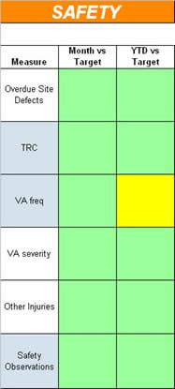
Suckling Transport maintains accident and other safety and environment incident data for individual customers and across the whole of its business. Monthly Key Performance Indicator graphs are produced for the whole of the business and these are reviewed by the Directors annually. In addition graphs are produced for the Company’s two main customers.
On the ConocoPhillips contract, a balanced scorecard is maintained covering safety, environment, cost and service. A sample of a Safety scorecard is shown opposite. This demonstrates that all issues in the most recent month were on target and all but one were on target on a year-to-date basis, with this one showing amber. This indicates that we are just outside the target but should achieve it by the year end.
Other contacts have similar KPI targets.

Accident Reduction
Reducing accident frequency and severity is a challenge that Suckling Transport faces across the whole of its business. From 2005 to 2008 reasonable progress had been made in reducing accident severity and this was reflected in the Company’s motor vehicle insurance claims record but, little improvement had been seen in accident frequency over the same period.
Suckling Transport launched its Zero Incident Project in June 2008 with the objective of eliminating road accidents completely. To achieve zero we adopted a four-phase approach:
- Interrogate and audit our safety systems, policies and procedures;
- Identify technological developments and other improvements that could reduce accidents;
- Improve near miss and potential incident reporting by the workforce;
- Improve Journey Management controls and driver training arrangements;
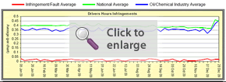
The Company’s safety systems were subjected to audits by five major oil companies - Shell, Total, ConocoPhillips, Exxon Mobil and BP - to ensure its policies and procedures met the most stringent requirements. Audits by Shell, ConocoPhillips and ISO accreditation body Trans European Certification Limited continue annually.
The workforce was consulted and a ‘fitness to drive’ process was put in place, including random and with cause drugs and alcohol tests, return to work procedures and we increased the frequency of driver medicals.
Staff formed focus groups and conducted cold case reviews of past accidents, enlisting the help of suppliers to identify any new technology that could have prevented those incidents. Fourteen separate initiatives were launched to test items such as object sensors on vehicles, reversing aids and a lane departure warning system.
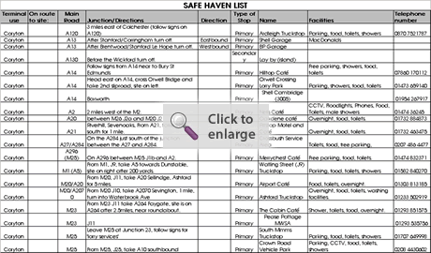
These Focus Groups have become an integral part of our safety improvement programme.
Because every accident, near miss, or potential incident is an opportunity to improve safety, drivers were incentivised and encouraged to produce potential incident and near miss reports in order to identify risks before accidents occurred. In 2011 473 such reports were submitted. This recognises that, when the Company achieves zero incidents, the only way to maintain that status will be to prevent accidents through near miss and potential incident investigations.
Journey management procedures were improved. The Freight Transport Association analyse the Company’s tachograph records but we decided to go beyond the legislative requirements by checking records to ensure that drivers were complying with local speeding restrictions and were not recording their rest breaks whilst delivering. Accident black spot maps were provided at eachOperating Centre and full Site Route Risk Assessments (SRRA) are conducted for each delivery location see Appendix. A list of Safe Havens was produced for each operating centre, which identified safe parking areas for drivers.
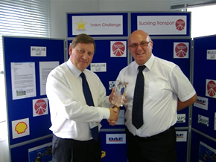
Vehicles are fitted with on-board computers which produce reports to identify any driving skills shortages in the workforce. Periodic driving skills assessments have been replaced with targeted, intervention training. Trials are currently being conducted on new software that will automatically check for speed compliance against the speed limit of the road being used.
Six drivers were selected as our Instructor Team. They received intensive training from a U.S. Instructor in the Smiths System of defensive driver training. They were equipped with laptops and given access to the reports produced by the vehicle telematics.
In July 2009, the Company launched its 1mKm Challenge. Teams nominated their chosen charities and these received a donation each time a team completed one million kilometers without an accident of any kind.

Financial and other Benefits
The significant reduction in the cost of motor vehicle accidents resulted in a 14% decrease in our insurance premiums in 2010 and another 14% in 2011. Our Insurers have also donated £16,000 towards our 1mKm Challenge initiative.
Vehicle downtime has greatly reduced, improving the efficiency of our fleet. Driver turnover has fallen considerably. And fuel efficiency has improved too.
Improved safety has also improved our relationship with our customer. This year the contract that began with Shell UK Oil in 2003 was renewed for another 5 years. The contract that began with ConocoPhillips in 2001 has also been renewed until June 2013 and we are hopeful of extending it further after that date.

Lessons Learned
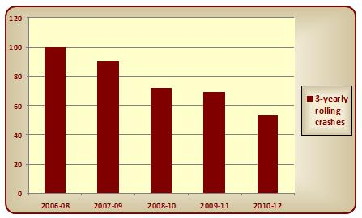
Benchmarking our performance against others demonstrates the benefits of that training and drivers now see this as enhancing their skills, rather than imposing compliance of the rules. The chart below shows how well Suckling Transport drivers perform against the national average and the industry sector average, with regard to compliance with EU drivers’ hours legislation.
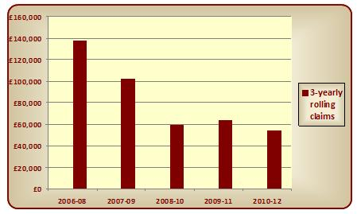

Current and Future Developments
Future developments, certainly in the short-term, revolve around our continued journey towards zero incidents. Maintaining zero status once we get there will rely on preventative skills and the co-operation of the workforce in identifying potential risks and near miss incidents.
Beyond the zero incident project, we shall focus on our environmental performance and have signed up for the FTA Carbon Reduction Scheme.
This year the Company fleet of commercial vehicles and cars have all been fitted with Vehicle Event Data Recorders (VEDR), or forward facing cameras, as they are better known. On-board computers fitted to the vehicles let the office know when a harsh braking incident has occurred and the video of the incident is then downloaded from the VEDR. This is then treated as a near miss incident and discussed at safety workshop meetings with employees that are held every three months. Footage taken from actual close encounters generate excellent discussions and prompt suggestions for corrective action.

