Case Study - United Utilities Operational Services

Profile
Company Name: | United Utilities Operational Services
Business Sector: | Utilities
Postal Address: | Trem y Ffynnon, Sluvad Road, New Inn, Pontypool
Postcode: | NP4 0TA
Fleet Size Overall: | 1,690 vehicles in total (Sept. 2009)  60 large commercial  1,250 vans  380 cars
Private vehicles used for business purposes: | 1,800 (including commuting)

Company Overview
United Utilities is the UK's largest listed water company. We own, operate and maintain utility assets, including water, wastewater, electricity and gas. We're a FTSE 100 company with a turnover of £2 billion and are the UK's market leader in utility outsourcing.
We see ourselves as stewards of the natural resources of water and energy, using our rich legacy of engineering and planning skills to build the essential backbone of thriving communities in the North West of England, in the UK and across the world. Some 20 million people worldwide benefit from our expertise in operating and managing water, wastewater, electricity and gas networks.
Through our determination, we turn complex processes into something as simple for our customers as turning on a tap, flushing a toilet or switching on the heating. We really are helping to plan for the future, decades ahead, developing new technology and processes.
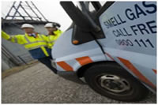
Wherever we are, we deploy our vision, energy, engineering and operational experience to help new and existing communities to grow - providing them with the essential services they need.
Not only do we provide water to seven million people across the North West of England, we also share our knowledge and expertise, helping other organisations to develop practical and sustainable solutions which make their operations more efficient. Our clients include Northern Gas Networks, Southern Water, Welsh Water, Scottish Water and Electricity North West - and that's just in the UK.

Nature of Operation and Driving Activities
United Utilities Operational Services and its main customers of Welsh Water and United Utilities Operations Limited (Northern Gas Networks) have a fleet including, LGV, vans, leased company cars and grey fleet users. Most of the employees operate both in the field and in office locations that require mobility of various kinds.
Office based staff commute to and from the fixed placed of work in ether company cars or private vehicles. Operational teams within the field carry out their duties using a company vehicle or their own vehicle to do the day to day job.
The vehicles used are either of standard type produced by the major manufacturers or are converted thus enabling operational teams to carry out field activates.

Organisational Structure
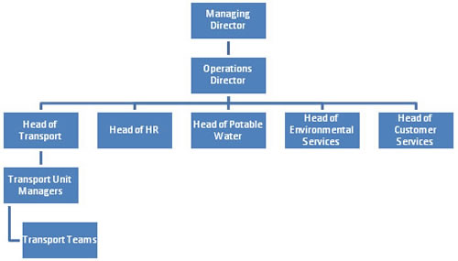

Work related Road Safety Policy and Procedures
The business sees the management of road risk as a key component of transport strategy. This has led to the following management of road risk framework being the catalyst for change.
- United Utilities Operational Services recognises the need to protect employees and others from the dangers of work related driving.
- UUOS is committed to the principle that transport accidents, including road traffic accidents, are not an acceptable fact of life but serious, costly and often avoidable events.
- UUOS has general duties under the current legislation to ensure the safety of employees and others affected by its work activities, and a duty to assess significant risks under the Management of Health and Safety at Work Regulations 1999.
- In practice, risk assessment needs to take place not only at an organisational level (by line managers), but also at a personal level by the individual driver.
- UUOS will endeavour to meet those statutory requirements and provide standards not less than those set out in any relevant approved Codes of Practice.
- UUOS will take all reasonable steps to ensure as far as reasonably practicable that employees driving at work do so in a manner that reduces the risk to themselves, other employees or any other person who could be affected.
- Staff involved in driving of vehicles, whether they are part of the company owned commercial fleet, supplied on the Company Car Scheme or private vehicles driven on work matters will be covered by this Policy

Work related Road Safety Guidance for Drivers
In providing advice and guidance to all drivers within the business the following strategy has been developed:
As part of the health and safety roadmap for 2009 / 10, it is intended to continue the development of value added solutions which limits our exposure to potential health and safety issues as a result of our road transport activity.
The strategy we have developed has three main strands:
- Provide the business with best practice information / advice
- Provide a road risk register of employees and an associated improvement plan
- Develop a real time approach to driver licence management
The main areas that this covers are:
- Identify risks around vehicles, drivers, journeys
- Improving driver behaviour and competence
- Vehicle checks
- Driving Licence checks
- Best practice in relation to:
  - Mobile phone use
  - Smoking and the vehicle
  - Drink and drug driving
  - Speed and the dangers
  - Tiredness
  - Winter driving
  - Other topical information

Specific examples of procedures
We have a number of policies that help the business and its employees understand responsibilities in the area of managing road risk. One example is detailed below:
MOBILE PHONES/RADIO AND MICROPHONE
From February 27th 2006 drivers caught using a hand held mobile phone whilst driving will have their licence endorsed with 3 points YOU can also be fined up to £2,500.
It is company policy that drivers must never use a hand held mobile phone when driving.
- It is illegal to use a hand-held mobile phone when driving.
- Keep your mobile phone switched off when driving and use your voicemail, a message service or call diversion so that messages can be left for you when your phone is switched off.
- Only use your mobile phone after you have stopped in a safe place. Never stop on the hard shoulder of a motorway except in an emergency.
- You may think a hands-free phone will enable you to have control of your vehicle, but your mind will not be fully on your driving. It is not like talking to a passenger who will be aware of what is happening when you are driving.
- Avoid taking calls on a hand-free phone whilst driving, but if you must end the conversation quickly. Otherwise you will put yourself and other road users at risk.
- You may use a mobile phone when driving for help in an emergency. On a motorway it is best to use a roadside emergency telephone, as the emergency services will be able to locate you easily. Other distractions Do not forget the advice in the Highway Code about other distractions which may affect your concentration when driving.
To Drive Safety Avoid:
  - Loud music that may mask other sounds.
  - Trying to read a map.
  - Inserting a cassette or CD or tuning the radio.
  - Arguing with your passengers or other road users.
  - Eating or drinking.

Auditing and review
The auditing and review process is captured in two ways within the business.
Compliance around certain areas is contained in the yearly health and safety roadmap. An example of this is that during 2009 / 10 100% of the population is required to move towards online checking of driver licence status. At the same time 100% of the population is required to go through a driver risk assessment process.
In order to maintain sustainment of the strategy the main strands of the programme such as the above and the output action plans are then captured within the Business Quality Management BSI system. This subjects the processes and procedures to both internal and external independent audit.

Performance measures
The business operates a dashboard KPI set that gives a flash report of non behavioural and behavioural activity to all stakeholders within the business. The flash report is backed with an electronic detailed data set that allows analysis to be done and as a result continuous improvement activity can take place. The KPI set benchmarks and measures the following areas:
- Vehicle repair and maintenance regime
- Fuel management
- Accident management and all associated activity
- Tyre management
- External benchmarking and customer satisfaction
All local management takes a responsibility for compliance of driver, journey and vehicle where they can affect behaviours.

Accident reduction
As part of the management of road risk strategy United Utilities Operational Services has, since 2006, been working with a leading independent incident management business. As well as managing the supply chain in relation to claim handling through to uninsured loss recovery one other added value service provided is the provision of valuable management information.
This then allows us as partners to carry out analysis of trends and activity which then creates the opportunity to develop action plans around improving driver behaviour in this area.
The data below illustrates the success in this area:
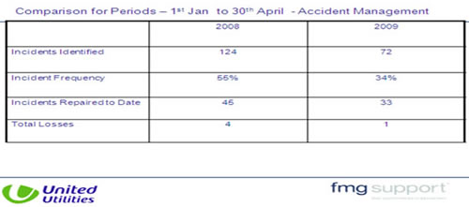

Financial and other benefits
United Utilities works in partnership with AIG but is a self insured organisation. Therefore it is important that recovery of all costs takes a frontline focus in the eyes of the operational teams. This leaves it safe to say therefore that prevention before things happen needs to be the approach of the business. The road risk strategy plays a leading part in that approach as it has the potential to continue a downward trend of incidents and associated costs.
Although there are a lot of costs associated with accidents and incidents a cost improvement associated with the incident data above is stated for clarity of comparison. However it is safe to say that all other associated cost such as third party claims, uninsured loss recovery and sickness pay for staff has improved as a result of improved behaviour and management.
In addition in working with our fuel management partner for example it is also possible to track activity associated with miles driven and fuel consumption.
Therefore the data blow indicates the resulting cost improvement associated with the above accident improvements.
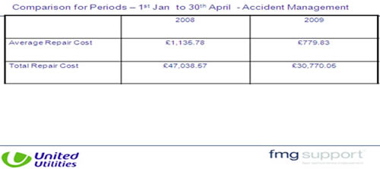

Lessons learned
Following the road risk strategy being put in place it has been possible to begin the journey of improving our status in the eyes of all our stakeholders both within the business and outside.
It was not until putting this strategy in place and following a clear path was it possible to see the gaps we had in the business. It is important that being a high profile business working with both city and public stakeholders that we should take our responsibilities seriously.
It is quite clear that sustainability of the strategy can add value to the position of the business in the eyes of our utility peers but also in the eyes of our partners within the road transport and fleet sectors.
It is also safe to say that this is a complex journey; changing culture and bringing people with you is no easy task. There needs to be a passion for this area of work and a champion needs to be found to drive the process along. Accepting the challenges along the way and not getting despondent when things go wrong are key to success.
Networking amongst peers is also important and it is this that will help contribute to future developments within United Utilities Operational Services.

Current and future developments
A process of continuous improvement is being followed and standing still is not an option for the business now that there is a passion for the work.
As a result of beginning this journey and having created a network of peers the Haddon Matrix for example will be used to look at current position and set a path for the future. It is intended to work with a partner that can help this process.
We are working with a partner to create a driver awareness road show that will focus on areas such as:
- Driver checks
- Winter driving
- Drink and drug driving
- Use of mobile phones
- Tiredness
All these areas will be part of an ongoing communications campaign.

Additional information
United Utilities Operational Services has recently been recognised by its peers in the fleet industry as follows:
- 2009: Fleet News - Van Fleet Manager of the Year
- 2009: Fleet News - Van Fleet of the Year Highly Commended
The management of road risk strategy was an integral part of the award submission.

