Case Study - Wolseley UK

Profile
Company Name: | Wolseley UK
Business Sector: | Distribution of Plumbing, Heating & Building Materials
Postal Address: | The Wolseley Center, Harrison Way, Spa Park, Royal Leamington Spa, Warwickshire
Postcode: | CV31 3HH
Fleet Size Overall: | 6,000 vehicles
HGV: | 800
LGV: | 2,085
Company Cars: | 3,000
Private vehicles used for business purposes: | 120

Company Overview
Wolseley UK is part of Wolseley PLC, one of the world’s largest building and plumbing suppliers to both trade and private customers. The business sits at the hub of the construction industry offering in excess of 400,000 products to the building sector.
We interface with the public sector through more than 2,000 retail outlets across the UK and Ireland encompassing brands like: Plumb Center, Build Center, Climate Center, Parts Center, Drain Center, Electric Center and Pipe Center as well as through recent acquisitions such as Bathstore.com, Brandon Tool Hire, William Wilson, Heat Merchants, Brooks and Tubs & Tiles and Encon Insulation.

Nature of Operation and Driving Activities
To support this massive outlet network, Wolseley UK operates a fleet of around 3,000 commercial vehicles which provide a 24 hour distribution service to branches and customers with stock and products being stored in 15 Distribution Centres throughout the UK. The UK car fleet is made up of 3,000 vehicles which are used on a daily basis by the branch network and central function employees for business purposes.

Organisational Structure and Forums
Figures 1 and 2 show our business unit structure in the UK and Ireland

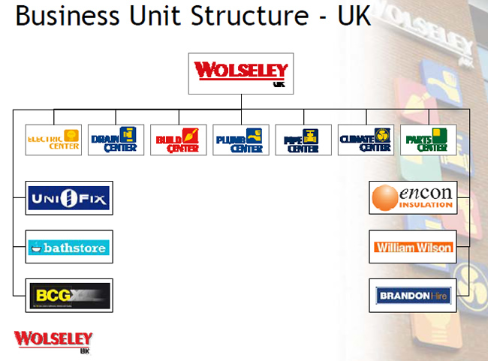
Figure 1 - Wolseley UK Organisational Structure

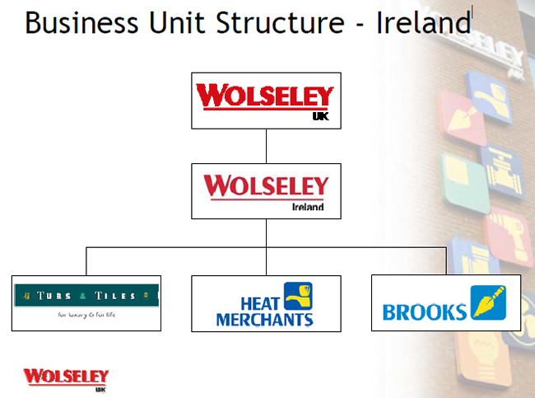
Figure 2 - Wolseley UK Organisational Structure continued
To ensure that continued focus and attention is maintained, Wolseley UK established the Fleet Safety Steering Group, aimed at reducing the number of collisions experienced each year. The group, which meets quarterly, consists of both car fleet and commercial fleet managers. It also contains a number of operations managers to ensure that practical effective initiatives are implemented; and it is supported by a range of external suppliers including our insurer, broker, fleet supplier and risk management specialist. It is the key driver for identifying effective collision reduction programmes and proposing fleet safety policies to Wolseley UK’s Leadership Team.
A listing of initiatives which the Wolseley UK Fleet Safety Steering Group (FSSG) has or is in the process of implementing is shown below.
- New fleet safety policy statement, approved by the Wolseley UK board in April 05, and progress against all elements reviewed during 2007.
- Comprehensive fleet safety action plan.
- Online driver RoadRISK assessment, Risk Foundation and Safe Driving Pledge program initially involving 50, then 1,700, drivers. Plans are now in discussion for a UK roll-out to 4,500 drivers and a pan-European program for 8,000+ people; followed by a global roll-out to all of the current 74,000 employees who drive as part of their work.
- Employee, induction, commercial and car driver handbooks issued to all relevant staff in the UK, all including safe driving as a condition of employment.
- Communications program including safety alerts, email reminders, quarterly commercial vehicle and company car driver newsletter and regular features in all company-wide publications.
- On-road driving assessments for all new commercial vehicle drivers.
- Online safety pledge and risk assessment required as permit to drive before collection of company car.
- Realignment of internal charging for vehicle insurance premiums and incident deductibles to make managers more accountable.
- New accounting code established to capture costs for avoidable maintenance (own damage collisions) and driver abuse.
- Established documented procedure for incident repairs for minor & major incidents.
- Increased speed and effectiveness of collision reporting.
- Driver license checks, electronic and manual.
- Free eye sight screening and spectacles to all drives that require them.
- Management training.
- Driver Focus Groups.
- Comprehensive program of banksman training.
- Agency driver induction program.
- Successful three stage driver of the year competition – initially for commercial vehicle drivers and now being expanded to include all drivers.
- Alcohol and drugs polic
- Trialling collision avoidance systems such as reversing sensors.
- A corrective action policy, which will be linked to different levels of development and disciplinary actions in the event of a collision occurring is under review.
- Analysis of drivers’ collision rate, using CrashCOUNT and broker data. This process ensures that collision information is effectively communicated to senior management, and has led to a number of one-to-one’s occurring with the driver involved to raise issues and concerns.
- It was suspected that eyesight was a key cause of its collision rate. As a result, Wolseley UK now offers free eyesight screening to all drivers and pays towards the first pair of corrective glasses if the examination illustrates that they are required.
- Based on analysis of collision trends, the use of reversing aid technology is being trialled by a cross section of the company. This process will assist drivers in reversing vehicles so that effectiveness and cost benefit can be determined.
- Detailed investigations to determine the root cause of any collision and identify any re-training required.

Occupational Road Risk Guidance (What the guidance covers)
Wolseley UK takes the safety of its employees and vehicles very seriously. As a result, this view is regularly communicated to all employees that drive for work purposes. There are several guidance documents in circulation that help to illustrate this including the following:
- A formal fleet safety policy that is reviewed annually and communicated to staff. This policy helps to demonstrate Wolseley UK’s commitment to ensuring the safety of its employees while driving for work. The annual review process ensures it remains accurate and for continual improvements to be made.
- Car and commercial safe driving handbooks - issued to both sets of drivers outlining their responsibility to act in a safe manner at all times when driving for work purposes. Additionally, the handbooks contain further instruction, information and guidance to help keep the drivers and their families safe when driving for personal purposes also.
- Both the commercial and car fleet departments issue a quarterly newsletter to all locations and drivers that operate company vehicles. This process aims to raise awareness of all company drivers to current hot topics relating to fleet management and vehicle maintenance as well as highlighting methods of best practice.
- Safety alerts are issued to all Wolseley UK locations following the occurrence of a serious incident. Not only does this process ensure that effective safety communication is established, it also increases the awareness of all staff across the company so that control measures are implemented to prevent recurrences of similar incidents in the future. This initiative has proved to be one of the most successful for raising the attention to a serious topic or matter.

Road Safety procedures and specific examples of procedures
With 7,500 company vehicle drivers and a fleet of 6,000 vehicles, Wolseley UK takes its fleet safety responsibilities very seriously.
- In recent years, a new Occupational Health and Safety Management System were launched across all business locations in the UK to meet changes in legislation and Company policy. The FSSG used this as an opportunity to produce documented road safety procedures for the car and commercial fleet, and incorporated them into the Wolseley UK H &S manual.
- The Risk Foundation section of the online driver risk assessment has taken 15 sections of the Wolseley UK fleet safety policies at random, and tests an employees’ understanding of the procedures. An employee cannot complete the assessment or move onto the next section until all the questions are answered correctly and hence the policies both read and understood. Many organisations have road safety policies but many few make them living, breathing documents in this way.
- To reinforce learning, additional information and guidance is also made available on the Company intranet site on a regular basis.

Auditing and review
- Zurich recently undertook a second independent fleet audit to follow-up on the one undertaken in 2004. The outcomes in Figure 3 below show a clear improvement in the policies and procedures that the FSSG has implemented, in all the areas covered by the audit.
- The online driving assessment programme, which has been developed in conjunction with our insurers Zurich, is designed to enable the identification of potentially ‘at risk’ drivers, so that preventive measures can be taken prior to any such incidents occurring. The system is designed to help significantly improve the accident and collision performance of all the company’s drivers. Wolseley UK initially launched the programme to 1,000 drivers (500 company car drivers and 500 commercial) with a view to rolling it out to all company drivers during 2008.
- Wolseley UK’s success is due to many reasons, not least its constant desire to never stand still. A key element of this fact is the drive towards continual improvement and we regularly benchmark the Wolseley UK fleet safety programme against others and identify areas for further development.
- Wolseley UK are active participants in the fleet safety benchmarking study funded by the Department for Transport and operated by Interactive Driving Systems. The Company has also recently signed up as a ‘Business Champion’ with Roadsafe as part of the ‘Driving for Better Business’ forum. Best practice sharing has also been conducted with BT, Nestle, and NKL Automotive to name a few.
Area of fleet safety | Wolseley % Oct. 2004 | Wolseley % Apr. 2006 | Average Fleets %
Fleet safety policy | 39 | 84 | 73
OHS policy and risk assessment | 47 | 78 | 68
Legal compliance | 60 | 88 | 76
Organisational leadership and culture | 48 | 81 | 72
Journey/mobility planning | 62 | 72 | 77
Driver recruitment and induction | 74 | 86 | 70
Driver management | 61 | 80 | 65
Driver wellbeing | 42 | 73 | 62
Vehicle management | 58 | 83 | 76
Claims reporting and investigation | 43 | 69 | 64
Marketing and community involvement | 36 | 82 | 46
Reversing | 49 | 70 | 64
Cash for cars | 60 | 80 | 62
Agency drivers | 50 | 60 | 73
Overall | 53 | 78 | 68
Figure 3 - Zurich Fleet Audit outcomes

Performance measures
Performance reviews take place at several different levels within Wolseley UK.
- The FSSG reviews the data, policies, process and procedures against plan on a quarterly basis.
- Sub-committees focus on specific issues, such as agency drivers, on an on-going basis.
- The Health and Safety Board Report is produced monthly, with major incidents escalated to the board immediately. WRRS is a key element of this report.
- Output KPIs are monitored on an on-going basis.
- Monthly reports are collated by Wolseley UK’s insurers outlining the Company collision performance.
- The audit results conducted by Zurich on Wolseley UK’s fleet safety practices (figure 3) have shown significant improvement from a standing start in 2004. This process will be repeated again later in 2008.
- The outcomes from the online driver risk assessment enable the identification of ‘at risk’ drivers so that specific targeted interventions can be identified to reduce the risks to those employees.
- As a positive outcome of the FSSG, an opportunity to raise the profile of unrecovered losses associated with incidents caused by third parties has led to an increase in the amount of monies recovered by the commercial and car fleet teams. Figure 4 below highlights the monthly and total income from this focused effort. To date, over £500,000 has been clawed back from third parties, and this has essentially funded a large chunk of the safety program.
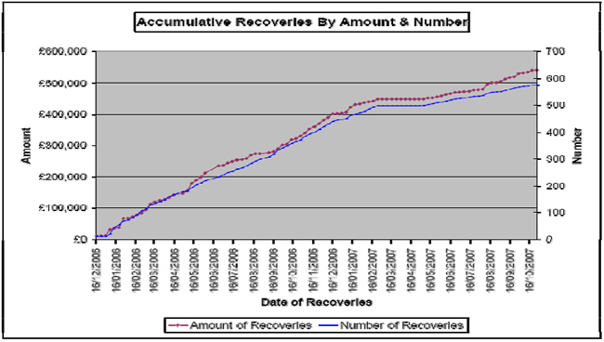
Figure 4 – Uninsured loss recovery
- Collision ratios are a very good indicator of an organisation’s road safety performance. Figure 5 below illustrates Wolseley UK’s performance improvement over the last few years based on the number of third party incidents per vehicle. Whilst the fleet size has doubled in the last three years, the number of vehicles involved in a third party collision has reduced by nearly 50% from 65% to 35%. This data shows the clear and sustained success of the program.
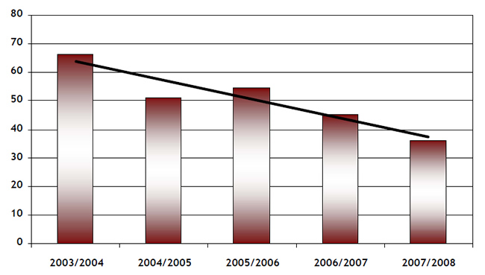
Figure 5 – Third party involved vehicle collision ratios
- Overall, insurance premiums have been effectively managed and uninsured loss recoveries have increased substantially over the past three years.

Cost and benefits
The cost savings and benefits achieved from investing in the fleet safety programme have already been illustrated in the previous sections.
However there are two elements of our on-going initiatives that are particularly rewarding.
- Independent Fleet safety audit successes, which show measurable improvement (Please refer to Figure 3) in our processes from a standing start in 2004.
- The external recognition we have received from the likes of RoSPA, Brake, the Prince Michael Road Safety Awards, the Fleet Safety Benchmarking group, and industry publications such as Commercial Motor and Fleet News.

Lessons learned
Put simply, driving is probably the largest risk that Wolseley UK’s employees face on a daily basis. It is in recognition of this fact that the focus towards managing WRRS was initially given.
Since the introduction of the fleet safety strategy, a heightened awareness to fleet safety and collision reduction measures has occurred across the company and key to the continued success is to now maintain this momentum.
Introduction of the steering committee has engaged our employees and stakeholders in the process. On the other hand, the awards have helped to motivate our senior, operations and OHS managers to continue investing in the initiative and the many plans we have to keep the programme going.
The legal, moral and financial benefits brought about from investment in the programme are clear to be seen and as a result, the focus on WRRS within Wolseley UK has never been higher. This will continue to be the case for continual improvements to be made in years to come.

Current and future developments
At Wolseley UK our safety ethos is about continuous improvement in the future, whilst being respectful of where we have come from. To ensure that this focus is maintained, the FSSG crates an annual action plan to identify the next cluster of initiatives to deliver each year. The primary aim of these initiatives is to reduce the collision frequency rate within Wolseley UK. Progress against the planner is then reviewed by the FSSG at each meeting. A copy of this planner is available upon request.

Additional information
Overall, this document clearly shows a major commitment to WRRS by Wolseley UK, supported by its risk management partners.
For more information on the Wolseley UK safe driving programme please contact:
- paul.gallemore@wolseley.co.uk
- www.wolseley.co.uk
- 01926 705622
- harnam.singhnijjar@wolseley.co.uk
- www.wolseley.co.uk
- 01926 705320

