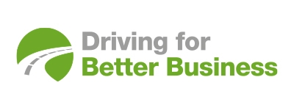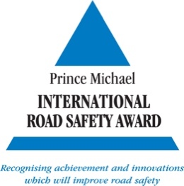

16 November 2021

DRIVING FOR BETTER BUSINESS WINS ROYAL AWARD
National Highways has been granted a Prince Michael International Road Safety Award for its Driving for Better Business programme for its “inspiring” and “truly innovative” approach to saving lives and reducing road injuries.

In a letter to Nick Harris, Chief Executive of National Highways, HRH Prince Michael of Kent said: “For many years I have been impressed by the Driving for Better Business campaign initially developed by RoadSafe and am delighted that its key messages and approach have been adopted and developed by your team in National Highways to make it such a well-regarded and sustainable programme.

“Initiatives such as yours which ensure the safe use of vehicles by those who drive for work are of immense importance. The approach taken to promote the critical role of employers in delivering road safety by highlighting the many business benefits that stem from good management is truly innovative. Your programme is a fine example of what can be done by sharing good practice and through inspiring leadership. I am sure it can be replicated elsewhere. Congratulations to you and the team which has made the programme such a notable success.”

Welcoming the Award, Driving for Better Business programme Campaign Manager Simon Turner says: “This is fantastic recognition for the work and dedication of the whole team. We could not have achieved this without the leadership and vision of our many partners and organisations who are willing to learn and share their experiences with others.”

Since its inception in 2007, Driving for Better Business has engaged with thousands of businesses in pursuit of its mission: to improve the levels of compliance for all those who drive or ride for work by demonstrating the significant benefits of managing work-related road risk more effectively. Through the Driving for Better Business programme, those organisations which collectively employ millions of staff who drive for work have access to a range of free tools and resources for employers, along with examples of good practice and strong leadership.

Established by HRH Prince Michael of Kent in 1987, each year the ‘most outstanding’ international road safety initiatives receive public recognition through the scheme.
The awards are presented in five main categories based on the five pillars of the Global Plan for a Decade of Action: road safety management, safer roads, safer vehicles, safer road users and post-crash response.
Media contact: Hadstrong https://hadstrong.com/ Becky Hadley on 07733 054839
About Driving for Better Business
Driving for work is one of the highest-risk activities that many employees undertake, whether they drive a commercial vehicle, a company car or make occasional work journeys in their own vehicle. As the gig economy continues to grow, this also means those who ride for work as well as those who drive.
Driving for Better Business is a free to access government-backed National Highways programme, delivered in partnership with RoadSafe, to help employers in the private and public sectors reduce work-related road risk, protecting staff who drive or ride for work, and others who they may share the road with.
Our mission is to improve the levels of compliance for all those who drive or ride for work by sharing good practice and demonstrating the significant business benefits of managing work-related road risk more effectively.
https://www.drivingforbetterbusiness.com/

