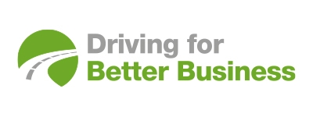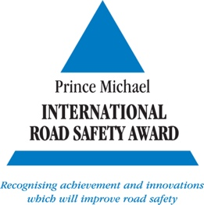
7 March 2022

CELEBRATING WOMEN IN TRANSPORT FOR INTERNATIONAL WOMEN’S DAY

Driving for Better Business is marking International Women’s Day (8 March), launching a year of videos, podcasts and features, and teaming up with Women in Transport, a non-for-profit promotional, professional-development and support group.

Women make up 47 per cent of the UK workforce yet remain underrepresented in the transport sector, accounting for only 20 per cent of workers. However, this is changing steadily, and women are represented at every level.

Driving for Better Business is a National Highways programme led by Anne-Marie Penny*, Senior Road Safety Policy Adviser, who says: “This is a great opportunity to raise awareness of the thousands of women who work in this sector, from CEOs of large multinational corporates, national and local government officials, directors of influential safety charities, freelancers, apprentices and everything between. Transport – like all areas of life – benefits from a diverse range of influences to best serve everyone.”

Through the Driving for Better Business programme, those organisations which collectively employ millions of staff who drive for work have access to a range of free tools and resources for employers, along with examples of good practice and strong leadership.
Women in Transport provides a varied and lively events programme with access to thought leaders, senior stakeholders and professional trainers. As the Secretariat to the All Party Parliamentary Group for women in transport, it is committed to working with the UK government to increase the representation of women in the transport sector.

Sonya Byers, CEO of Women in Transport says: “We are delighted to be teaming up with the National Highways Driving for Better Business programme to celebrate women’s achievements in the transport and fleet industry over the coming year. With this year's International Women's Day theme of #BreaktheBias, we have a wonderful opportunity to raise the visibility of talent we have at every level of transport from women just starting their career to senior leaders - and to showcase the diversity of opportunity in the transport sector."
*See how Anne-Marie Penny leads her team with inspiration and positivity in an interview here: https://www.drivingforbetterbusiness.com/podcast/women-in-transport/celebrating-women-in-transport-for-international-womens-day

Media contact: Hadstrong https://hadstrong.com/ Becky Hadley on 07733 054839

About Driving for Better Business
Driving for work is one of the highest-risk activities that many employees undertake, whether they drive a commercial vehicle, a company car or make occasional work journeys in their own vehicle. As the gig economy continues to grow, this also means those who ride for work as well as those who drive.
Driving for Better Business is a free to access government-backed National Highways programme, delivered in partnership with RoadSafe, to help employers in the private and public sectors reduce work-related road risk, protecting staff who drive or ride for work, and others who they may share the road with.
Our mission is to improve the levels of compliance for all those who drive or ride for work by demonstrating the significant business benefits of managing work-related road risk more effectively.
https://www.drivingforbetterbusiness.com/

