Strict embargo: 00.01hr Friday 3 March 2023

Driver caught steering huge car transporter with just his elbow by police in unmarked National Highways HGV cab

- Week of action to tackle unsafe driving on M1
- Eight police forces to patrol length of motorway in National Highways supercabs
- 33,254 offences recorded by police in ‘Operation Tramline’ HGVs
Police officers overtaking this heavily-laden car transporter were shocked to discover the driver was using just one elbow to control the huge vehicle as he travelled along a busy motorway.
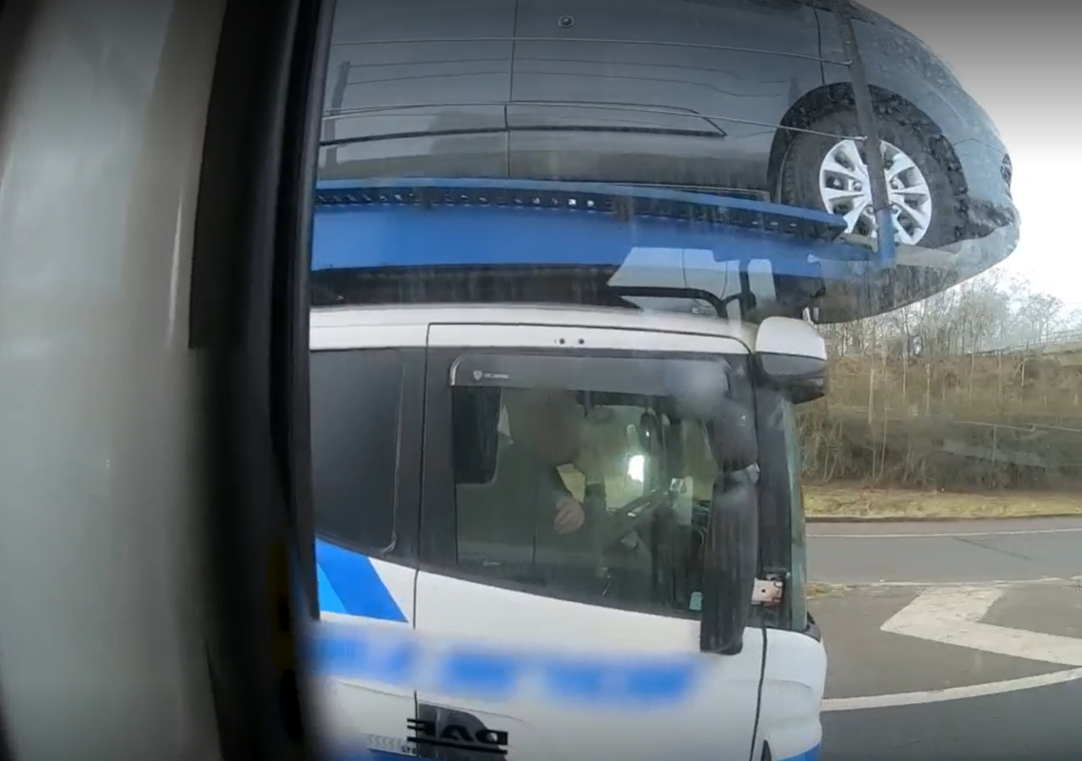
Caption: Watch footage here of the driver using his elbow to drive this transporter on the M40 near Gaydon in Warwickshire
The driver was seemingly oblivious to the police officers as they drove alongside him on the M40 in one of National Highways’ unmarked HGV cabs.
But he quickly put both hands firmly on the wheel when they caught his attention – and notified their colleagues travelling behind to pull the vehicle over.
Footage of a number of shocking incidents captured by police officers in the unmarked cabs has been released by National Highways today ahead of a week of action along the length of the M1.
Officers from eight different police forces will be patrolling the motorway between London and Leeds from Monday (March 6) to Sunday 12 March looking out for incidents of illegal driving. Incidents such as this driver who was spotted at the wheel of a horse box texting on his mobile phone – and without his seatbelt on.
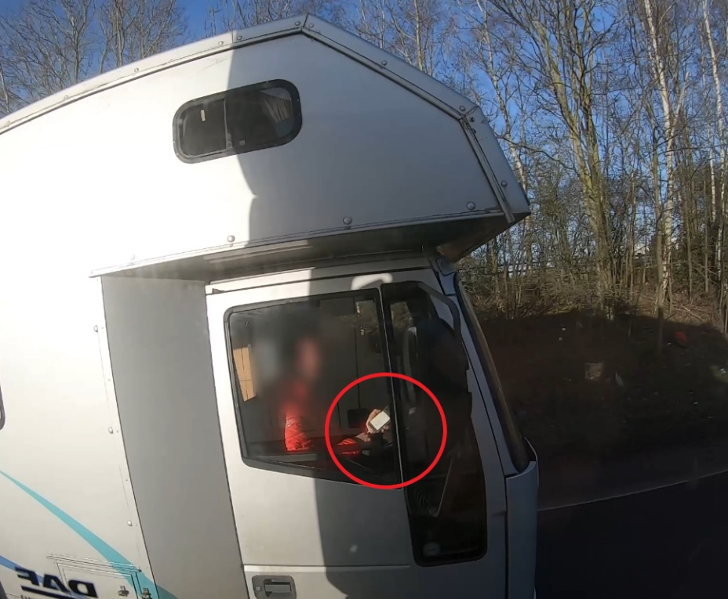
Caption: Watch footage here of this driver using his mobile phone on the A46 Coventry Eastern Bypass
While this car driver was also caught on camera holding up her mobile phone in her right hand as she drove along the motorway – and the moment she was pulled over by Warwickshire Police officers.
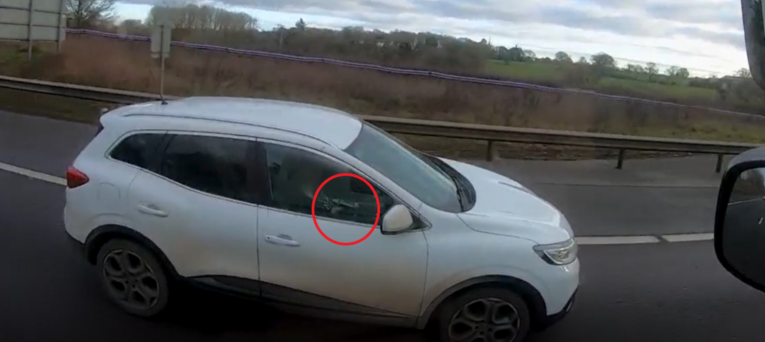
Caption: Footage of this car driver holding her mobile phone up to talk into as she drives one-handed along the M40 can be seen here
From the elevated position in the HGV cab, officers can spot unsafe driving behaviour – whatever vehicle the motorist may be in.
More than 33,254 offences have been recorded since the ‘Operation Tramline’ HGV cabs national safety initiative was launched by National Highways in 2015. And some 30,380 vehicles have been stopped by police partners.
The most common offences are not wearing a seatbelt (9,962) and using a mobile phone (8,368) followed by 2,257 who were not in proper control of their vehicle.
Consequences for drivers range from warnings to fixed penalty notices, court summons or arrest.
Hundreds of thousands of drivers travel over 21 million miles on the M1 every day, accounting for one in seven of all motorway journeys.
The aim of the multi-agency Week of Action on the M1 – which has been labelled Operation Freeway - is to reduce the number of incidents on the motorway. In 2022 there were 73,593 incidents on the M1 – that is over 200 incidents every single day. There were 4,087 traffic collisions on the motorway last year.
National Highways Head of Road Safety, Jeremy Phillips, said:
“We are committed to reducing the number of people killed or seriously injured while travelling on our roads by 50% by 2025 and we have a long term ambition for zero harm. To achieve that we need to tackle the unsafe driving behaviour that we sadly still encounter.
“Hundreds of thousands of drivers use our roads every day and the vast majority are sensible behind the wheel but some are putting themselves and others at risk. Through this week of action we want to encourage motorists to think about their driving and to adopt safer behaviours.
“But those who continue to pose a risk should be aware that we are working with our police partners to make sure they are spotted and prevented from causing serious harm to themselves or others.”
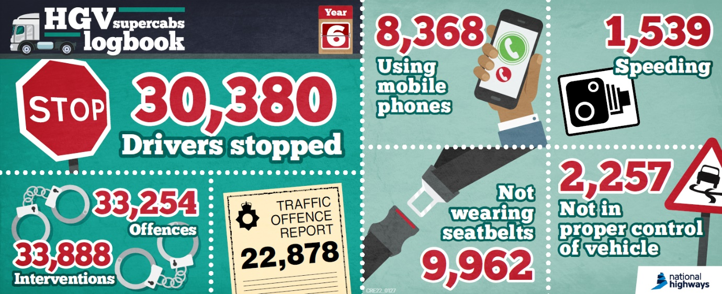
Police forces taking part in Operation Freeway are – West Yorkshire, South Yorkshire, Nottinghamshire, Derbyshire, Northamptonshire, Hertfordshire, Thames Valley and Bedfordshire, as well as the Leicestershire Road Safety Partnership.
In addition to the HGV cab patrols, partners taking part in the week of action will be present at motorway services offering advice to drivers and carrying out vehicle checks.
National Police Chiefs’ Council Lead for Roads Policing Operations, Commander Kyle Gordon, said:
‘We are pleased to be working with our key partner National Highways once again as we work to reduce the danger caused on one of our busiest roads, and beyond, by drivers who allow themselves to be distracted while driving. Too many people are killed or seriously injured on our roads every year. My officers have to visit the families of those killed on our roads, 5 times a day, every day of the week and every month of the year. I am very happy to support all initiatives that can help reduce these numbers.’

Further information:
MEDIA OPPORTUNITY:
There will be limited opportunities for media to film with police officers in the unmarked HGV cabs on Friday 3 March. Media events will take place at Northampton Services in the Midlands, Woodall Services in the North and Toddington Services in the South. To arrange an interview and a ride-out contact diane.davies@nationalhighways.co.uk or PressOfficeMidlands@nationalhighways.co.uk
National Highways spokespeople will be available for pre-record interviews on Thursday 2 March.

